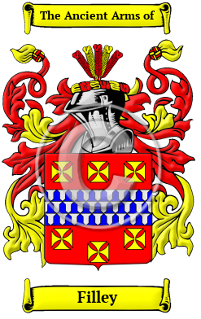

Filley

The surname Filley was first found in Essex where the name was first referenced in the year 1245 when Richard was recorded as Fitz le Roy, essentially 'son of the King' and we may allude to the reference to be that of King John. However, there was an earlier family of Fitzroy who was the illegitimate son of King Henry I about 1140. Known variations of the Filley family name include Fillery, Filley, Fillary, Fildry, Filary, Filery, Filey, Fillie, Fildery, Filleigh, Fitzroy, Fitzroi and many more.



SGT Roger Filley
Ancestor ID: 11928 Rank: Sgt Unit:
Pension: No Land Bounty: No Service: Militia State Served: KY
Spouse: Abiah Hale
Birth Date: May 25 1771 State: CT
Death Date: Jan 23 1815 State: LA

