Richmond Driving Tour

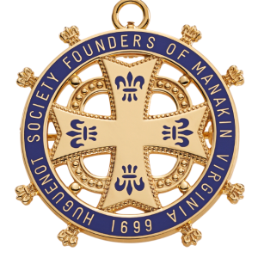

Huguenot Society of the Founders of Manakin

The Huguenot Society of the Founders of Manakin in the Colony of Virginia is a society dedicated to preserving the history and genealogy of all French Protestant Huguenots who came to Virginia prior to 1786.
The Society maintains a headquarters with an excellent research library to help trace Huguenot histories.
981 Huguenot Trail Midlothian, Virginia 23113

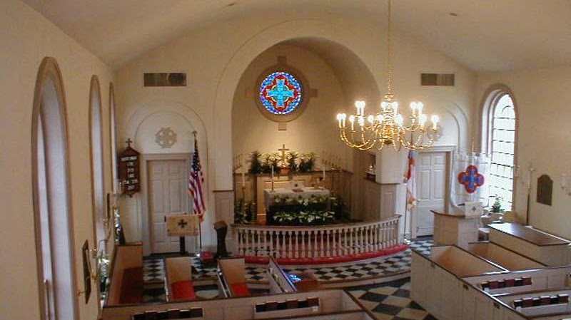

Manakin Episcopal Church

Our church origins extend back over three hundred years to the year 1701. The founding community of Huguenots was made up of French Protestants who followed the teachings of John Calvin. They had been forced to leave their homeland by the religious persecution that followed Louis XIV’s revocation of the Edict of Nantes in 1685. Fleeing to England, they became ardent supporters of William of Orange and helped him defeat James II. In gratitude for their support, William made it possible, in 1700, for many of them to move to the American Colonies by providing them with both land and financial aid.
985 Huguenot Trail, Midlothian, VA 23113 (804) 794-6401

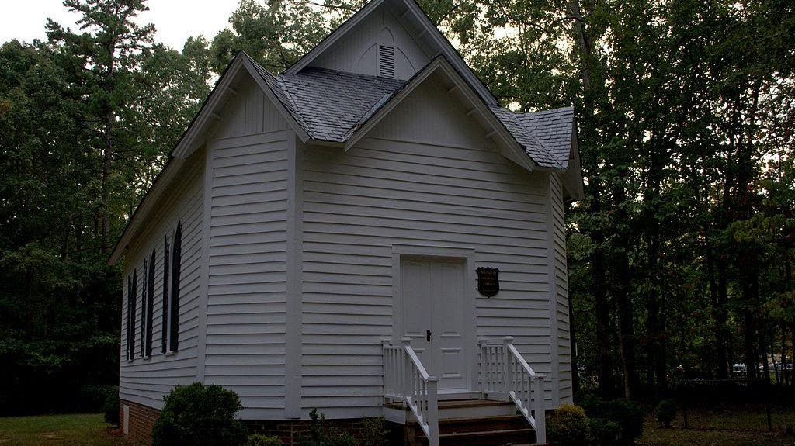

Huguenot Memorial Chapel and Monument

NRHP reference No. 88000214
VLR No. 072-0093

