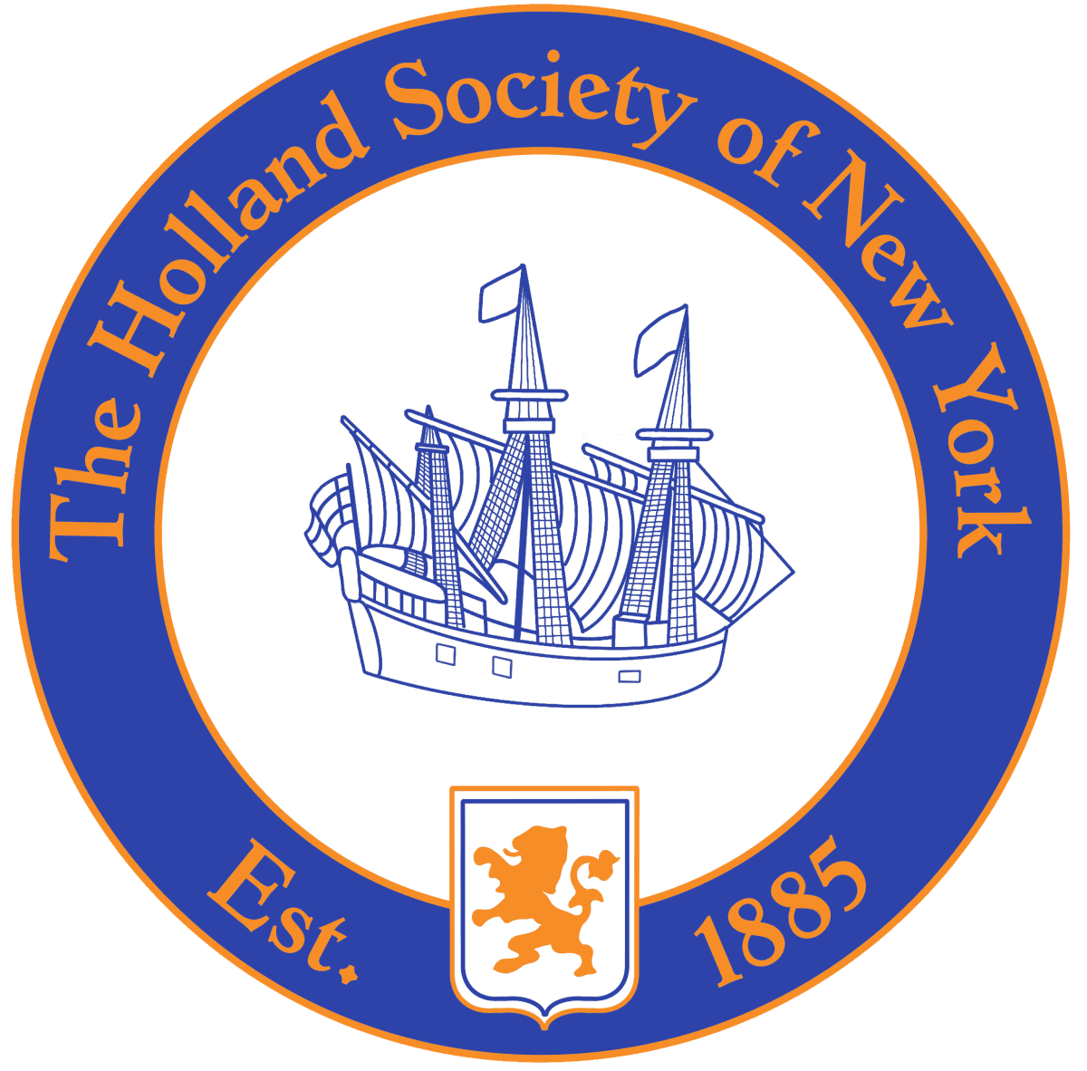

Holland Society of New York

Dutch native or Dutch resident of New Netherland or the American colonies (now a part of the United States) prior to or during the year 1675

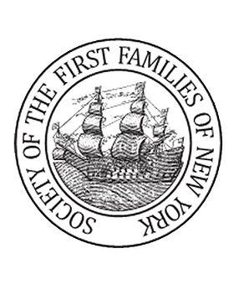

Society of the First Families of New York

Any individual at least eighteen years old, who is determined by the Society to be eligible based on proven lineal descent from an ancestor of the Founding Families of the State of New York, who was a resident of colonial New York, or its current borders, on or before November 24, 1783.



Society of Daughters of Holland Dames

Eligibility for Membership may be through any one of three avenues, or all three, if desired. Any woman shall be eligible who has reached the age of eighteen and is lineally descended from a person, male or female, (i) who was born, prior to the Treaty of Westminster, 1674*, either in the Netherlands or in New Netherland of Dutch parentage; OR (ii), whose ancestor resided in New Netherland prior to the Treaty of Westminster, 1674

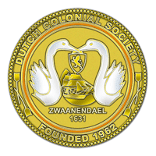

Dutch Colonial Society

Proven direct descent from a Dutch settler born in the Netherlands, and who immigrated, no later than 19 April 1775, to any settlement in what is now the United States. Also eligible are direct descendants of selected non-Dutch ancestors who resided in New Netherland prior to the Treaty of Westminster, 1674, or settled in what is now the United States no later than 19 April 1775, AND who have proven significant service to Dutch heritage in business, cultural, military, religious or political affairs either in the Netherlands and/or the United States.

