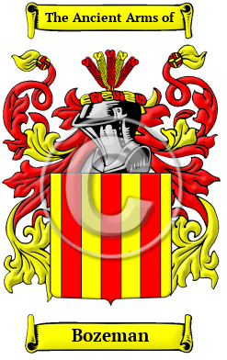

Bozeman

The origins of the Bozeman name lie with England's ancient Anglo-Saxon culture. Over the years, many variations of the name Bozeman were recorded, including Basham, Bosham, Barsham, Bassham, Bashan, Bashum and many more.
In the United States, the name Bozeman is the 4,317th most popular surname with an estimated 7,461 people with that name.

