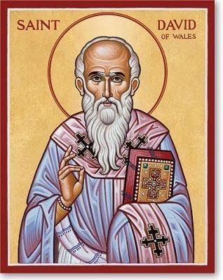

St. David
During the 6th century, St. David was responsible for forming several monasteries, in particular his abbey in Wales. This abbey was known for hard, physical labor while working in silence. The development of a joyous spirit was emphasized as they worked in silence, surviving only on bread, water, and the vegetables they grew. Even on his death-bed, he encouraged his monks to remain joyful in the Lord, no matter what their physical state in life.
St. David is considered the patron saint of Wales and poets. He is depicted most often with a dove sitting upon his shoulder. This picture represents the legend that a dove landed while he was speaking as the ground. As the dove pulled him up, the ground beneath him elevated him above the crowd so that he could be heard by everyone in attendance.
Feast Day is 1 March

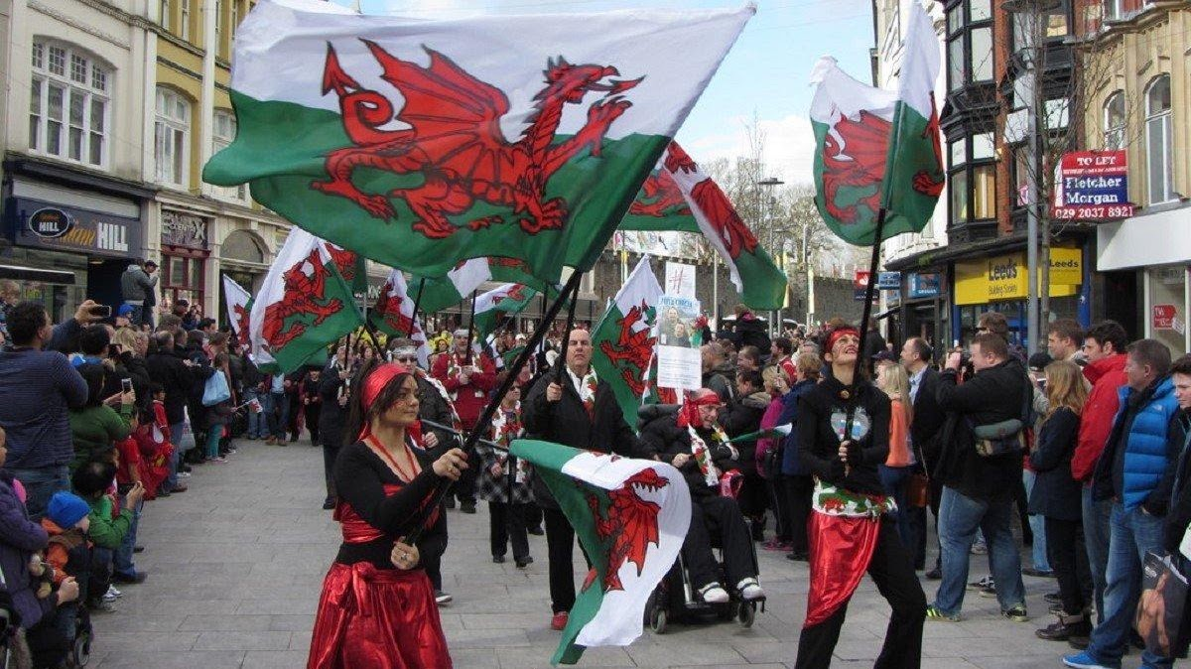

St. Davids Day
1 March
The Welsh Society of Philadelphia

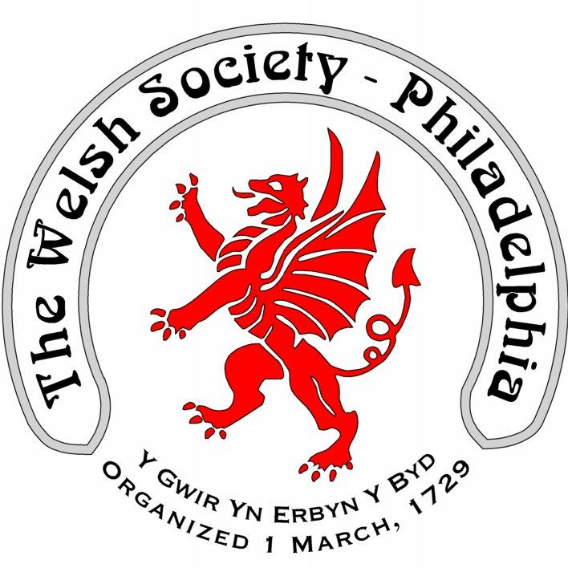

The Welsh Society of Philadelphia

The Welsh Society of Philadelphia has members that have a wide range of ages and interests. Everyone who shares our interest in keeping current with local Welsh American events is most welcome. Membership of the Welsh Society of Philadelphia provides the following opportunities:
A chance to participate in the historic and vibrant Welsh American community
Enjoy a variety of social and heritage events
Singing and community spirit at the Gymanfa Ganu
Receive notifications of upcoming events
Recognize outstanding Welsh Americans through the Robert Morris Award

