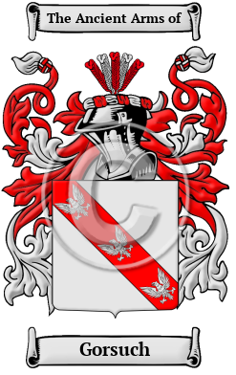

Gorsuch

The surname Gorsuch was first found in Lancashire at Gosfordsich (later named Gorsuch.) This family name include: Gossage, Gostage, Gorstidge, Gorstice, Gorstage, Gostige, Gossidge, Gossadge, Gossedge and many more.
In the United States, the name Gorsuch is the 12,214th most popular surname with an estimated 2,487 people with that name.

