We have 2 types of Membership: Full and Associate. For Full Membership, you must show that you had a ancestor in the United States on or before 17 September 1787. We accept your membership into the following organization for Full Membership:

------------------------------------------------------------------------------------------------------

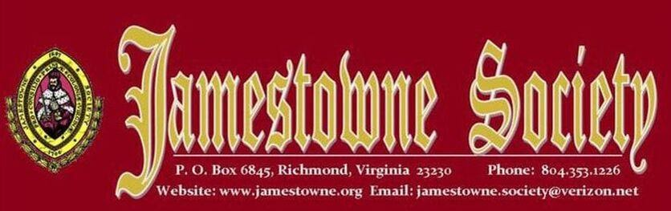
Jamestowne Society
10 April 1606 stock was sold in London Company or the Virginia Company
Resident in Virginia at the time of the 1624/25 Muster or earlier
Governor, Secretary of State, Treasurer, Attorney General, Clerk of the General Court, Member of the Council or House of Burgesses; Anglican Church (Church of England) minister in Virginia; served as an official Indian Interpreter in Virginia or owned land on Jamestown Island or lived on the Island on or before 1699
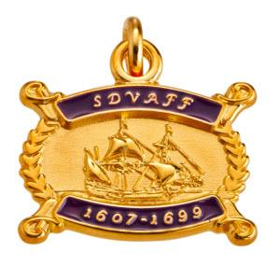
Sons and Daughters of Virginia Founding Fathers
The Sons and Daughters of Virginia Founding Fathers (SDVAFF) is a lineage society that is a non-profit, charitable organization dedicated: To honor those hardy and enterprising early ancestors who concentrated their efforts, labor and skills in building the enduring greatness of the Colony of Virginia. To recognize and record the names of those individuals who were residents within the boundaries of the Virginia Colony on or before 31 December 1699.

Virginia Huguenot Society
The Edict of Nantes, signed by Henry IV in April, 1598, ended the Wars of Religion, and allowed the Huguenots some religious freedoms, including exercise of their religion in 20 specified towns in France. The Revocation of the Edict of Nantes by Louis XIV in October, 1685, began a new persecution of the Huguenots. Hundreds of thousands of them fled France for other countries.

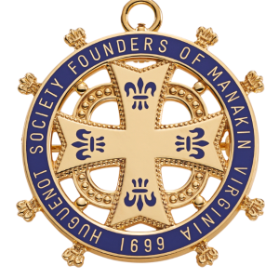
Huguenot Society of the Founders of Manakin
The Huguenot Society of the Founders of Manakin in the Colony of Virginia is a society dedicated to preserving the history and genealogy of all French Protestant Huguenots who came to Virginia prior to 1786.
The Society maintains a headquarters with an excellent research library to help trace Huguenot histories.
981 Huguenot Trail Midlothian, Virginia 23113

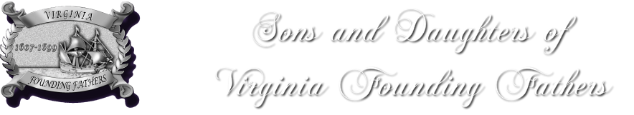
Virginia Founding Fathers
Any person eighteen (18) years of age or older who can prove lineal descent from an ancestor who was a resident of the Virginia Colony on or prior to 31 December 1699 is eligible for membership provided they are acceptable to the Membership Committee. Lineal descent (descendant) shall mean blood relative in the direct line of descent.

Daughters of the American Revolution
In applying for DAR membership, women must document their lineage back to an ancestor who aided the cause of American independence. These efforts may come through military, civil or patriotic service and must occur during the period between 19 April 1775 (Battle of Lexington) and 26 November 1783 (withdrawal of British Troops from New York).
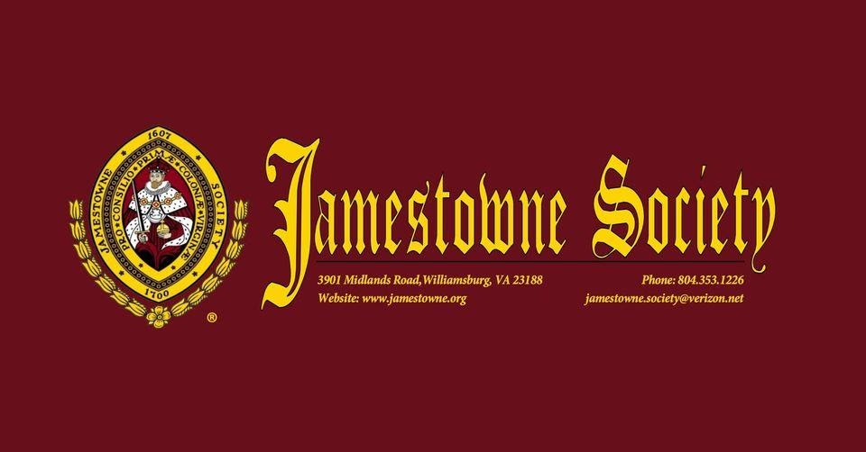
Jamestowne Society
The following criteria are used to determine whether an early settler may be included as a qualifying ancestor for purposes of membership in the Jamestowne Society. The individual:
was a stockholder in the London Company or the Virginia Company; or was a current member of one of the Guilds owning stock in the aforesaid companies during the period of investment; or was a signer of one of the three charters of the Virginia Company of London during the joint-stock company period of 10 April 1606 and 24 May 1624;
owned land on Jamestown Island or lived on the Island prior to 1700 (owning land in a neighboring area or neighboring county does NOT of itself qualify an individual);
was a resident in Virginia at the time of the 1624/25 Muster or earlier;
served as Governor, Secretary of State, Treasurer, Attorney General, Clerk of the General Court, Member of the Council or House of Burgesses prior to 1700; these persons shall be conclusively presumed to have had their domiciles on Jamestown Island during their terms of office;
was an Anglican Church (Church of England) minister in Virginia prior to 1700; or
served as an official Indian Interpreter in Virginia prior to 1700.
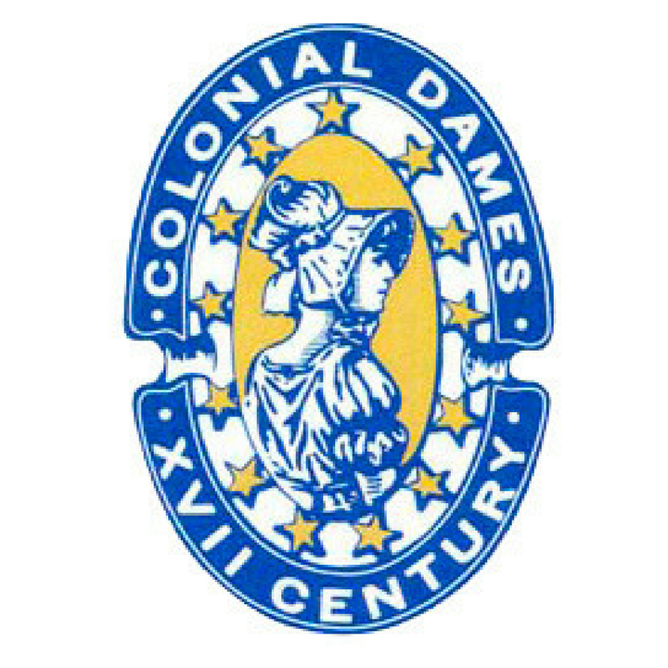
National Society Colonial Dames 17th Century
Any woman eighteen years of age or over of good moral character is eligible for membership, provided she has been invited by the Society, is eligible through birth parents or adopted parents if there is a blood relationship to the applicant, and is the lineal descendant of an ancestor who lived and served prior to 1701 in one of the Original Colonies in the geographical area of the present United States of America. Lineal descendant shall mean direct legal blood descendant.
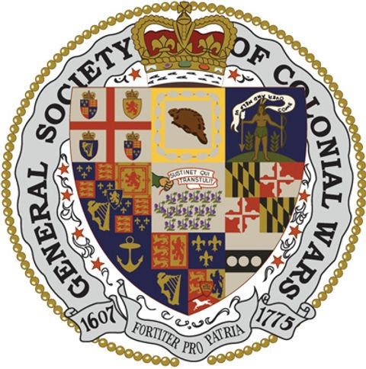
Society of Colonial Wars
Ancestor who served as a military or naval officer, or as a soldier, sailor, or
marine, or as a privateersman, under authority of any of the Colonies which
afterward formed the United States, or in the forces of Great Britain
which participated with those of the said Colonies in any wars in which
the said Colonies were engaged, or in which they enrolled men, during the
period from the settlement of Jamestown, May 13, 1607, to the Battle
of Lexington, April 19, 1775

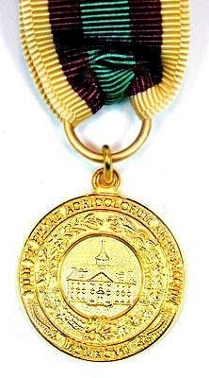
National Society Sons and Daughters of Antebellum Planters
To identify and honor the memory of ancestors who were “planters” within lands today comprising the 48 states of the continental United States between 1607 and 12 April, 1861. A “planter” is a large farmer, one owning not less than 500 acres of land. A rancher would be included in this definition. The 500 acres or more, does not have to be in one plot or in contiguous plots or even in the same county or same state. The property of one spouse may be aggregated with the property of the other spouse even if legal title is vested in a trustee, but aggregation is permitted only where the applicant descends from both spouses. Also eligible are collateral descendants of a “planter” brother or sister of the whole blood of a lineal ancestor,
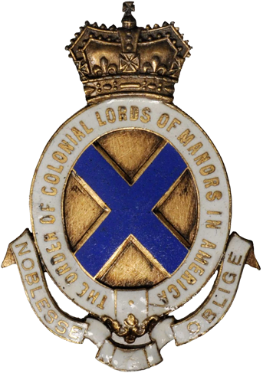
Order of Colonial Lords of Manors in America
Membership in the Order is solely by invitation, and is open to men and women who are lineally descended in either the male or female line from a recognized Patroon, Seigneur, or Lord of a Manor of New Netherland, the Province of New York, the Province of Maryland, or a similar system of landholding (with Court Leet or Court Baron) in any other of the original colonies.
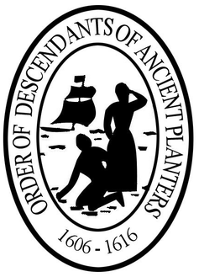
Order of Descendants of Ancient Planters
The term "Ancient Planter" is applied to those persons who arrived in Virginia prior to June 1616, remained for a period of three years, and paid their passage. They received the first patents of land in the new world from the Virginia Company of London, as authorized by Governor Sir Thomas Dale in 1618, for their personal adventure.
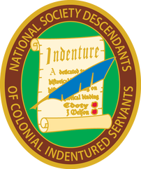
National Society Descendants of Colonial Indentured Servants
To preserve the history of indentured servitude through (1) conservation of historical documents, (2) publication and/or abstracting of primary source materials, (3) partnering with organizations to further public awareness acknowledge the contributions of our immigrant indentured servant ancestors, who brought their talents, skills, and labor to the colonies to help make their new found country a success.

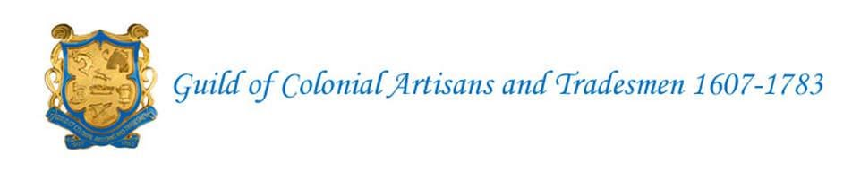
Guild of Colonial Artisans and Tradesmen
The Guild of Colonial Artisans and Tradesmen 1607-1783 is a hereditary society established to honor the memory and skills of our Colonial Ancestors who were accomplished in the field of art or trades which strengthened the building of our Nation.


Descendants of Colonial Clergy
For additional research and information on colonial ministers, the following books should be consulted. The following books should be consulted for lists of ministers of the colonial period who are the qualifying clergy.

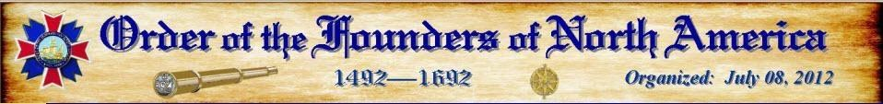
Order of the Founders of North America
Order of the Founders of North America (OFNA) is a lineage society whose purpose is to memorialize the individuals who founded North America through Colonization; including the Caribbean and offshore North Atlantic Islands during the period of 1492 to 1692.

National Society of The Colonial Dames of America
The Corporate Societies shall be composed entirely of women who are lineal bloodline descendants from an ancestor of worthy life who, residing in an American colony, rendered efficient service to our country during the Colonial period, either in the founding of a State or Commonwealth, or of an institution which has survived and developed into importance, or who shall have held an important position in a Colonial government, or who by distinguished services, shall have contributed to the founding of our nation. DATE OF ANCESTOR’S SERVICES. All services which constitute a claim to membership must have been rendered before July 5, 1776
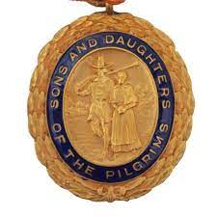
National Society Sons and Daughters of the Pilgrims
We appreciate your interest in the National Society Sons and Daughters of the Pilgrims. A male or female, without regard to religion or place of origin, is eligible to join our Society if he or she is a direct descendant of a “Pilgrim.” The term “Pilgrim” denotes any immigrant who settled before 1700 within the territory which later became the forty-eight contiguous states of the United States of America.

Order of the Founders & Patiots of America
Membership in the Order of the Founders and Patriots of America is challenging by design. With its double generational requirement and the need for a Founder on or before May 12, 1657 , the Order is considered one of the most exclusive lineage societies one can aspire to join.

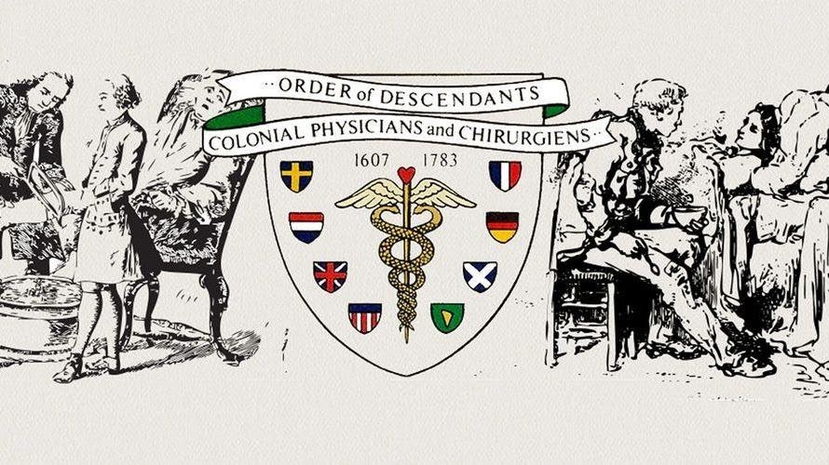
Order of Descendants of Colonial Physicians and Chirurgiens
Anyone who can prove blood lineal descendant from a Physician, Chirurgien, Apothecary, or Licensed Midwife who practiced their professions on the North American continent from 1607 to 1783 shall be eligible for membership in this Order.

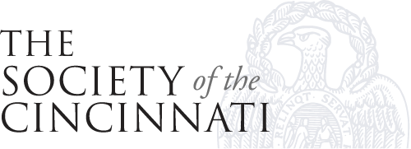

Society of the Cincinnati
The Society of the Cincinnati is a fraternal, hereditary society founded in 1783 to commemorate the American Revolutionary War that saw the creation of the United States. Membership is largely restricted to descendants of military officers who served in the Continental Army. The Society has thirteen constituent societies in the United States and one in France. It was founded to perpetuate "the remembrance of this vast event" (the achievement of American Independence), "to preserve inviolate those exalted rights and liberties of human nature," and "to render permanent the cordial affection subsisting among the officers" of the Continental Army who served in the Revolutionary War.
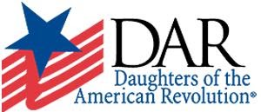
Daughter of the American Revolution
Any woman 18 years or older who can prove lineal, bloodline descent from an ancestor who aided in achieving American independence is eligible to join the DAR. She must provide documentation for each statement of birth, marriage and death, as well as of the Revolutionary War service of her Patriot ancestor.
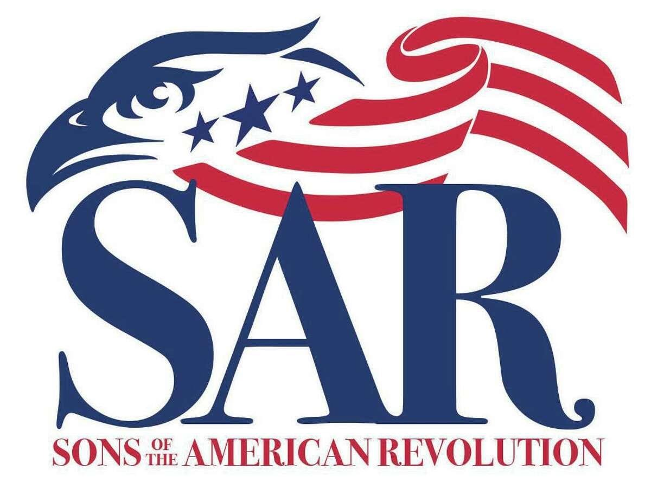
Sons of American Revolution
The Sons of the American Revolution honors our Revolutionary War patriot ancestors by promoting patriotism, serving our communities and educating and inspiring future generations about the founding principles of our Country. The SAR accepts patriotic service rendered, with some exceptions, for the period between 19 April 1775 and 26 November 1783.



Descendants of Colonial Regulators
Descendants of Colonial Regulators was initially formed to honor those ancestors who took part in the Regulation movements that occurred in North Carolina and South Carolina prior to the Revolutionary War. The War of Regulation or the Regulator Movement was an uprising that occurred from about 1765 and ended around 1771. During that time citizens took up arms against colonial officials they viewed as corrupt. Though the rebellion did not change the power structure, some historians view it as a catalyst to the American Revolution.


National Society Daughters of Colonial Wars
To honor and perpetuate the memory and spirit of the men and women who, by their acts and counsel, assisted in the establishment, defense and preservation of the American Colonies. To collect and preserve records relative to the American Colonial Period, and records of service of men who assisted in the establishment, defense and preservation of the American Colonies. To promote historical research and the study of history and to commemorate the events of the American Colony Period between 1607 and 1775.

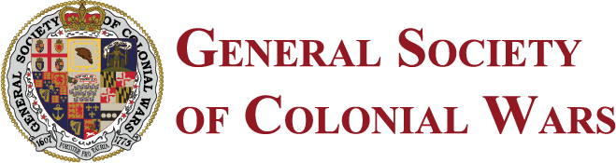
General Society of Colonial Wars
Who served as a military or naval officer, or as a soldier, sailor, or marine, or as a privateersman, under authority of any of the Colonies which afterward formed the United States, or in the forces of Great Britain which participated with those of the said Colonies in any wars in which the said Colonies were engaged, or in which they enrolled men, during the period from the settlement of Jamestown, May 13, 1607, to the Battle of Lexington, April 19, 1775
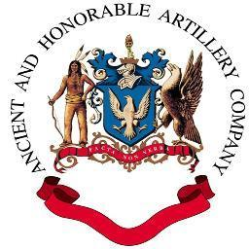
Ancient and Honorable Artillery Company
Women Descendants of the Ancient & Honorable Artillery is made up of lineal descendants of the 24 Founders of 1637 and for all members of the Ancient and Honorable Artillery Company between 1638-1774. for lineal descendants of the General court of Massachusetts Bay when the Charter was granted in 1638, namely, the Governor, the Governor's Council and for the Deputies to the General Court of 1638.

Daughters of the Cincinnati
Membership in the Daughters of the Cincinnati is by invitation only to any woman over the age of eighteen having an ancestor who served as an officer in the Continental Army, Continental Navy, Continental Marines, the French Royal Army, and the French Royal Navy during the American Revolutionary War (1775 – 1783).
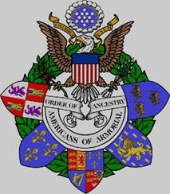
Order of Americans of Armorial Ancestry
Any person aged eighteen or over, of good moral character and reputation is eligible for membership in the Order provided the candidates prove descent from an immigrant ancestor who settled on or before 04 July 1776 within a territory that became the forty-eight contiguous states of the United States of America and who had a proven right to bear arms in the settler’s country of origin.

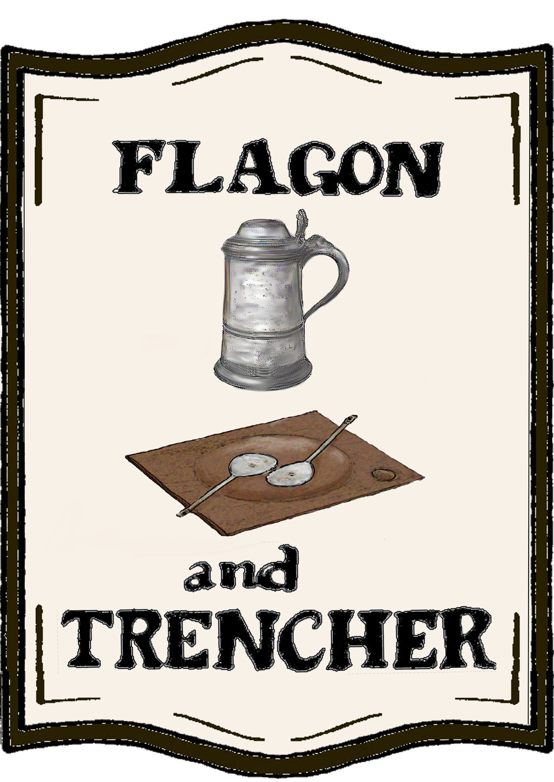
Flagon and Trencher
Flagon and Trencher is a hereditary society composed of men and women who can trace ancestry to one or more licensed operators of an ordinary tavern, inn, public house, or hostel, prior to July 4, 1776, in the area that became the original thirteen U.S. states. The society has published a number of biographical anthologies, documenting the lives of select colonial taverners. A record extraction project is underway. The objective is to eventually identify every colonial taverner for whom evidence survives.


Descendants of the Founders of Ancient Windsor
The first Founders List was literally carved in stone when the Sons and Daughters of the Pilgrims, erected the impressive Founders Monument on the site of the first meeting house on Palisado Green on May 30, 1930, the three-hundredth anniversary of the arrival of the Mary and John in the waters off Nantasket. That congregation formed the nucleus of the collection of several groups who settled in Windsor before the end of 1641. That day in 1930 marked the 300th Anniversary of the organization of the First Church in Windsor on the dock in Plymouth just before the Mary and John set sail. Many turned out for the church celebration that day

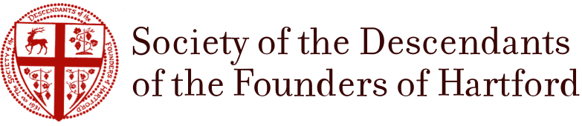
Descendants of the Founders of Hartford
The Society of the Descendants of the Founders of Hartford is a charitable and educational society organized in 1931. Among its purposes are: To foster literary, cultural, historical and other research aimed at strengthening the public understanding of the history and traditions of the City of Hartford; To celebrate appropriate anniversaries in the history of the City; To erect appropriate memorials in public places to commemorate the founding of the City; To promote the widest possible public interest in the history of Hartford; And to make grants to other organizations in support of the above. There are more than 300 living members, in almost every state and in several foreign countries. We meet once a year in Hartford for the annual Court and Dinner, which features a guest speaker and the introduction of new members.

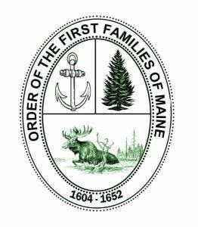
Order of the First Families of Maine
Membership is open to individuals at least eighteen years of age, who are lineal descendants of an ancestor who was a resident of present-day Maine, by the year 1652. Membership is by invitation only and shall be extended by the President General. Membership inquiries are welcome.

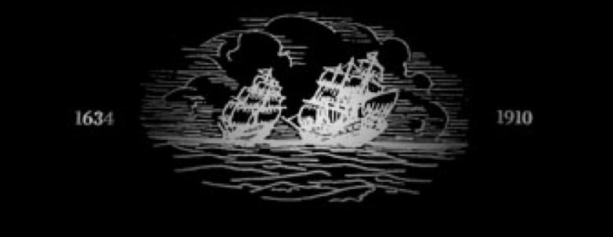
Society of The Ark and The Dove
The Society of The Ark and The Dove was founded in 1910 to perpetuate the memory of the first families of Maryland and to provide opportunities for fellowship for all those who trace their descent from Lord Baltimore and from those who came on the Ark and the Dove in 1634 to settle the proprietary province of Maryland.

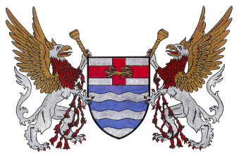
Hereditary Order of the First Families of Massachusetts
Men and women over the age of 18 years, who are lineal descendants of men or women who settled within the bounds of the Massachusetts Bay Colony before the year 1650 may be eligible for membership. For purposes of this Order, the term “settler” refers to one who lived in the Colony for at least one year, although possibly in more than one town during that time.
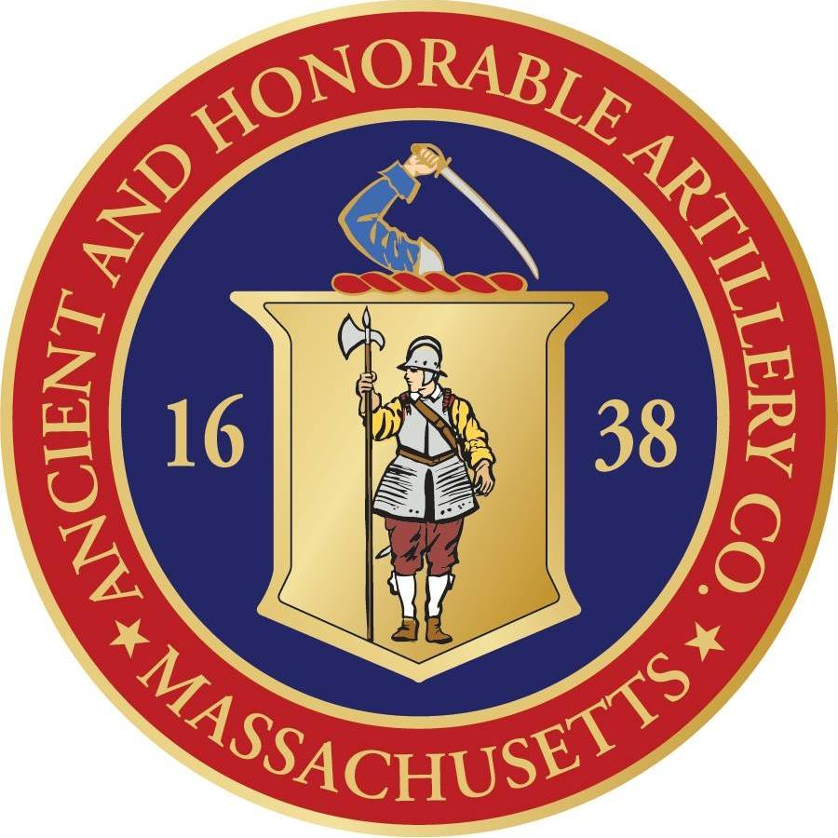
Ancient and Honorable Artillery Company of Massachusetts
Those individuals eligible for membership shall be at least eighteen years of age with legitimate descent from (1) a member of The Ancient and Honorable Artillery Company of Massachusetts who served between the years 1637-1774; (2) a minister who preached the Election Sermon during the years 1638-1774; (3) Governor John Winthrop, (4) Deputy Governor Thomas Dudley, (5) a member of the Council or a delegate to the General Court in 1638 when the Company Charter was granted, (6) members of the Ancient and Honorable Artillery Company of Massachusetts “by right of descent,” or (7) members of the National Society of Women Descendants of The Ancient and Honorable Artillery Company.
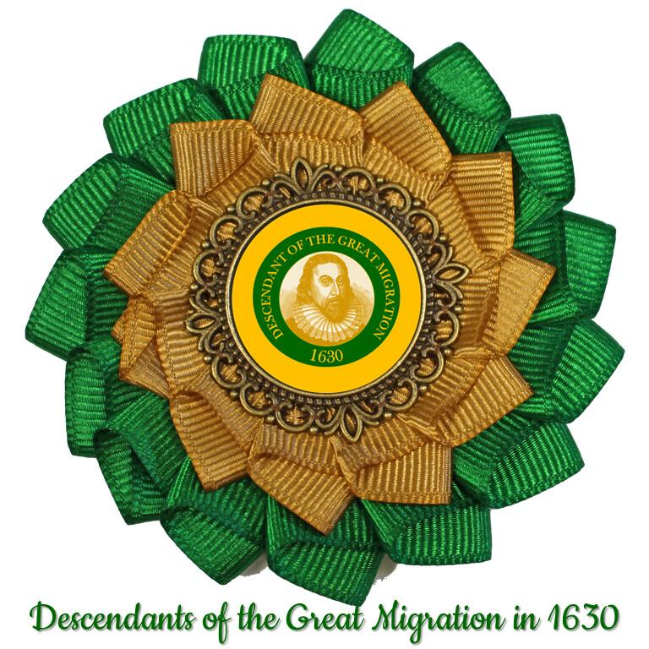
The Winthrop Society
The Winthrop Society currently consists of proven descendants of the first settlers of the Massachusetts Bay Colony. It is open to all men and women of good character and proven descent from one or more passengers of the Winthrop fleet, or of others who settled in the Bay Colony and Down East* by the end of 1640.


General Society of Mayflower Descendants
The General Society of Mayflower Descendants is committed to research on the lineal descent of the Mayflower Pilgrims and education about the Pilgrims who traveled aboard the Mayflower in 1620. The Society provides education and understanding of why the Mayflower Pilgrims were important, how they shaped western civilization, and what their 1620 voyage means today and its impact on the world.

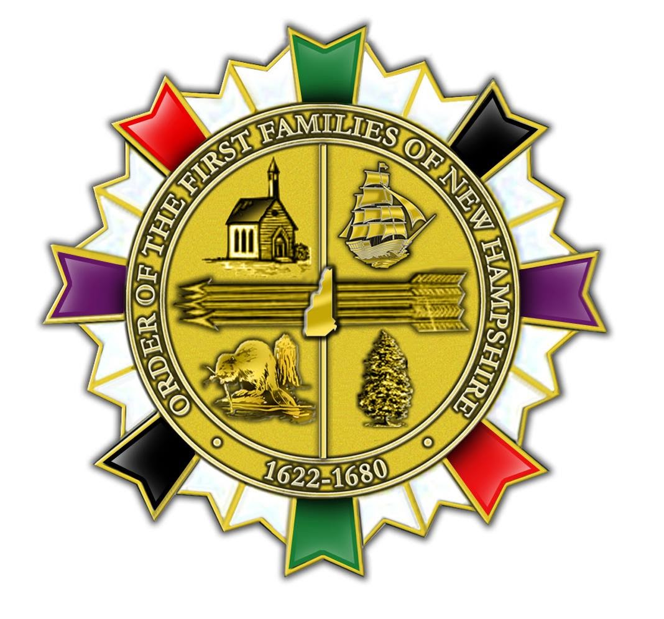
Order of the First Families of New Hampshire
Honor those hardy and enterprising early ancestors who concentrated their efforts, labor and skills in building the enduring greatness of the State of New Hampshire. Recognize and record those individuals who established residency, owned land or businesses within the boundaries of present day New Hampshire between 1622 - 1680.

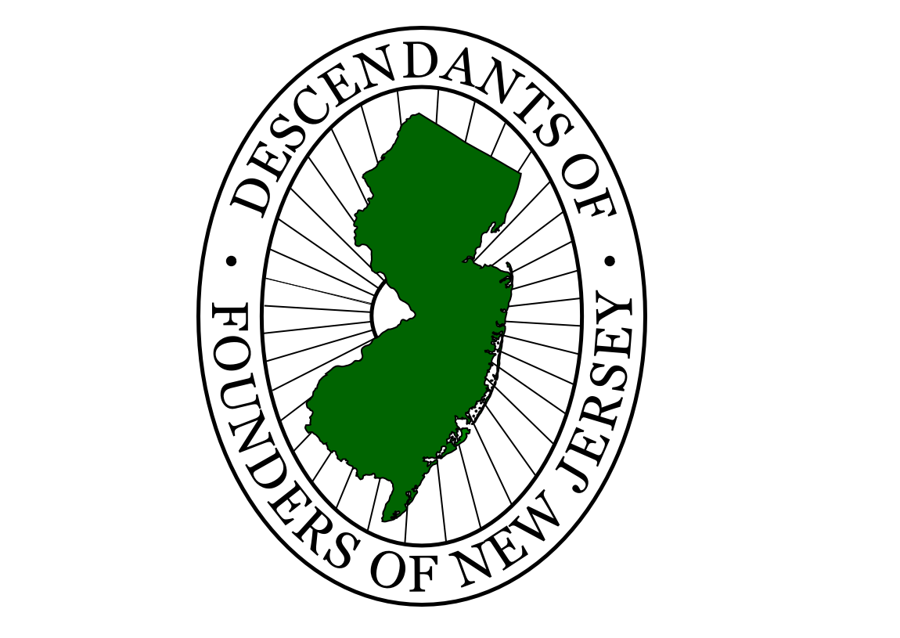
Descendants of Founders of New Jersey
Settlers came to East Jersey as early as 1618 when the Dutch from New Amsterdam settled at Bergen (now Jersey City), and in West Jersey as early as 1623 when Fort Nassau was established on the Delaware River. In March 1664, King Charles II formally granted the land to his brother, James, Duke of York. In June 1664, James divided the grant between Lord John Berkeley and Sir George Carteret. The two Jerseys were formally divided by the Quintipartite Deed of 1 July 1676 and governed as separate proprietary colonies until 17 April 1702.

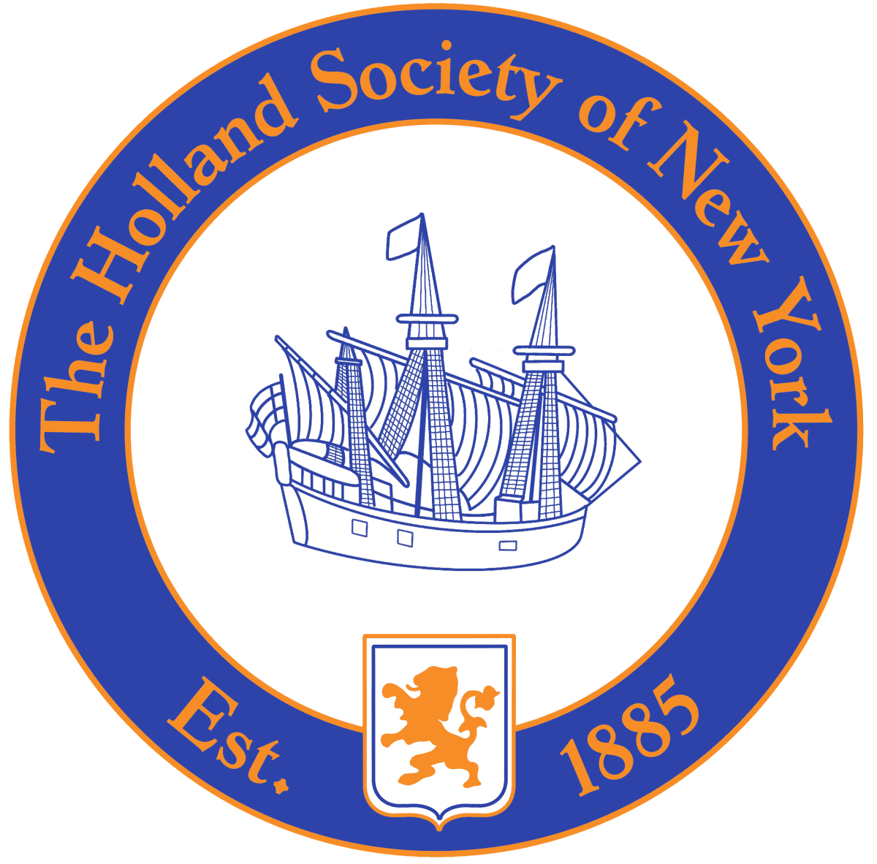
Holland Society of New York
Dutch native or Dutch resident of New Netherland or the American colonies (now a part of the United States) prior to or during the year 1675
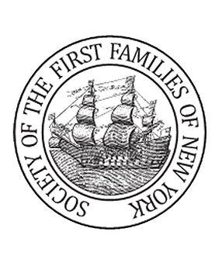
Society of the First Families of New York
Any individual at least eighteen years old, who is determined by the Society to be eligible based on proven lineal descent from an ancestor of the Founding Families of the State of New York, who was a resident of colonial New York, or its current borders, on or before November 24, 1783.
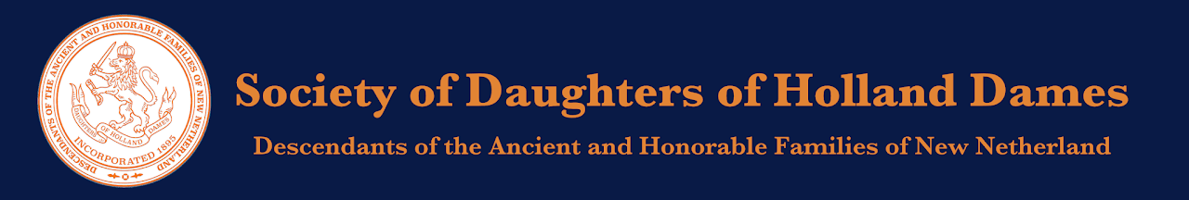
Society of Daughters of Holland Dames
Eligibility for Membership may be through any one of three avenues, or all three, if desired. Any woman shall be eligible who has reached the age of eighteen and is lineally descended from a person, male or female, (i) who was born, prior to the Treaty of Westminster, 1674*, either in the Netherlands or in New Netherland of Dutch parentage; OR (ii), whose ancestor resided in New Netherland prior to the Treaty of Westminster, 1674
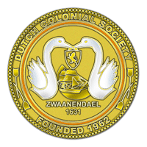
Dutch Colonial Society
Proven direct descent from a Dutch settler born in the Netherlands, and who immigrated, no later than 19 April 1775, to any settlement in what is now the United States. Also eligible are direct descendants of selected non-Dutch ancestors who resided in New Netherland prior to the Treaty of Westminster, 1674, or settled in what is now the United States no later than 19 April 1775, AND who have proven significant service to Dutch heritage in business, cu

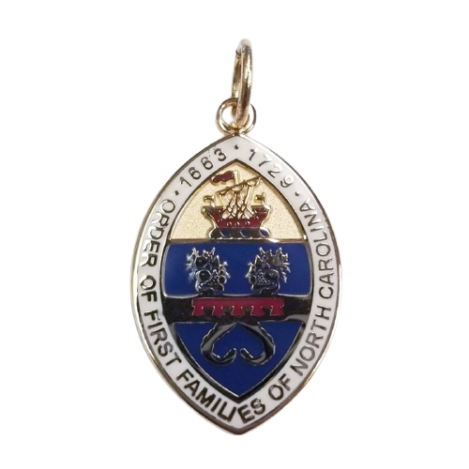
Order of First Families of North Carolina
The Order of First Families of North Carolina is composed of, and limited to, individuals lineally descended from a person who was a resident/colonist on or before the 12th day of July, Anno Domini, 1729, in that part of the PROVINCE OF CAROLINA which later became the STATE OF NORTH CAROLINA.

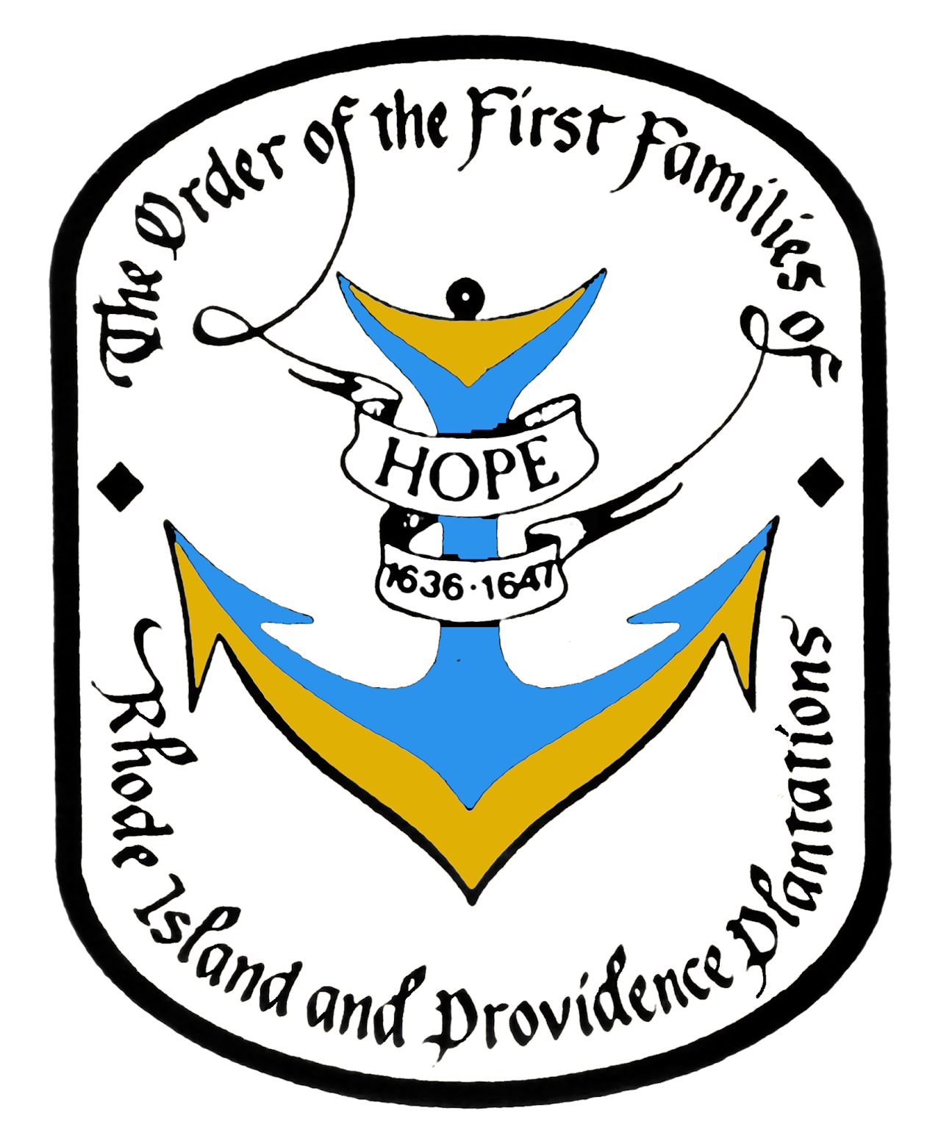
Order of the First Families of Rhode Island and Providence Plantations
Men and women, age 18 and older, who can prove lineal descent from an ancestor who was resident on land presently a part of the State of Rhode Island and the Providence Plantations prior to January 1, 1647/8, may be eligible for membership.

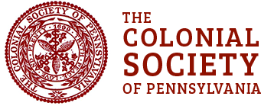

Colonial Society of Pennsylvania
The Colonial Society of Pennsylvania celebrates anniversaries of events connected to the settlement of Pennsylvania which occurred prior to 1700, as well as the collection, preservation, and publishing of records and documents related to the early history of our Commonwealth.



Welcome Society
The purposes of the society are given in its 1906 charter (Listed Above). Though it is not specifically stated in the charter, the Society was founded as nonprofit and educational. Originally, the membership was limited to the descendants (male or female) of those who were passengers on the Welcome. Presently, membership is composed of descendants of those ancestors who traveled with fellow Quakers to America during the course of the year of 1682. This includes 22 ships and 23 crossings of the Atlantic.

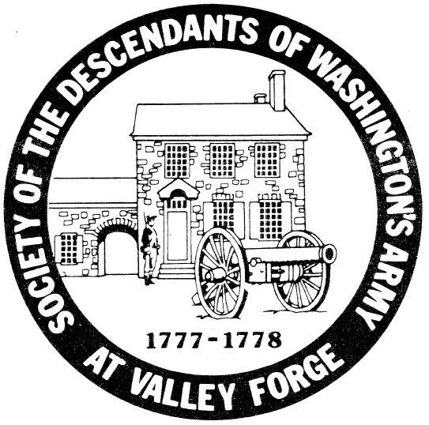
Society of the Descendants of Washington's Army at Valley Forge
The Society of the Descendants of Washington's Army at Valley Forge is a historical & genealogical organization where one must prove descent from a person that spent time at Valley Forge, Pennsylvania with the Continental Army between December 19, 1777 and June 19, 1778.

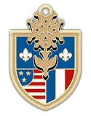

Huguenot Society of Pennsylvania
In 1918 in Reading, Pennsylvania, approximately ten men and women of known Huguenot descent founded The Huguenot Society of Pennsylvania, one of the first societies for the descendants of Huguenots established in the United States. They settled on April 13, 1918 (the 320th anniversary of the Edict of Nantes) for their first official meeting, and set out to write a charter, find interested members, and decide upon the organization's structure. At this meeting, they developed a set of objectives for the organization, which included perpetuating and maintaining the history, principles, and beliefs of the Huguenots; "publicly commemorating at stated times the principal events in the history of the Huguenot;" maintaining a library and museum of materials pertaining to Huguenots in America and specifically in Pennsylvania; promoting scholarly study of their history; and above all, celebrating and preserving the spirit of a people who withstood persecution and intolerance "because of their adherence to the basic tenets of the Protestant faith and their devotion to liberty." This is a list of the original Huguenot Society of Pennsylvania members in 1918. To read the original proceedings of the 1918 meeting, click here.

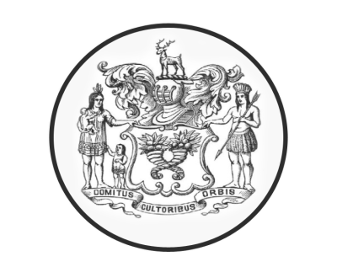
The Society of First Families of South Carolina
South Carolinians ​​​are proud of our long, rich history. Our state has been influencing the birth and direction of a nation since the earliest days of colonization. The Society of First Families of South Carolina 1670-1700 is working to perpetuate the memory of those who achieved a permanent settlement in South Carolina between 1670 and 1700; cherish, maintain and extend the institution of American freedom; and foster true patriotism and love of country.


National Society Colonial Dames 17th Century
The National Society Colonial Dames XVII Century is an organization of women, eighteen years of age or over, who are lineal descendants of an ancestor who lived and served prior to 1701 in one of the Original Colonies in the geographical area of the present United State of America. Our members are devoted to preserving the memory of those that settled in the United States of America prior to 1701.
The National Society Colonial Dames XVII Century, as a non-profit organization, was established on July 15, 1915, with its headquarters in Washington D.C. Constructed in 1884, the headquarters building holds historical significance and is listed on the National Register of Historic Places.
1300 New Hampshire Avenue, NW · Washington, DC 20036-1502 · Phone: 202-293-1700

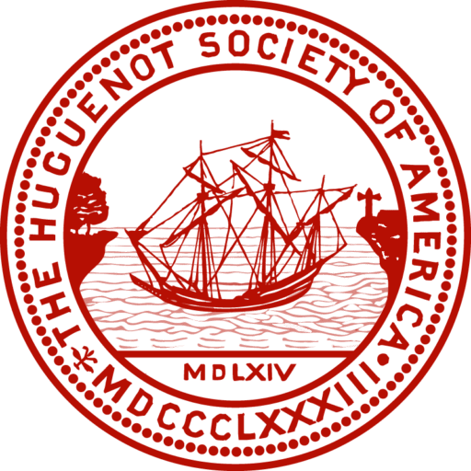
Huguenot Society of America
Applicants must be above the age of eighteen and a lineal descendant in the male or female line of a Huguenot who emigrated from France, and that such Huguenot émigré or one of his or her descendants in the same line either settled in what is now the United States of America or left France for countries other than America prior to the promulgation of the Edict of Toleration on November 28, 1787.
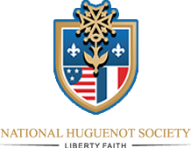
National Huguenot Society
The objectives of The National Huguenot Society are patriotic, religious, historical, and educational. Their design is to perpetuate the memory, the spirit, and the deeds of the men and women in France known as Huguenots who were persecuted in the 16th and 17th centuries because of their adherence to the basic tenets of the Protestant faith and their devotion to liberty, and who emigrated either directly or through other countries to North America and contributed by their character and ability to the development of the United States.

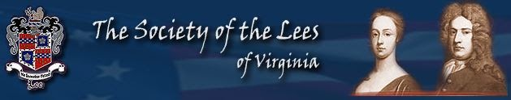
Society of The Lees of Virginia

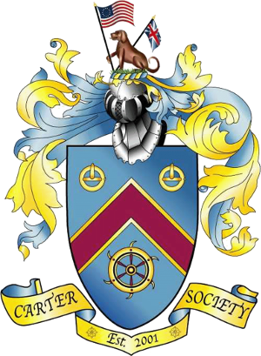
Carter Society
Our forefathers, the Carters of early Virginia and their progeny, helped forge this nation based upon freedom and liberty for all men, and it is a heritage worthy of honor. The Carter Society has emerged slowly but with an extreme sense of purpose. May no man sway us from the path we have set.


First Settlers of Shenandoah Valley
The qualifying FIRST SETTLER ancestor needed for FSSV membership is a person who resided in an area that is located in present-day Shenandoah Valley before 31 December 1799.

__________________________________________________________________________

NOTE: From the following organization your ancestor must be proven to be here on or before 17 September 1787.

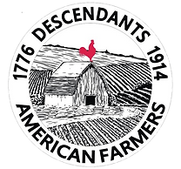
National Society Descendants of American Farmers
Founded in 2019, the National Society Descendants of American Farmers is a non-profit, non-political organization for descendants of American farmers who were living within the present boundaries of the contiguous continental states of the United States of America between July 4, 1776 - July 4, 1914 . Whether you are currently a member of the NSDOAF, a prospective member, or you are trying to learn more about the Society, this website will hopefully give you the information you are seeking. Please click on the links that are most relevant to you.

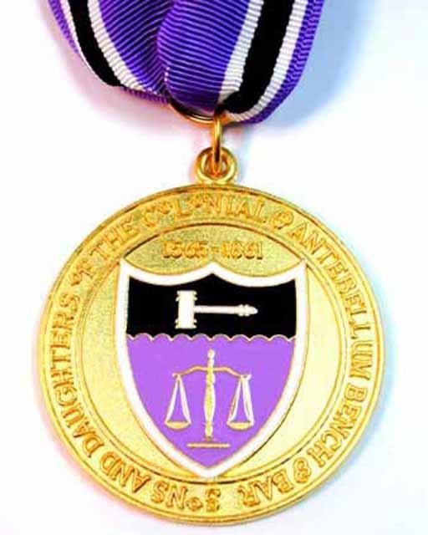
Colonial and Antebellum Bench and Bar
Membership in this society is open to anyone age 18 or older who can prove lineal descent from an ancestor who served as a judge or a lawyer prior to 12 April 1861 in any part of what is now the Continental United States of America.
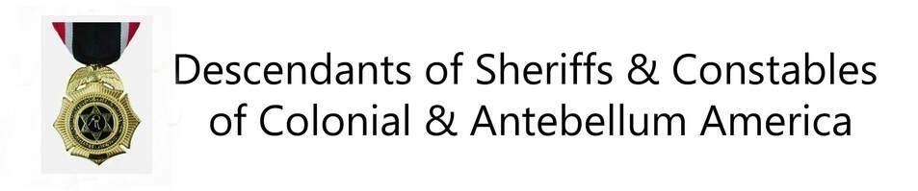
Descendants of Sheriffs & Constables
Membership is extended to men and women 18 years of age or older who are lineal descendants of an ancestor from any area which later became part of the United States of America who held a position of any public-sector (non-military) law enforcement officer (also called peace officer) prior to 1861 charged with upholding the peace and empowered to arrest criminals. The following is a partial list of acceptable positions: Sheriff, High Sheriff, Under Sheriff, Deputy Sheriff, Constable, High Constable, Lesser Constable, Marshal, Corps of Rangers (in TX), Bailiff, Night Watch, Deputy, Jailer, Gaoler, Conservator of the Peace (not a Judge or Justice), Prison Guard, Detective (not Private), Police Officer (Boston, New York, Philadelphia, et al.), Correctional Officer, Customs Officer, Immigration Officer, Probation Officer, Parole Officer, Auxiliary Officer, Court Messenger (New Amsterdam), and all the deputies of the above.

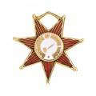

Continental Society Daughters of Indian Wars
CSDIW was organized in Atlanta, Georgia in 1988. Our organization is comprised of women who are citizens of either the United States of America, The Dominion of Canada, or Mexico, who are not less than sixteen years of age and is the lineal descendant of a Native American or Immigrant American ancestor who participated in any capacity, such as Passive Service, or in actual hostilities, one against the other, during the period May 14, 1607 to 1900.

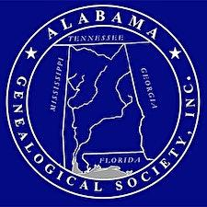
Alabama Genealogical Society
First Families of Alabama is a certificate program offered by the Alabama Genealogical Society to its members and is designed to identify and honor the memory of early residents of the state of Alabama. Early residents are those settlers who resided within the present boundaries of Alabama prior to statehood, 14 December 1819. Criteria for the certificate are:
- Membership* in Alabama Genealogical Society
- Completion of Application and Proof of Descent
- Attached copies of documented proof of descent for each generation
- A check for $20.00 for each certificate payable to Alabama Genealogical Society
The application and documentation is submitted to the First Families of Alabama Committee for verification of the information. Approved applications and documentation will be deposited in the Special Collection Department, Samford University Library, to help preserve the history of your ancestors and aid others in their research. This safe location prevents the possible loss of your valuable family research and preserves your lineage for easy retrieval by researchers. This program is one sure way to preserve your lineage as each member qualifying for the First Families of Alabama will receive a beautiful signed and numbered certificate, suitable for framing.
*Membership information can be found in the membership section

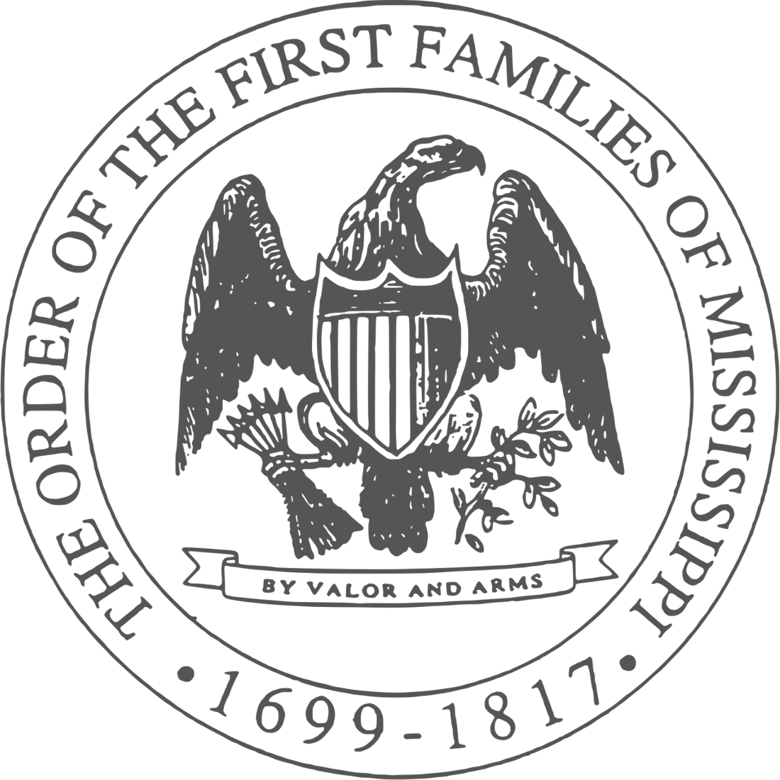
Order of the First Families of Mississippi
OFFM is committed to genealogical documentation, historical education, and recognition of the achievements of our state, not only from the colonial period of 1699 through 1817

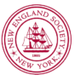
New England Society In The City Of New York
The New England Society in the City of New York (NES) is one of the oldest social and charitable organizations in the United States, and was founded in 1805 to promote "friendship, charity and mutual assistance" among and on behalf of New Englanders living in New York.
NES celebrates the New England spirit and heritage through its philanthropic outreach, social events and cultural activities. Our charitable focus is education. The NES Scholarship Program assists New York City students at New England colleges and universities. Another signature program is the annual New England Society Book Awards, which recognize books of merit that honor New England and its culture.

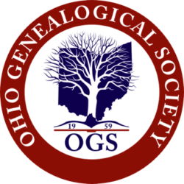
Military Order of the Daughters and Sons of Ohio
Any member of OGS who can prove satisfactory lineal descent from a resident of the State of Ohio who served in the armed forces of the United States or the British colonial forces of the original thirteen colonies prior to the American Revolutionary War, according to the Society’s rules and guidelines, is eligible to become a member of the Military Order of the Daughters and Sons of Ohio (MODSO).

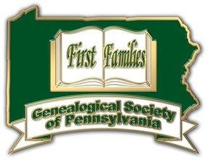
Genealogical Society of Pennsylvania
Colony and Commonwealth: 1638–1790

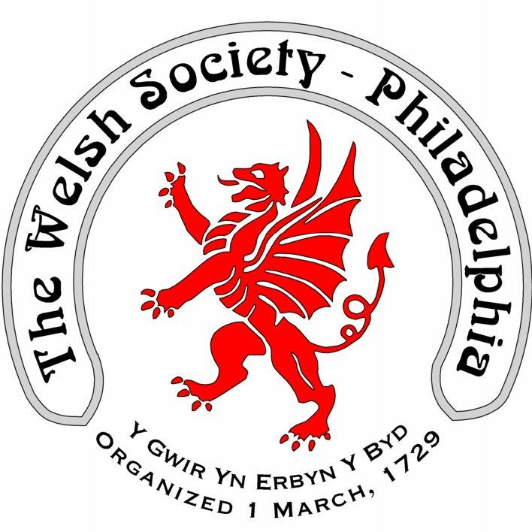
The Welsh Society of Philadelphia
The Welsh Society of Philadelphia has members that have a wide range of ages and interests. Everyone who shares our interest in keeping current with local Welsh American events is most welcome. Membership of the Welsh Society of Philadelphia provides the following opportunities:
A chance to participate in the historic and vibrant Welsh American community
Enjoy a variety of social and heritage events
Singing and community spirit at the Gymanfa Ganu
Receive notifications of upcoming events
Recognize outstanding Welsh Americans through the Robert Morris Award

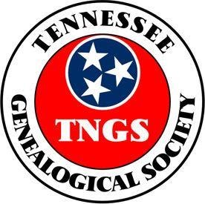
Tennessee Genealogical Society
Colonial -- prior to 1 June 1796

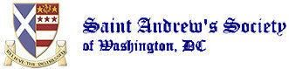
Kirkin’ O’ The Tartan
T he St. Andrew’s Society has conducted the Kirkin’ Service at the National Cathedral. Reserved seating in the National Cathedral is available for this service in reserved areas. Reservations are free to all Members and Guests and they may be obtained from the Society’s Sergeant-at-Arms and Kirkin’ Chairman David S. McKenzie. For seating , please e-mail the Chairman at caberman162@yahoo.com

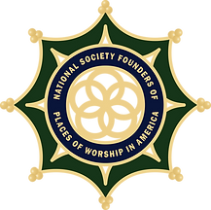
National Society Founders of Places of Worship in America
Membership is open to males and females of good moral character and reputation, at least eighteen years of age, who can prove lineal descent from a person who, in the timeframe prior to and including 1850 and within the territory that became the forty-eight contiguous states of the United States of America, contributed in one of the following categories:
A founding signer of a Covenant, doctrine, named in town minutes or referenced in historical documents as having met in faith or began a new house of worship in any faith.
Held membership within first year of founding or meeting.
Donated land or monies which were used to build a meeting place/building for worship.
Permitted property (land, home or building) to be used for the purposes of holding worship.
Circuit Rider and mobile Ministries, in which clergy traveled to more than one location to hold service.

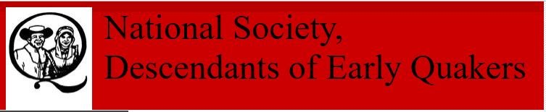
Early Quaker Descendants
Men, Women and children who establish descent, either lineal or collateral, from an early member of the Society of Friends (1835 or before), throughout the world, shall be eligible for membership. Junior members are eligible from birth to age 25 years.

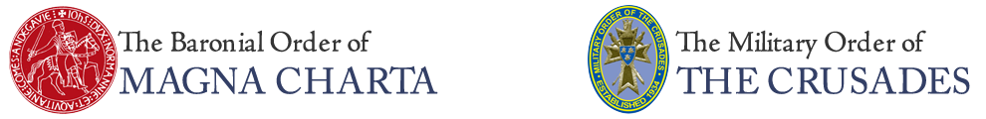
Magna Carta Barons
Magna Charta Barons, Crusaders and Templar Knights appears below. Note that many of these Gateway ancestors have approved lines that will lead to 1) Magna Carta Barons, 2) Crusaders and 3) Templar Knights. But not all Gateways listed have approved lines that will qualify for membership in all three Orders. New information is always welcome and the Order will be glad to add to this list if genealogical research proves it advisable. As always, the Order retains the right to accept or reject a line based on the most current genealogical research.

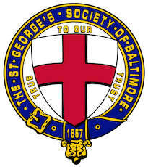

St. George's Society of Baltimore
The St. George's Society of Baltimore is a philanthropic and social organization founded in 1867 to afford relief and advice to the indigent natives of England and Wales and the British Colonies or to their wives, widows and children; and to promote social intercourse amongst its members. In recent years, through its 501(c)(3) Foundation, The St. George's Society of Baltimore has supported the Invictus Games Foundation, Help For Heroes, the Royal British Legion, and Prince's Trust USA, as well as providing hospitality to officers and ship's company of visiting Royal Navy ships. The Society also sponsors several events celebrating British culture and history annually to promote fellowship amongst its members and hospitality for their families, friends and guests.

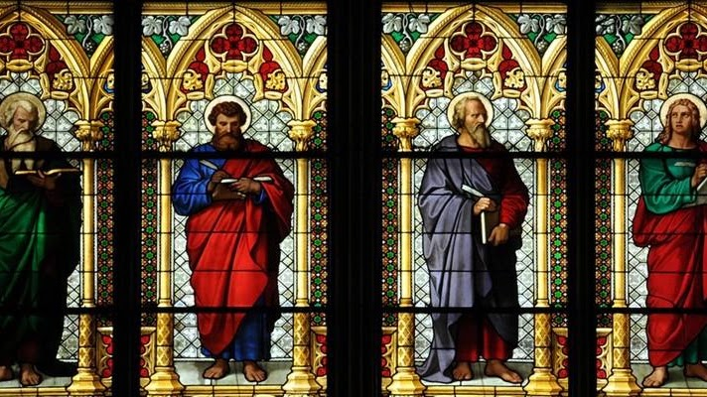
National Society of Saints
Welcome to the National Society of Saints and Sinners website. We are adding new information daily. Please check back with us often, as we enlarge our list of approved Saints. Our first Council meeting on 14 April 2011, was a tremendous success. Several items of import to our members were discussed and resolved. We extend a heartfelt thank you to our members for helping us make the Society an even greater pleasure to join.

Order of the Crown of Charlemagne
The Order of the Crown of Charlemagne was organized in the United States on January 1, 1939 and incorporated in the District of Columbia on October 10, 1939. It is an idependent patriotic and lineal society named in honor of the Emperor Charles the Great (742-814) and also named after an ancient noble and chivalric order in Europe which according to tradition was instituted by the Emperor in 802 to distinquish and honor his most valiant warriors who fought in the war against the heathen Saxons. Descendants of the Emperor have Maintained the order without great interruption through the centuries. The Order meets once a year in Washington, DC at a "black tie" dinner event the second Thursday of April.


Magna Carta Barons
Magna Charta Barons, Crusaders and Templar Knights appears below. Note that many of these Gateway ancestors have approved lines that will lead to 1) Magna Carta Barons, 2) Crusaders and 3) Templar Knights. But not all Gateways listed have approved lines that will qualify for membership in all three Orders. New information is always welcome and the Order will be glad to add to this list if genealogical research proves it advisable. As always, the Order retains the right to accept or reject a line based on the most current genealogical research.


St. Andrew's Society
Founded over 250 years ago, we are a fraternity of Scottish descendants from around the Nation’s Capital who celebrate our Scottish culture and heritage. Our mission to “Relieve the Distressed” is fulfilled through charitable works through the Washington Scots Charity & Education Fund.
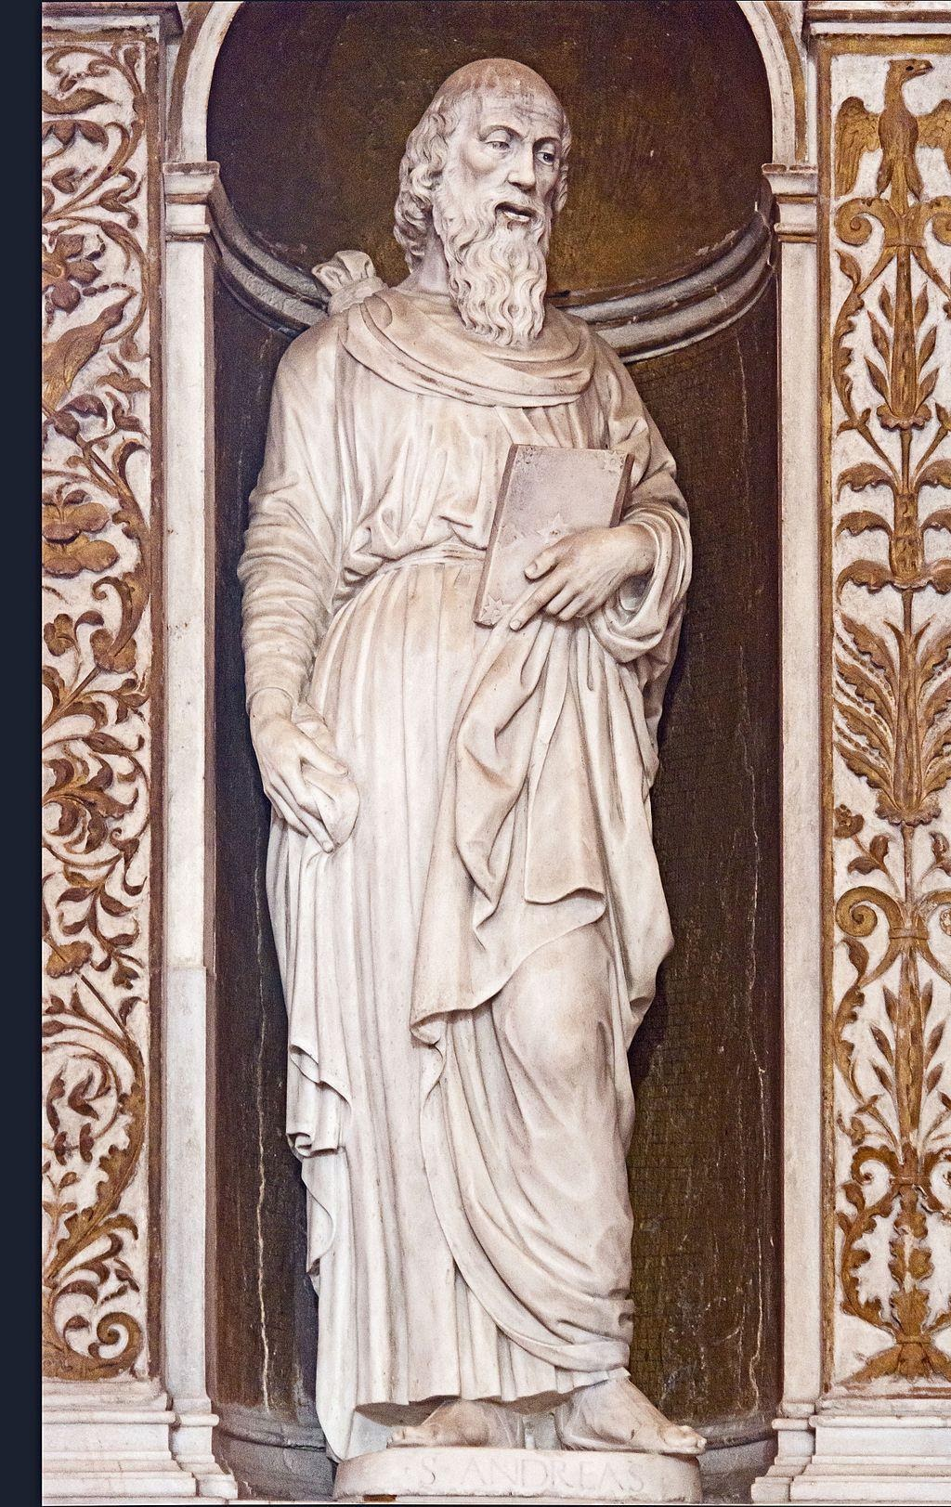
St Andrew's Socitieties
Wherever they’ve settled, Scots have taken with them the traits that their homeland is so well known for. Find out how the charitable institutions they set up all those years ago are helping spread Scotland’s values across the globe

Prairie Patriot Certificates are available for descendants of all wars. The Veteran must have served during the indicated war and lived, died, or was buried in Illinois. The applicant may be a direct descendant (through bloodline -- "child of a child") or an indirect descendant (through a sibling of the veteran) and must prove the relationship on the accompanying forms. Wars that are included in the project are: Revolutionary War

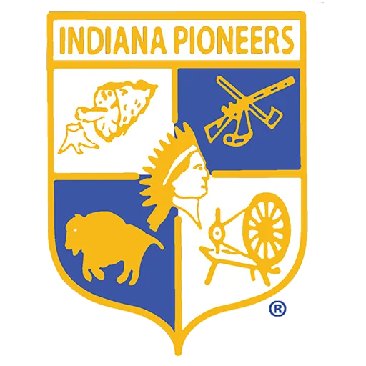
If you have a direct-line ancestor that resided in the State of Indiana by December of the eligibility year, then you may submit an application for membership in The Society of Indiana Pioneers.
The Society has a two-tiered eligibility map, shown below. Ancestors must have resided there not later than December 31, 1840.

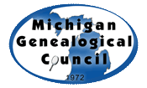
The Michigan Pre-Statehood and First Families certificates are offered by Michigan Genealogical Council as a way to honor our ancestors who settled the Great Lakes State. Recipients will receive either the Pre-Statehood or the First Families certificate, depending on the arrival date of their earliest Michigan (or Michigan territory) ancestor. Pre-Statehood before Jan. 26, 1837

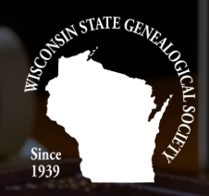

A Wisconsin Pioneer or Century Ancestors Certificate is awarded to applicants who submit evidence to prove direct descent, and that their ancestor settled in Wisconsin prior to 1851

