Famous Descendants

For a list of famous descendants of Charlemagne: https://famouskin.com/famous-kin-menu.php?name=4143+charlemagne

Order of the Crown of Charlemagne

Historical and genealogical research and to perpetuate the memory and to honor the name of Emperor Charlemagne; to bring into one group the descendants of his successors and heirs; to maintain and promote the traditions of chivalry and knighthood; to recognize acts of merit; to recognize achievements in the Arts, Sciences and Letters; to inspire patriotism and loyalty to our country; and for such other lawful and proper purposes as the Executive Council of the order may from time to time decide upon. To collect and preserve books on genealogy, family history, heraldry and general history. To collect and preserve documents, manuscripts, relics, records and traditions relating to Emperor Charlemagne and his successors; to create a popular interest in ancient history and genealogy. The Order is non-political and non-sectarian.
The Order meets once a year in Washington, DC at a "black tie" dinner event the second Thursday of April.

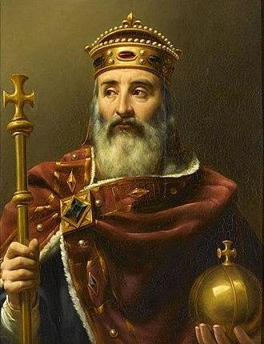

Feast Day

Charlemagne was revered as a saint in the Holy Roman Empire and some other locations after the twelfth century. The Apostolic See did not recognise his invalid canonisation by Antipope Paschal III, done to gain the favour of Frederick Barbarossa in 1165. The Apostolic See annulled all of Paschal's ordinances at the Third Lateran Council in 1179. He is not enumerated among the 28 saints named "Charles" in the Roman Martyrology. His beatification has been acknowledged as cultus confirmed and is celebrated on 28 January.

"Hail, o Charles, beloved of God, Apostle of Christ, defender of His Church, protector of justice, guardian of good customs, terror of the enemies of the Christian name!
"The tainted diadem of the Caesars - purified by the hands of Leo - sits on your august forehead; the globe of the Empire rests in your vigorous hand; the ever-victorious sword in your combats for Our Lord is sheathed at your waist, and on your forehead the imperial anointing was added to the royal unction by the hand of the Pontiff who consecrated you and confirmed your authority. As the representative of the figure of Christ in His temporal Royalty, you desired that He would reign in you and through you.
"Now God rewards you for the love you had for Him, for the zeal you displayed for His glory, for the respect and confidence you showed toward His Spouse. In exchange for an earthly kingship, transitory and uncertain, you enjoy now an immortal kingdom where so many million of souls, who by your hands escaped idolatry, today honor you as the instrument of their salvation.
"During the days of celebration of the birth of Our Lord by Our Lady, you offered to them the gracious temple you built in their honor (the Basilica of Aix-la-Chapelle), and which is still today the object of our admiration. It was in this place that your pious hands placed the newborn garment worn by her Divine Son. As retribution, the Son of God desired that your bones should gloriously rest in the same place to receive the testimony of the veneration of the peoples.
"O glorious heir to the three Magi Kings of the East, present our souls before the One who wore such a humble garment. Ask Him to give us a part of the profound humility you had as you knelt before the Manger, a part of that great joy that filled your heart at Christmas, a part of that fiery zeal that made you realize so many works for the glory of the Infant Christ, and a part of that great strength that never abandoned you in your conquests for His Kingdom.
"O mighty Emperor, you who of old was the arbiter of the whole European family assembled under your scepter, have mercy on this society that today is being destroyed in all its parts. After more than a thousand years, the Empire that the Church placed in your hands has collapsed as a chastisement for its infidelity to the Church that founded it. The nations still remain, troubled and afflicted. Only the Church can return life to them through the Faith; only she continues to be the depositary of public law; only she can govern the powerful and bless the obedient.
"O Charles the Great, we beseech you to make that day arrive soon when society, re-established at its foundations, will cease asking liberty and order from the revolutions. Protect with a special love France, the most splendid flower of your magnificent crown. Show that you are always her king and father. Put an end to the false progress of the faithless empires of the North that have fallen into schism and heresy, and do not permit the peoples of the Holy Empire to fall prisoner to them."

