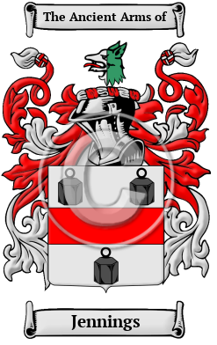

Jennings

The history of the name Jennings began when it was derived from The name Jennings is derived from the personal name John, or perhaps more accurately from several diminutions of the name John, such as Jan, Jon, or Jen. The name has been spelled Jennings, Jenings, Jennins, Jennyns, Jennens, Jennynge, Jennynges, Jenyns and many more.
In the United States, the name Jennings is the 274th most popular surname with an estimated 96,993 people with that name

