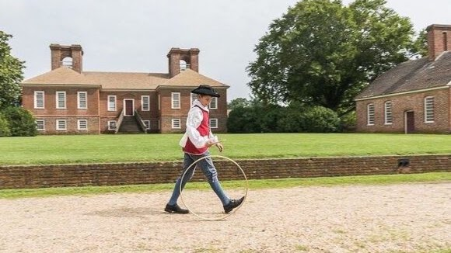

Stratford Hall & Grounds
This is the Lee Manor and 2 Signers of the Declaration of Independence. Explore the Great House, garden, grounds, Visitor Center exhibit: Stratford at the Crossroads, & the Gift Shop. Enjoy $4 admission, 18th-century colonial games, outdoor yard games, and a summer craft-making activity. Explore the historic grounds, nature trails, and Potomac River beachfront and tour the Great House with one of our five self-guided audio tours. Live music in the Great Hall from 12 – 3 pm. National Historic Landmark #66000851
483 Great House Rd, Stratford Hall, VA, United States, 22558
(804) 493-8038

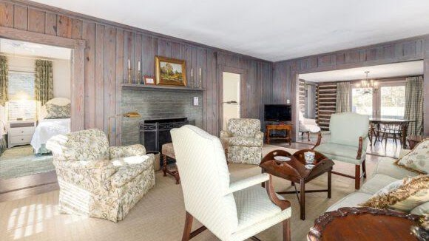
Cabins at Stratford Hall
Nestled in the woods between the Great House and the Potomac River, Stratford Hall’s rustic and comfortable lodging provides a unique opportunity to stay on the property of one of the great historic houses in America.
Phone reservations are taken daily 9 a.m. to 5 p.m. Rooms are available to book online 24 hours a day. All rooms are non-smoking. During festival weekends in May & September, we require a two-night weekend. We offer a special discount of 10% off standard lodging rates for military & veterans, AAA members. To inquire about availability, please call (804) 493 – 1967 or email reservations@stratfordhall.org. Our Reservations department is available daily 9 a.m. to 5 p.m. Please call by 2 p.m. for same day reservations.

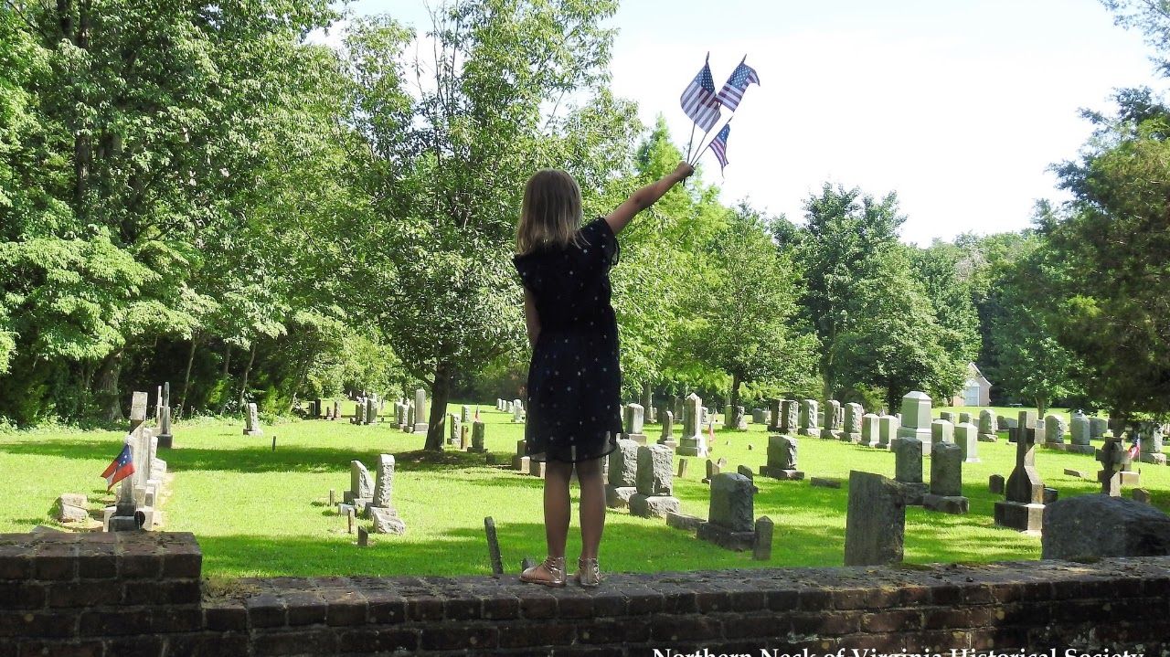
Burnt House Field
4 July 8:15 AM
The Northern Neck of Virginia Historical Society and Cople Episcopal Parish invite you their annual Independence Day Celebration. This event is supported by the James Monroe Chapter, Sons of the American Revolution.

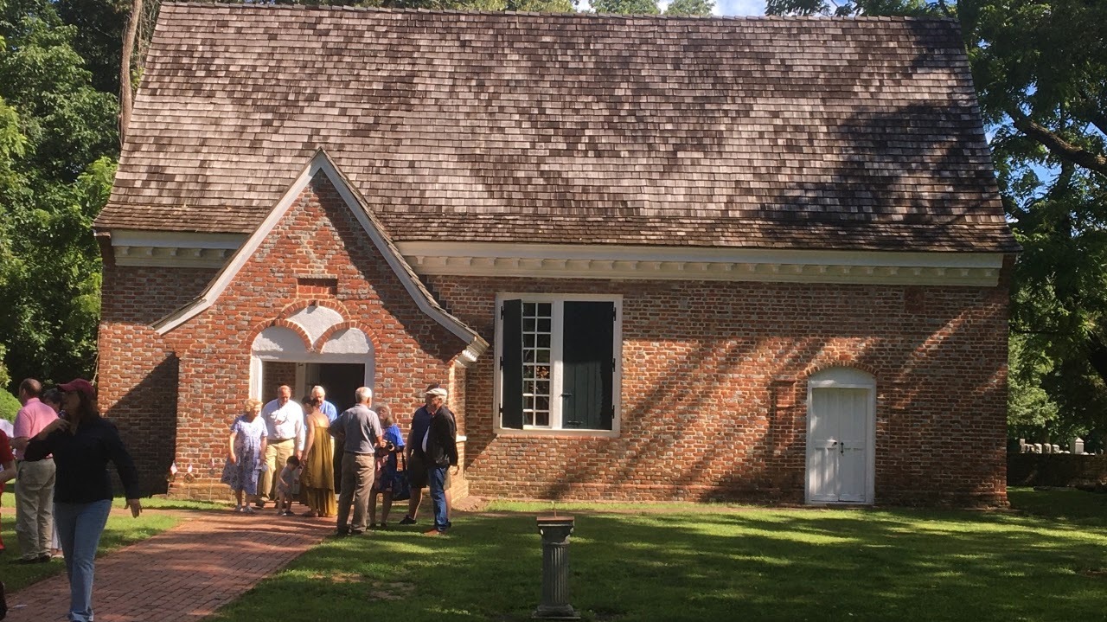
Yeocomico Church
4 July 9:00 AM Patriotic Service
Richard Henry Lee and his father, Thomas, both served on the Cople Parish Vestry in the 18th century. This is also where George Washington was Christened by Col. George Eskridge. This Independence Day service will be filled with related messages and the singing of our favorite national hymns. This Family Friendly Event Is Open To The Public And Admission Is Free.
1219 Old Yeocomico Rd, Kinsale, VA 22488
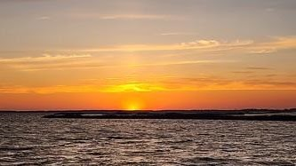
Westmoreland State Park
Sunset Kayak Paddle Tour
Extra fee: The cost is $20 for a solo kayak and $25 for a tandem kayak..
Children welcome: Yes.
Phone: 804-493-8821
Email Address: westmoreland@dcr.virginia.gov
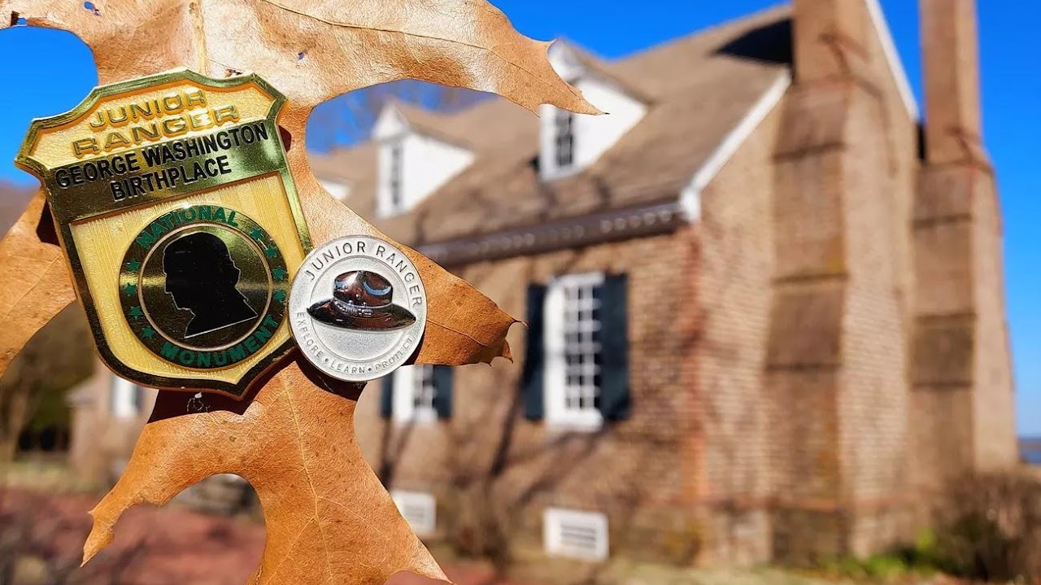
George Washington Birthplace
National Monument
Tour George Washington Birthplace and become a Junior Ranger. Junior Ranger activity booklets are free and available upon request at the park visitor center. After completing the booklet, Junior Rangers receive a special badge to mark their accomplishment. Can't make it to George Washington Birthplace National Monument? Not a problem. Contact us to request a digital copy for you to print at home.
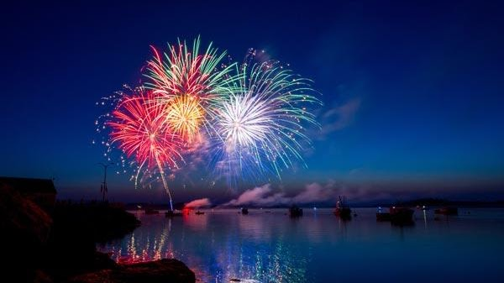
Colonial Beach
Restaurants & Casino

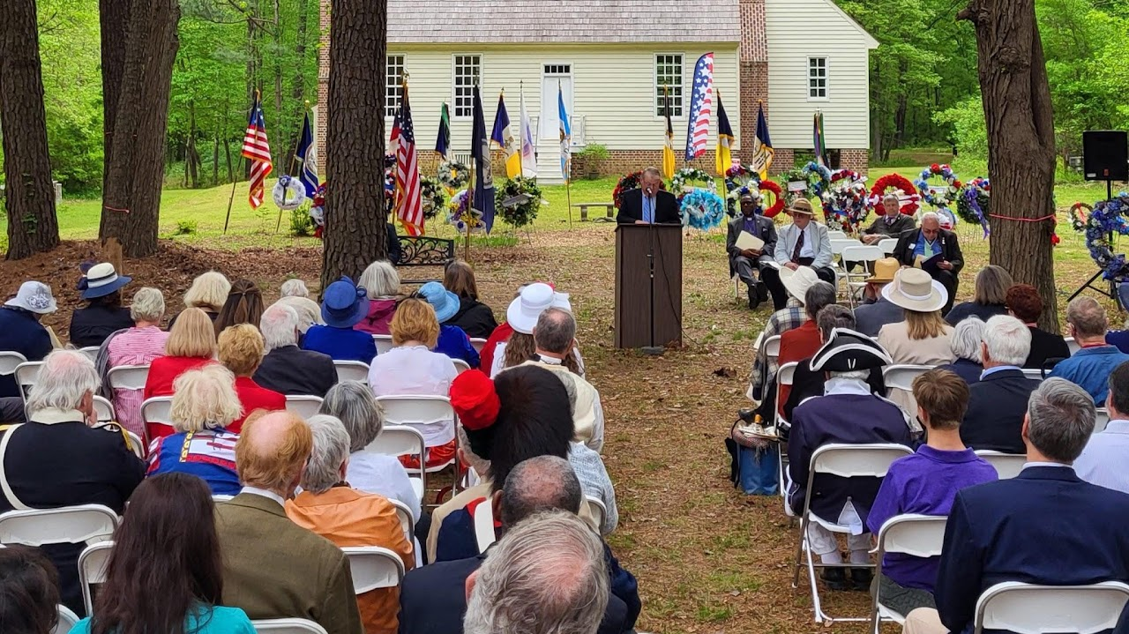
James Monroe Birthplace
The James Monroe Birthplace Park & Museum is a +70-year project of the James Monroe Memorial Foundation, which was established by the descendants of President James Monroe. Through the charitable contributions and generous donations of everyday people both here and abroad, we are now beginning to see the culmination of this project with the establishment of the Visitors Center and the completion of the Birthplace Home with the park's various activity trails.

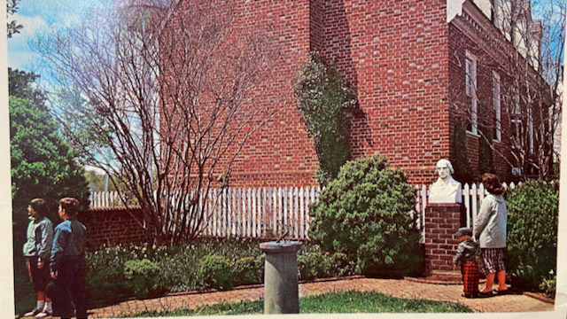
Westmoreland County Museum
The Presidents Garden contains marble busts of George Washington, James Monroe, and James Madison (all born in the Norhtern Neck), plus a sundial in the center with the names of all eight president’s born in Virginia. The marble busts are the work of sculptor, Attilio Piccirilli.
Mondays-Saturdays 10:00am – 4:00pm
15880 Kings Hwy Montross, VA 22520
Email: wcmuseum@verizon.net Phone: (804) 493-3133
Download and fill out our research request form here.

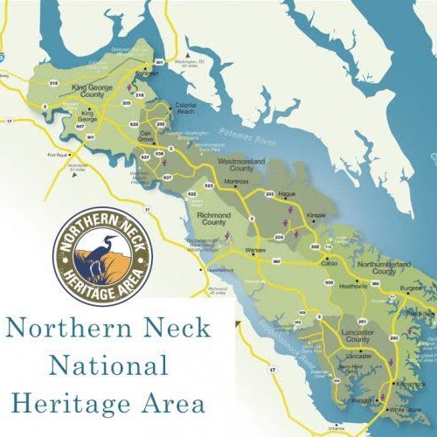

Northern Neck
This peninsula nestled between the Potomac and the Rappahannock Rivers and spilling into the Chesapeake Bay was part of the enormous 1649 land grant by Charles II, known as the Fairfax Grant. The bountiful waters of the Potomac and Rappahannock Rivers, and the Chesapeake Bay supported and induced English settlement. The English built stately homes and farmed tobacco for export to England, which became the basis of the Northern Neck’s economy during the Colonial era. The Northern Neck’s most famous son, George Washington, born on Pope’s Creek off the Potomac River, called the region “the Garden of Virginia.” Our nation’s fifth president, James Monroe, was born in Westmoreland County in 1758.
The Lee family of Virginia called the Northern Neck home and built Stratford Hall in the 1730s, of bricks fired from the clay soil on the premises. A son of Thomas Lee, Richard Henry Lee, co-wrote the Westmoreland Resolves, which proposed American independence in 1766 in protest against the Stamp Act. Richard Henry Lee and his brother Francis Lightfoot Lee were the only two brothers to sign the Declaration of Independence. The last Lee to survive to maturity, Robert E. Lee, was born at Stratford Hall in 1807.
Kid Friendly Activities
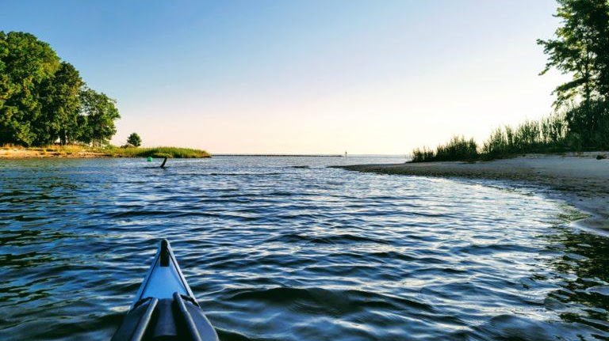
Bonum Creek Landing
this creek has a water trail that offers protected paddling, suitable for beginners (just avoid winds out of the north, which can make this creek a little wavy). Bonum Creek Landing is located right next to a working waterfront, so as soon as you launch, you get a feel for that true Chesapeake watermen’s culture. If you head up the creek, there are some long stretches of undeveloped shorelines that are perfect for some wildlife viewing. Osprey, bald eagles, and great blue herons are frequent sightings.
1336 State Rte 763, Kinsale, VA 22488

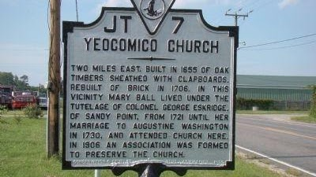
Yeocomico Church Marker
Two miles east. Built in 1655 of oak timbers sheathed with clapboards. Rebuilt of brick in 1706. In this vicinity Mary Ball lived under the tutelage of Colonel George Eskridge, of Sandy Point, from 1721 until her marriage to Augustine Washington in 1730, and attended church here. In 1906 an association was formed to preserve the church.
map

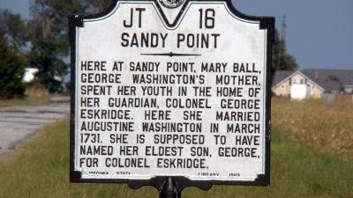
Sandy Point Marker
Here at Sandy Point, Mary Ball, George Washington’s mother, spent her youth in the home of her guardian, Colonel George Eskridge. Here she married Augustine Washington in March 1731. She is supposed to have named her eldest son, George, for Colonel Eskridge.
map
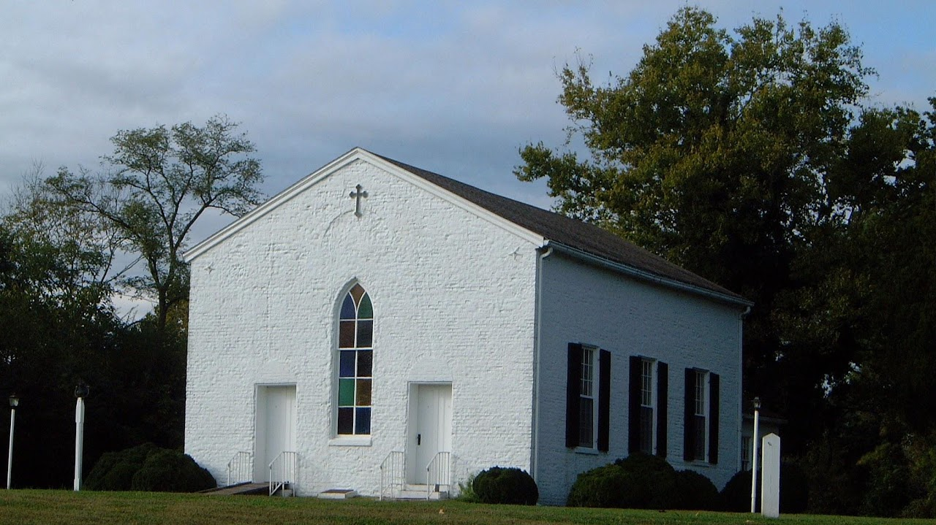
Nomini Episcopal Church
One of the two churches of the Cople Parish. It was built in 1704 on land given by Youell Watkins, and was replaced in 1755 by a brick church at the same site. George Washington attended services here twice in 1768. This was the last colonial church burned (1814) by the British Admiral Cockburn, who carried off the church silver during his pillaging-expedition on the Potomac and its tributaries. The present building was erected about 1652. The first Nominy Church of 1655 stood on the north side of the river opposite of this place.
Worship at Nomini Church
Fifth Sundays Starting at 10 am

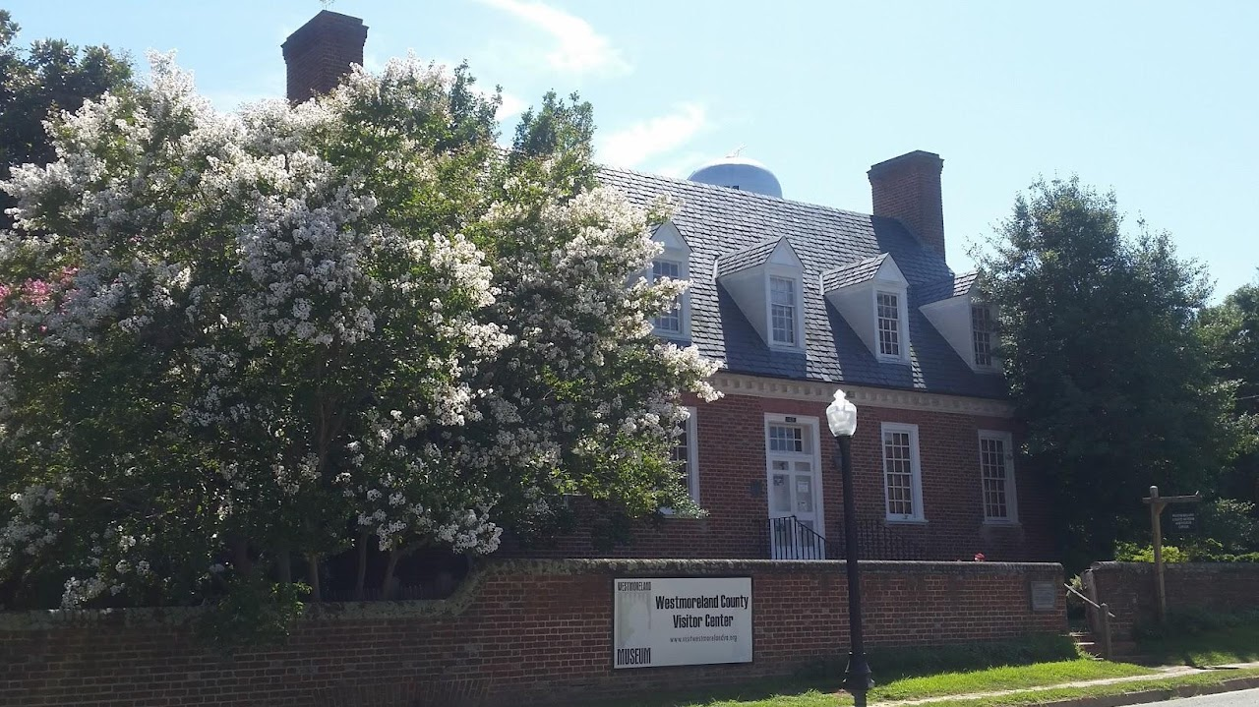
Westmoreland County Museum
Westmoreland County, Virginia is ancestral home of three of our nations first five presidents – George Washington, James Monroe and James Madison. The only two brothers to sign the Declaration of Independence- Richard Henry and Francis Lightfoot Lee were also Westmoreland County residents. The County is also the location of Nomini Hall, where Robert Carter III voluntarily freed nearly 500 of his enslaved people, beginning in 1791.
15803 Kings Hwy Montross, VA 22520
Courthouse: (804) 493-3133
Museum: (804) 493-8440
Merchantile: (804) 493-3018

Northern Neck Driving Tour

Resources
Wikitree
The Library & Genealogical Center | Westmoreland County Museum | Montross Virginia
Westmoreland County, Virginia Genealogy • FamilySearch
News | Westmoreland County Government (westmoreland-county.org)
Westmoreland County, Virginia - Wikipedia
History & Genealogy | Central Rappahannock Regional Library (librarypoint.org)

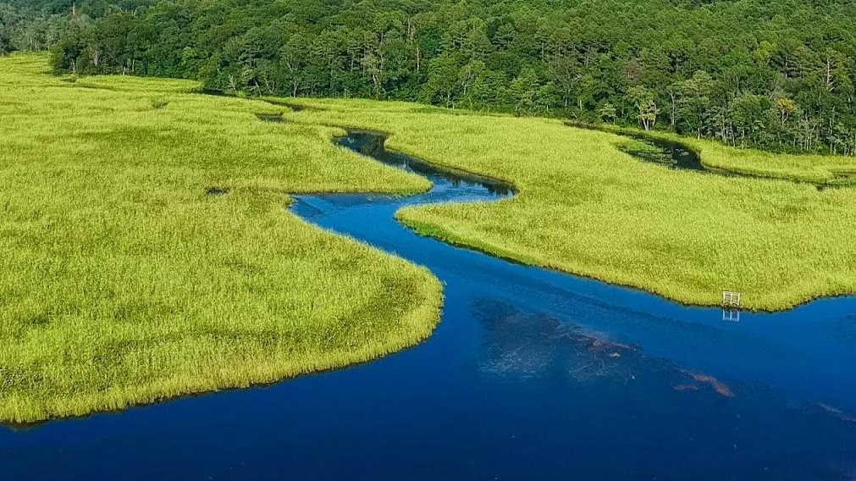

Rappahannock River Valley National Wildlife Refuge
(804) 333-1470
336 Wilna Road Warsaw, VA 22572-2961

