Resources
Frederick County, Maryland Genealogy • FamilySearch
Frederick County, Maryland - Wikipedia
Frederick County Genealogical Society - Surname Research
Map

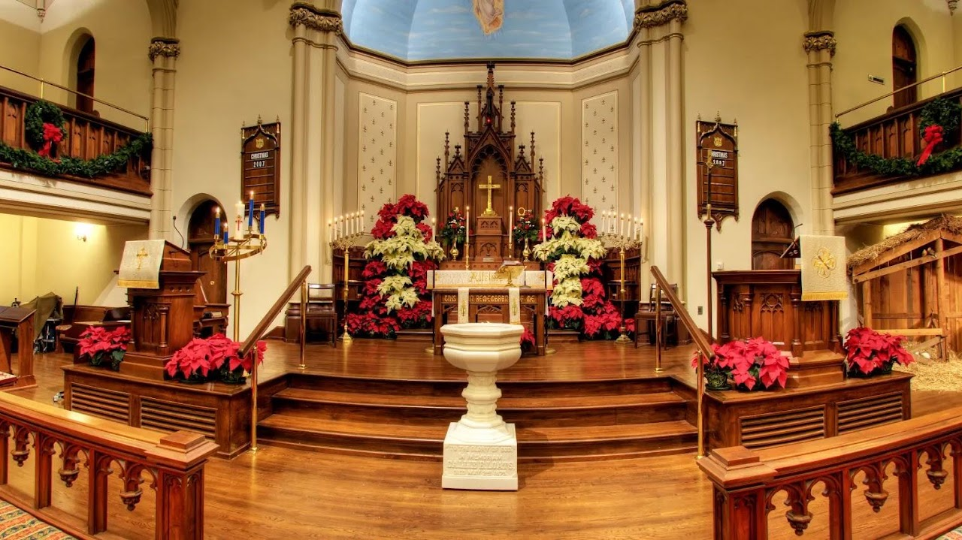

Candlelight Tour of Historic Houses of Worship
4:00 PM
❖ Organ, Piano, and Harp (4–4:30PM) All Saints’ Episcopal Church
❖ Nancy Beith, Piano with Gail Slezak, Piano (4–4:30PM) Frederick Presbyterian Church
❖ Terry Sparks studio recital; Concordia a capella choir (4–5PM) Grace United Church of Christ
❖ Evangelical Bells (4–5PM) Evangelical Lutheran Church
❖ Tri State Harp Ensemble led by Sally Lay (4–6PM) Calvary United Methodist Church

4:30 PM
❖ David Duree, Clarinet and Paulela Burchill, Flute (4:30–5PM) Frederick Presbyterian Church
❖ Carol Sing-Along (4:30–5PM) All Saints’ Episcopal Church

5:00 PM
❖ Maryland Talent Education String Program (5–5:30PM) All Saints’ Episcopal Church
❖ Janice Jackson, Soprano (5–5:30PM) Frederick Presbyterian Church
❖ One God ~ One Voice Choir (5–6PM) Grace United Church of Christ
❖ The Praise Ensemble (5–6PM) Evangelical Lutheran Church

5:30 PM
❖ Jonathan Kurtz, Jazz Piano (5:30–6PM) Frederick Presbyterian Church
❖ All Saints Handbell Choir (5:30–6PM) All Saints’ Episcopal Church

6:00 PM
❖ All Saints Adult Choir (6–6:30PM) All Saints’ Episcopal Church
❖ Spires Brass Quintet (6–6:30PM) Frederick Presbyterian Church
❖ Peal Bells Ringing and Demonstration led by Quilla Roth (6–7PM) Calvary United Methodist Church
❖ Choir of Evangelical Lutheran (6–7PM) Evangelical Lutheran Church
❖ Nathan Strite, Organ (6–7PM) Grace United Church of Christ

6:30 PM
❖ Cambria Van de Vaarst, Harp (6:30–7PM) All Saints’ Episcopal Church
❖ Nancy Beith, Piano (6:30–7PM) Frederick Presbyterian Church
❖ One God One Voice Choir (6:30–7:15PM) Centennial Memorial United Methodist Church

7:00 PM
❖ Janice Jackson, Soprano (7–7:30PM) Frederick Presbyterian Church
❖ All Saints Handbell Choir (7–7:30PM) All Saints’ Episcopal Church
❖ Trinity Brass Ensemble (7–8PM) Calvary United Methodist Church
❖ Justin Furnia, Piano (7–8PM) Grace United Church of Christ
❖ Frederick Flute Choir (7–8PM) Evangelical Lutheran Church

7:15 PM
❖ Christmas Music (7:15–7:45PM) Centennial Memorial United Methodist Church

7:30 PM
❖ All Saints Adult Choir (7:30–8PM) All Saints’ Episcopal Church
❖ Spires Brass Quintet (7:30–8PM) Frederick Presbyterian Church

7:45 PM
❖ Catoctones, seasonal Christmas repertoire followed by Christmas Carol Sing-a-Long (7:45–8:30PM) Centennial Memorial United Methodist Church

8:00 PM
❖ Lisa Jarosinski, Soprano (8–8:30PM) Frederick Presbyterian Church
❖ Organ, Piano, and Harp (8–8:30PM) All Saints’ Episcopal Church
❖ Seasonal Organ and Piano music played by Dr. Adela Peeva (8–9PM) Calvary United Methodist Church
❖ Singing Christmas Carols (8–9PM) Grace United Church of Christ
❖ Daniel Catalano, Pipe Organ Carol Sing-Along (8–9PM) Evangelical Lutheran Church

8:30 PM
❖ Bobby Staples, Organ with Dr. Avery Pettigrew, French Horn (8:30–9PM) Frederick Presbyterian Church
❖ Carol Sing-Along (8:30–9PM) All Saints’ Episcopal Church

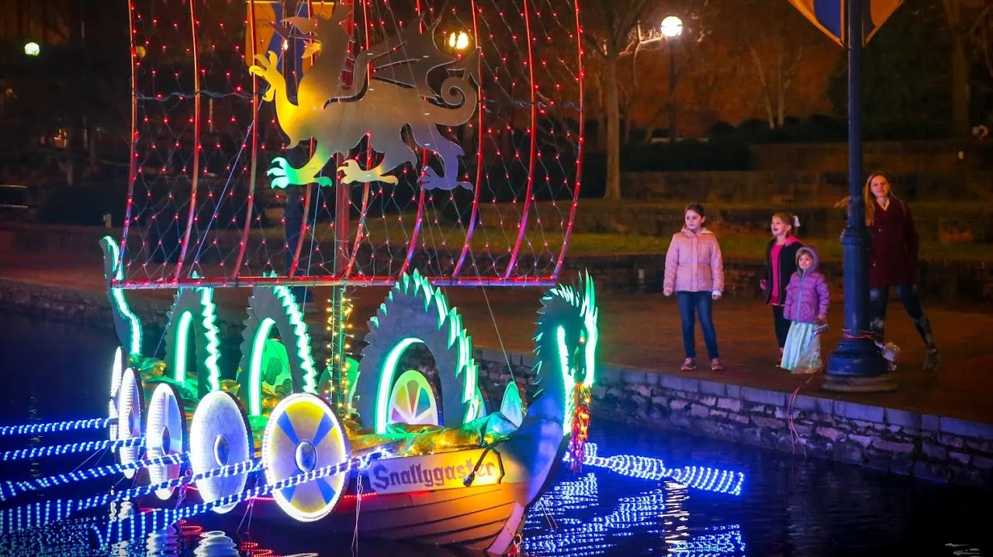

Sailing Through The Winter Solstice
Sailing Through the Winter Solstice display will take place from November to March.
You can view the boats anytime day or night. In fact, you may want to take a look while it's light out and again after it gets dark and the lights come on. Lights typically turn on at sunset, so this is a great time to see them both ways.

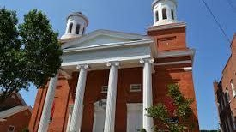

Evangelical Reformed UCC
The beloved Candlelight Tour of Historic Houses of Worship returns this holiday season in Downtown Frederick. This special open house celebrates Frederick’s tradition of religious diversity, local history, and the holiday season on Tuesday, December 26, 2023 from 4PM-9PM. This is Frederick's most popular church tour and is a great opportunity to step inside some of its most beautiful buildings.
15 W. Church St. Frederick, MD 21701 301-662-2762
Sundays, 10:30 – 11:30 a.m.
On all Sundays except the first Sunday of each month when all are invited to participate in the Sacrament of Communion, children aged 5 – 5th grade may go to Junior Church after the Thought for the Day during the worship service. Junior Church, a space to join in creative spiritual formation activities.

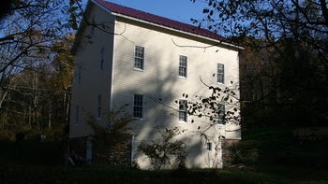

Hyattstown Mill
The mill at Hyattstown was built in 1798. At the time of the town's founding,the miller was George Wolfe, Sr., who had taken over the mill when William Richards died, Mr. Wolfe purchased the mill site in 1807 and sold the property to Benjamin Waters and Frederick Baker for $5,000. In 1814, Baker operated the mill until 1872 when he sold it to Ortho Norris and wife, Sarah. They sold the property to William Farrer, who made substantial improvements to the mill over the next five years. It was a two-run flour mill and sawmill, with one employee and an output of 6,000 bushels of meal and 35,000 feet of lumber annually, valued at $4,125.00
14920 Hyattstown Mill Rd, Hyattstown, MD 20871 · (301) 830-1142
The Mill Gallery is normally open weekends from 10:00 to 4:00 and other times by appointment.

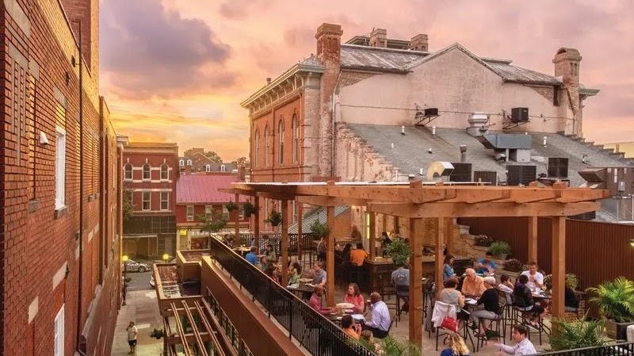

Brewer's Alley Restaurant
Frederick County's original brewpub. Contemporary American regional cuisine and wood-fired pizza oven complement fresh beer brewed on premises along with other craft beer. Brewer’s Alley’s location at 124 North Market Street is steeped in Frederick history. The first residents of Frederick held a lottery to raise money to build a town hall and market house on this location in 1765, which was completed in 1769. This structure served its purpose for over 100 years and was witness to the birth of Frederick as a city. The Market House spanned the Civil War, including the ransoming of the city by Confederate General Jubal Early. Also, remembered as the old Frederick Opera House, this building hosted speeches by presidents and presidential candidates. Reservations.

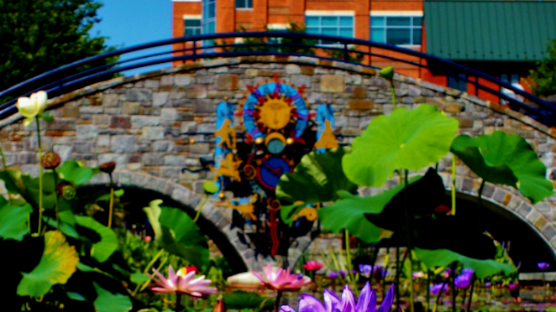

Church Street Garage
17 E Church St, Frederick, MD 21701

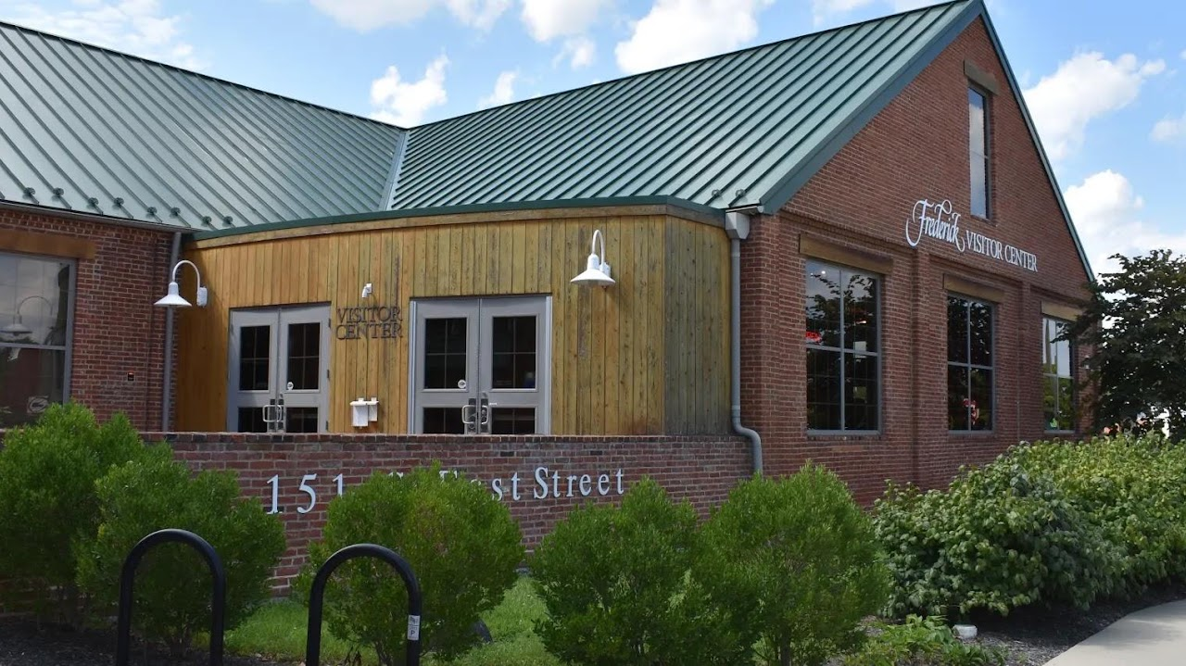

Visitor Center
151 S East St. Frederick, MD I 301-600-4047
The Visitor Center is the perfect place to begin your trip to Frederick! Housed in a beautifully renovated circa-1899 industrial warehouse, the visitor center holds 2,200-square-feet of interpretive exhibits. A state-of-the-art theater features an introductory film about Frederick. A wide variety of maps, guides and information on regional attractions and events are available.

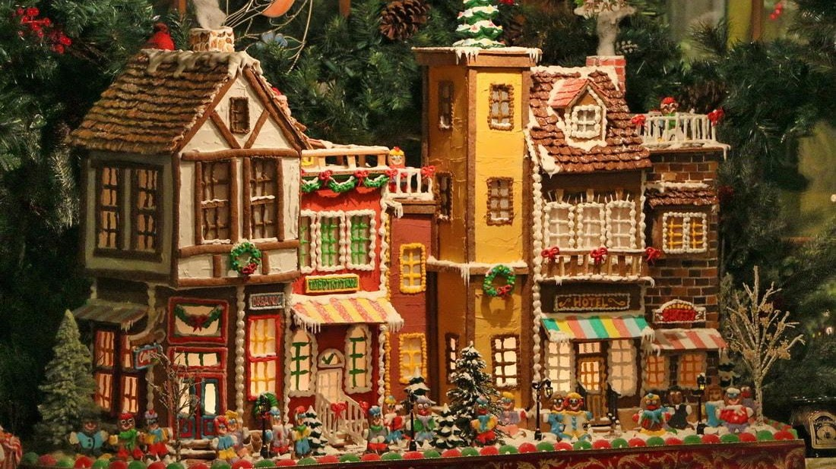

Gladchuk Brothers
Open Tuesday - Saturday only for lunch and dinner
Our ingredients are the freshest and seasonal. Menus change so check back with us often. We bake daily, and all of our meals are prepared to order. Soups, sauces, and desserts are all in house made.
(301)662-7750.
489 West Patrick St., Frederick, Maryland 21701

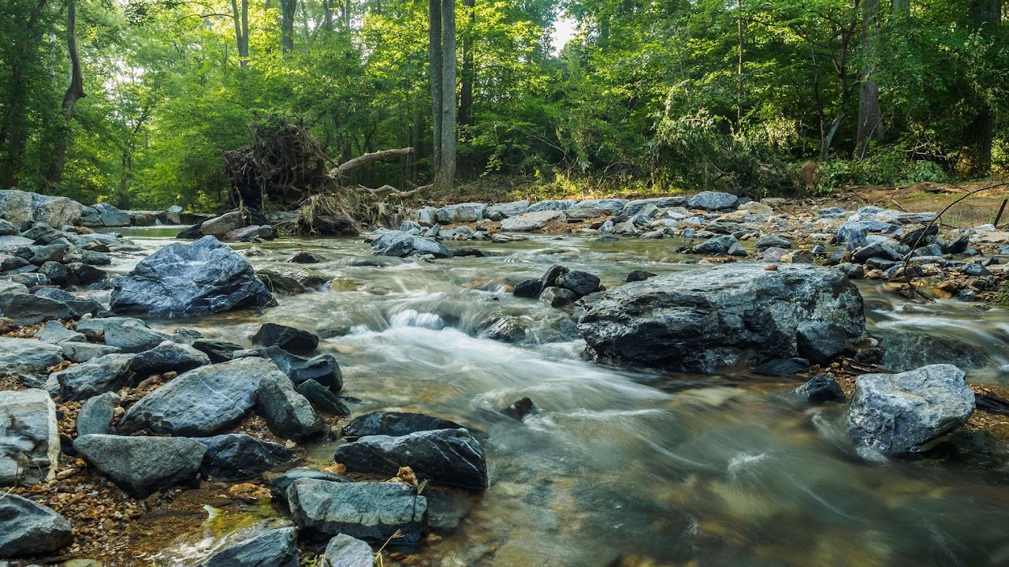

Little Bennett Regional Park
The 3700 acres that is Little Bennett Regional Park used to be agricultural and mercantile land. The park landscape contains natural and built features and clues to former communities of people and occupations whose histories tell a story. As early as the 18th century, the Little Bennett Valley was the scene of agriculture and small-scale industries capitalizing on the region’s abundant resources of timber, water, vegetation and vast acreage for farming. Like all of Montgomery County, Little Bennett land included plantations and industries that used forced chattel slave labor as the economic engine of their success. Several grist mills, a sumac mill, a sawmill, a saw and bone mill, and a whisky manufactory were established at various times along the Little Bennett Creek. Only the Hyattstown Mill remains as testimony to those early enterprises. The valley’s steep and rocky slopes were not particularly encouraging as a soil type for farming, but tobacco was cultivated in this area much later than other areas of the county, even into the 20th century, when most of the county had shifted to grains. Around the close of the 19th century, a small rural community was established in the valley. It was named Kingsley after the King Family, who were prominent in the area, and was colloquially known as Froggy Hollow. The last remaining vestige of that settlement is a one-room schoolhouse now open to the public on a limited basis.



Bushwaller's Irish Pub
Monday- Thursday 11:30 am - 2:00 am
Friday - Sunday 11:00 am - 2:00 am
Sunday Brunch until 3pm
Due to our limited dining room seating we are a First Come First Serve Restaurant, we do not take reservations for parties under 6.

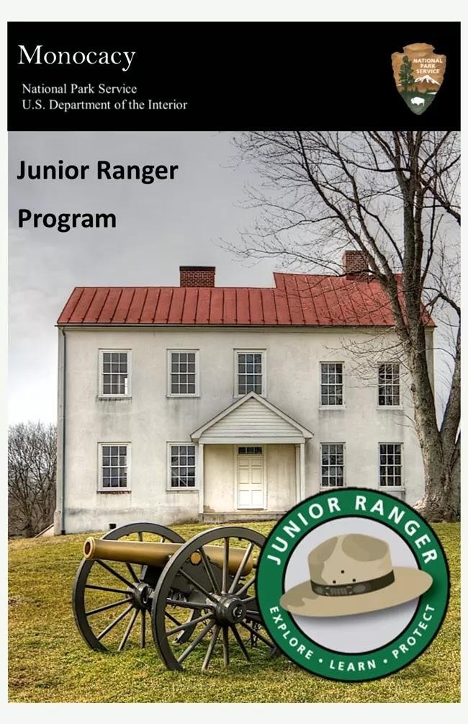

Monocacy National Battlefield
5201 Urbana Pike Frederick, MD 21704
The Visitor Center hours are 9:00 a.m. - 5:00 p.m., seven days a week. The Visitor Center is closed on Thanksgiving Day, Christmas Day, and New Year's Day.
For additional information, the Visitor Center staff can be reached at 301-662-3515.
This site is fee-free year-round. No entrance fee or pass is required.

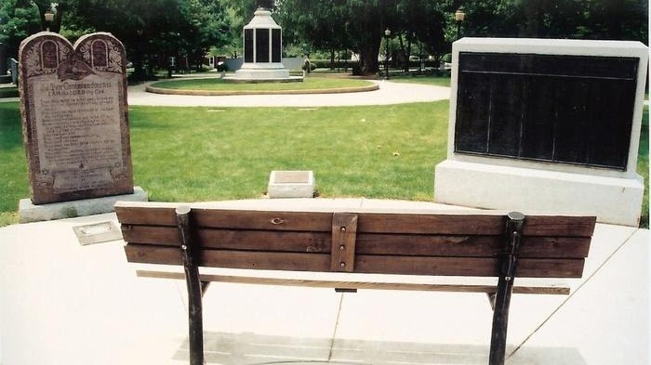

Evangelical Reformed Cemetery
The Evangelical Reformed Church and Cemetery were (abandoned) in 1924. A bronze plaque was erected to establish the burials of the earliest settlers in Frederick. No stones exist today and many of these internments were originally at the Trinity Chapel (abandoned). The plaque in Memorial Grounds Park has been able to add 366 inscriptions from the two cemeteries. There are 30 more names recorded on a plaque at the Trinity Chapel cemetery. Now the present site of the Memorial Grounds Park,
210 North Bentz St. Frederick, Frederick County, MD.

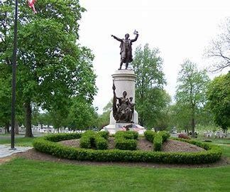

Francis Scott Key Monument
Inside the entrance to Mt. Olivet Cemetery is the Francis Scott Key monument. The author of “The Star-Spangled Banner” in 1814 which became our national anthem in 1931, Key was born in 1779 in Frederick County. In 1800 he established his first law office in Frederick. Key died in Baltimore at age 63 in 1843. After the Civil War, his body was reinterred here to Mt. Olivet Cemetery. In the 1890s, money was raised to build a monument to Key and in 1898 this monument and statue, sculpted by Italian artist Pompeo Copini, was dedicated. Key, his wife, and one of their children are buried under this monument and grave. A brochure near the cemetery’s restrooms is available to guide you through the rest of the cemetery.
515 S. Market St. Frederick, MD 21701

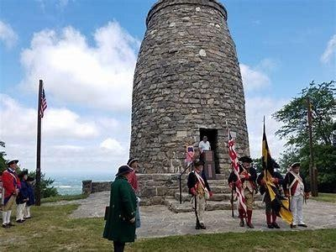

Washington Monument State Park
Contact: 301-791-4767
6620 Zittlestown Road Middletown MD 21769
Hours: 8 a.m. to Sunset (April to October) & 10 a.m. to Sunset (November to March)
Located atop South Mountain, Washington Monument State Park is named for the first completed monument dedicated to the memory of George Washington. The Washington Monument is a rugged stone tower that was initially erected by the citizens of Boonsboro in 1827. The monument makes it an ideal site for spotting migratory birds such as hawks, eagles and falcons, especially in mid-September. The main office for South Mountain State Battlefield is located in Washington Monument State Park. Stop by the park office or museum to learn more about the first major Civil War battle fought in Maryland. The main parking area, picnic pavilion and museum are accessible to the mobility impaired. The comfort station, however, is not.

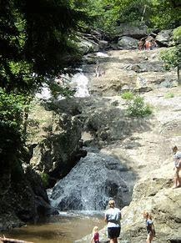

Cunningham Falls State Park
The Cunningham Falls State Park is renowned for McAfee Falls, a 78-foot cascading waterfall that is considered the largest in the State of Maryland. Visitors are allowed to set up camp in the pre-approved campgrounds that oversee the beautiful waterfalls at a distance. Fall asleep to the sound of rushing water and the great nature ambiance surrounding you. Reservations​
Contact: 301-271-7574​
Email Cunningham Falls
14039 Catoctin Hollow Road Thurmont, MD 21788
Hours: ​8 a.m. to Sunset, April-October
10 a.m. to Sunset, November-March​

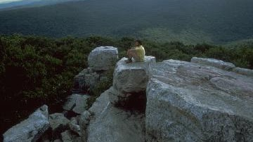

Catoctine Mountain National Park
Nestled within the mountains of Western Maryland, Catoctin Mountain Park is one of more than 420 national park units in the nation. Whether you are a first-time visitor or come often, below is information you will need to know.. Adventure awaits at Catoctin Mountain Park! Nestled in the Blue Ridge Mountains, this park is the perfect getaway. Hike a trail, enjoy an epic view, and sleep under the stars. This site is fee-free year-round. No entrance fee or pass is required.
14707 Park Central Road Thurmont, MD 21788

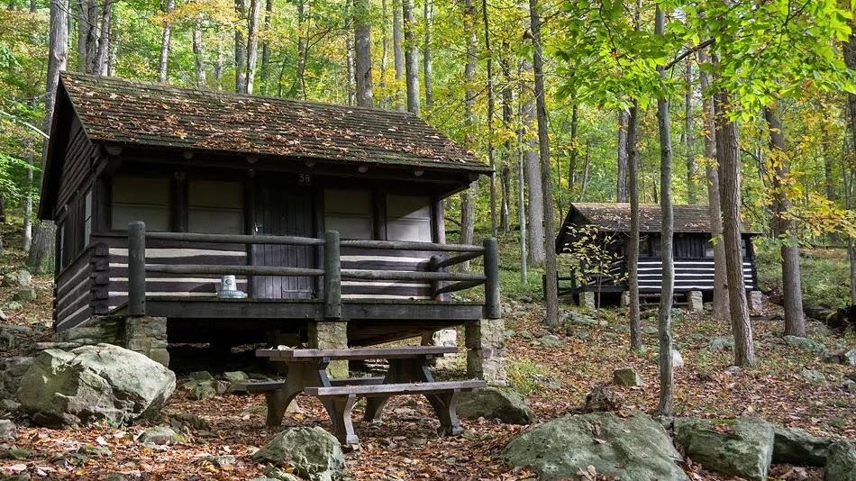

Camp Misty Mount
The cabins at Camp Misty Mount sleep 4-6 people, with a few larger lodges for families and small groups.
Cabin 16, Loop: Middle CABIN ELECTRIC 6 people max, 2 vehicles max, Overnight. $140 per night

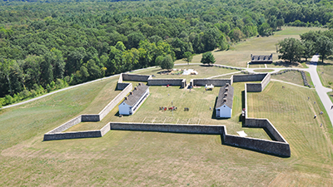

Fort Frederick State Park
Open Thursday to Monday from Memorial Day to Labor Day and on the weekends in the spring and fall, when staff and volunteers dressed in period clothing occupy the fort, demonstrating daily life during the French and Indian War.
The 585-acre park borders the Potomac River and the Chesapeake and Ohio Canal National Historical Park passes through the park. The park also features a boat launch, flat water canoeing, campsites, camp store, hiking trails, a picnic area with large pavilion and a playground.
11100 Fort Frederick Road Big Pool MD 21711​

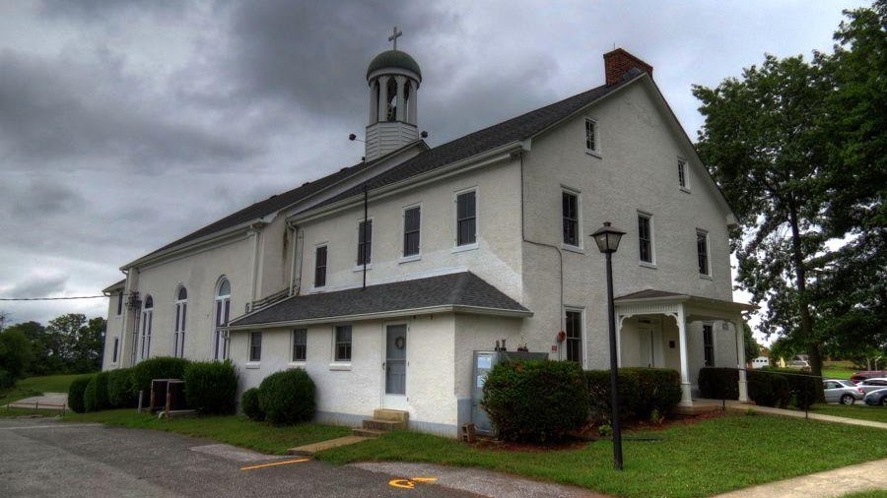

Graceham Moravian Church
39°36′59″N 77°22′43″W
8231 Rocky Ridge Road, Graceham Frederick County, Maryland
On Sunday mornings during the school year we offer Sunday school for all ages beginning at 9:15am and our worship service is from 10:30am - 11:30am.
Our Sunday School is suspended during the summer months and our worship service takes an hour earlier beginning at 9:15am.
Graceham Moravian Church and Parsonage is a historic church building and parsonage. It is a two-story Flemish bond brick church built in 1822, and covered with white stucco because of deteriorated masonry. The church was built as an addition to the adjacent meeting house and parsonage built in 1797. This building and the church's cemetery having uniform flat gravestones (called God's Acre by the Moravians) represents Maryland's only remaining 18th century Moravian settlement.

