Resources
Annapolis, Maryland - Wikipedia
Annapolis, Maryland • FamilySearch

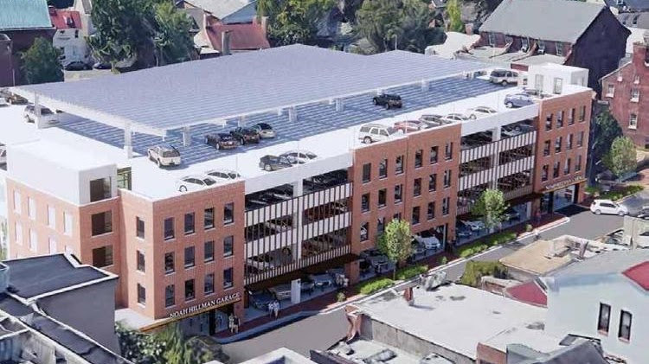

Premium Parking

150 Gorman St, Annapolis, MD 21401
+14102165620
Can make online reservations

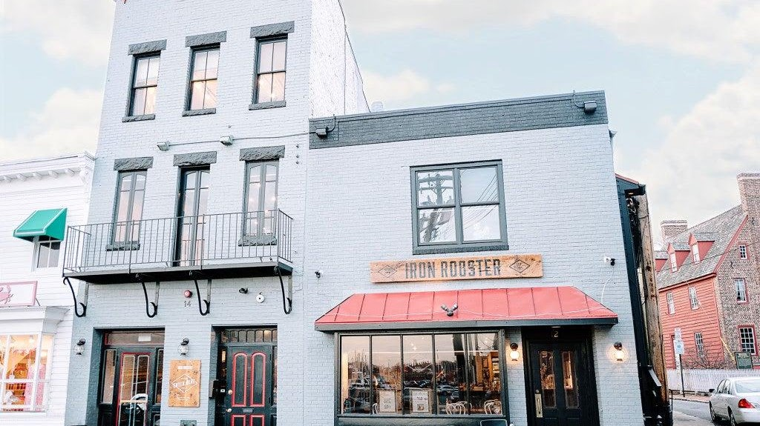

Iron Rooster

8:00 am - 9:00 pm
12 Market Space Annapolis, Maryland 21401
(410) 990-1600

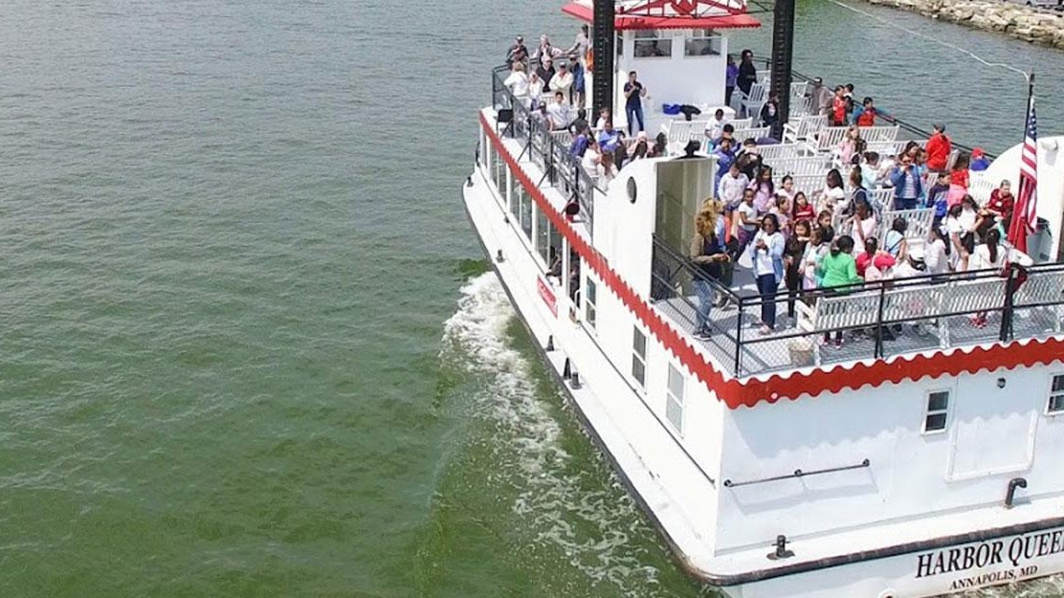

Cruise & Tours Annapolis

Susan Campbell Park, Annapolis, MD 21401
410-268-7601 x 100
$25/Adult $10/Child

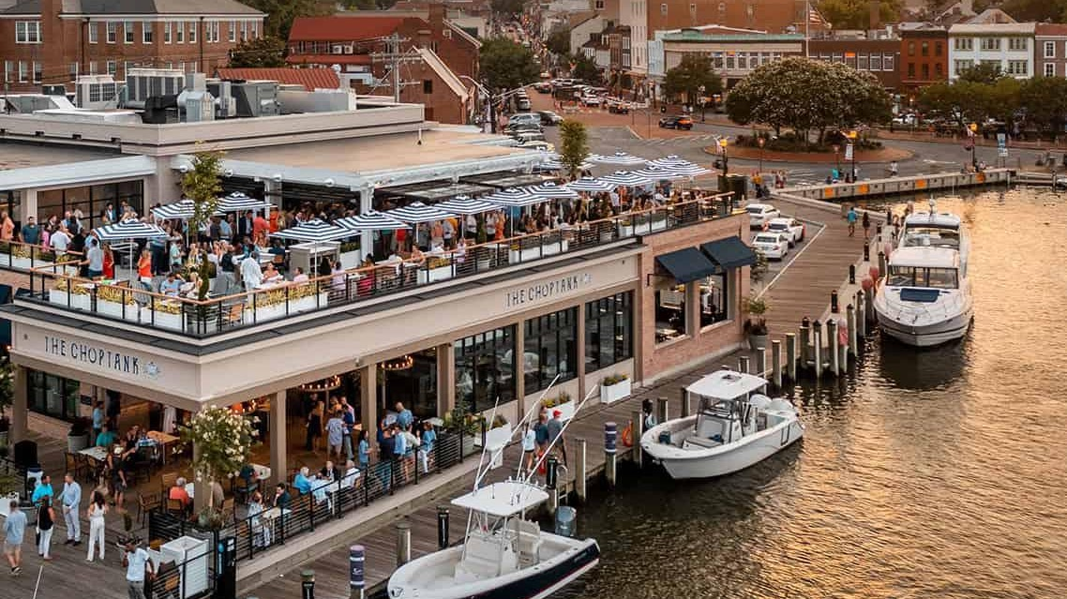

The Choptank
https://thechoptankrestaurant.com/annapolis/
110 Compromise St, Annapolis, MD 21401
+14438081992

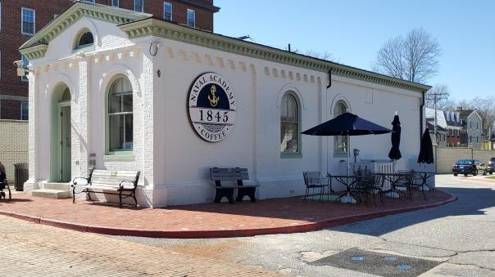

1845 Coffee & Tea

2 Truxtun Road, Annapolis, Maryland 21402
Phone: 410-293-2611

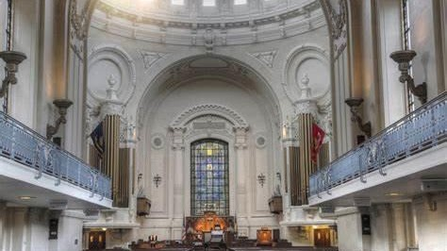

Naval Academy Chapel

The United States Naval Academy Chapel is one of nine designated chapel spaces on the grounds of the United States Navy's service academy. Protestant and Catholic services are held there. The Brigade Chapel is a focal point of the Academy and the city of Annapolis. The chapel is an important feature which led to the Academy being designated a National Historic Landmark in 1961. The remains of John Paul Jones were interred in the crypt beneath

121 Blake Road, Annapolis, MARYLAND. (410) 293-1100

Sun. at 1100 Traditional Protestant Worship Main Chapel

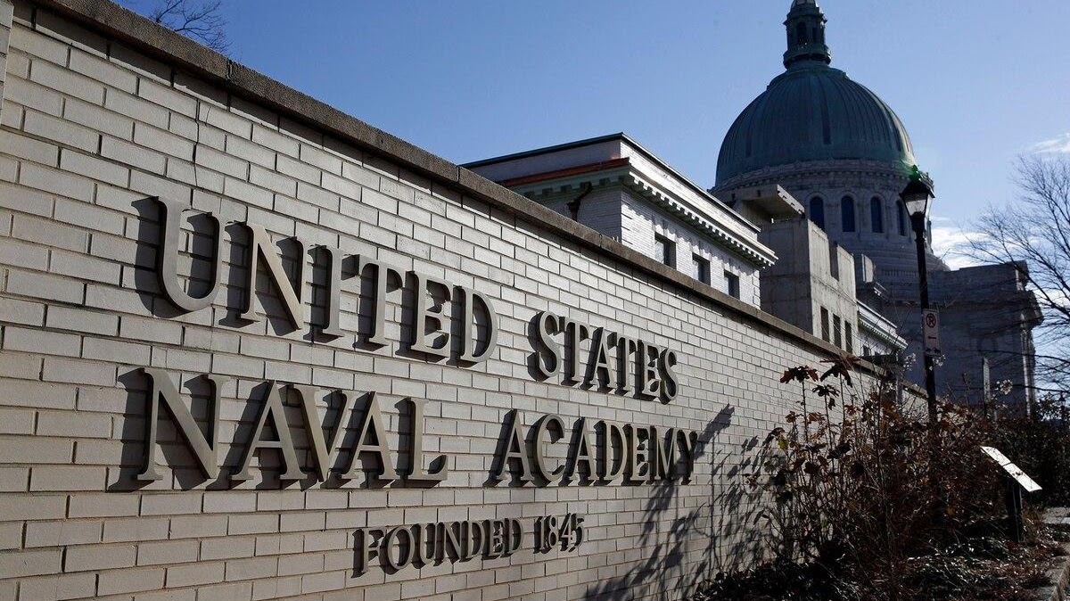

Leftwich Visitor Center

Naval Academy tours are a must-do! Wander the Yard’s scenic walkways by foot or cover more ground quickly by electric car. Either way, you’ll enjoy a behind-the-scenes look at the life of a midshipman and the rich and tumultuous history of one of the greatest fighting forces on Earth!
52 King George St, Annapolis, MD 21402 (410) 293-8687

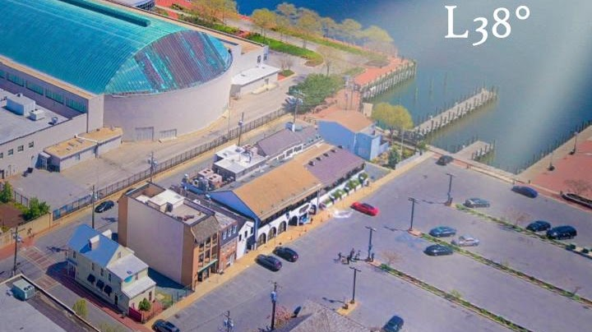

Latitude 38° Waterfront Dining

+16672042282
12 Dock St, Annapolis, MD 21401
Opentable

Storm Bros. Ice Cream Factory

130 Dock St, Annapolis, MD 21401
+14102633376

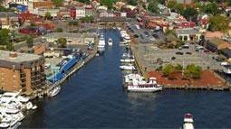

Susan Campbell Park

Dock St, Annapolis, MD 21401

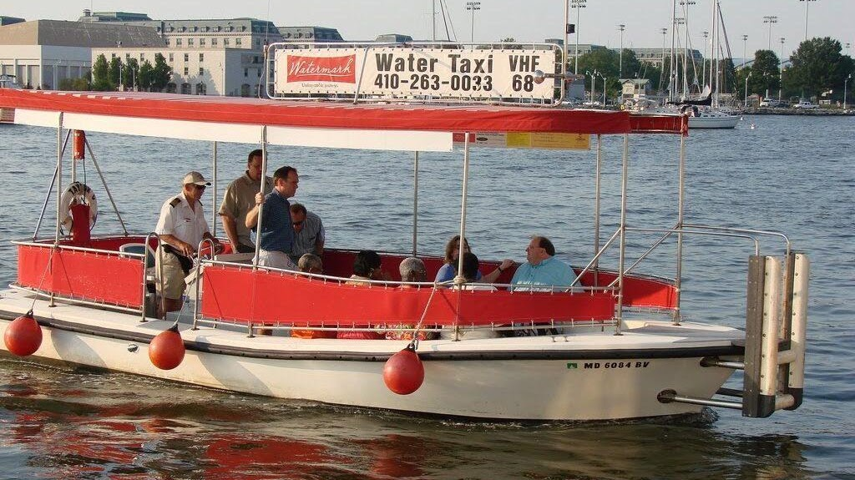

Water Taxi

Watermark operates Annapolis Water Taxi service throughout the Annapolis Harbor including Spa Creek & Back Creek. Service operates continually, advanced reservations not required for public use. $4.00 to $9.00 per person, depending on destination. Minimums apply in Back Creek and upper Spa Creek. Rates are for one-way transit.
410-263-0033

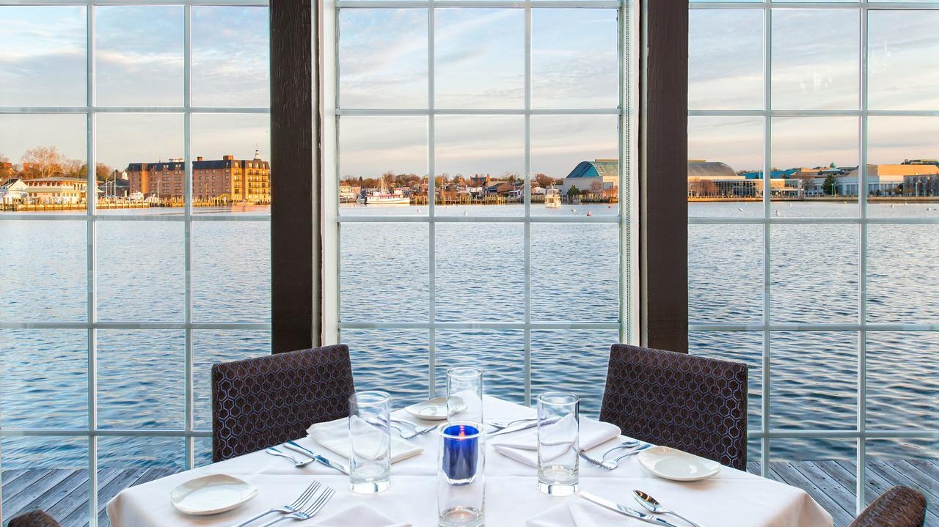

Chart House

300 Second St, Annapolis, MD 21403 (410) 268-7166
SUN: 10:00 AM - 9:00 PM
MON - THU: 4:30 PM - 10:00 PM
FRI - SAT: 4:30 PM - 11:00 PM

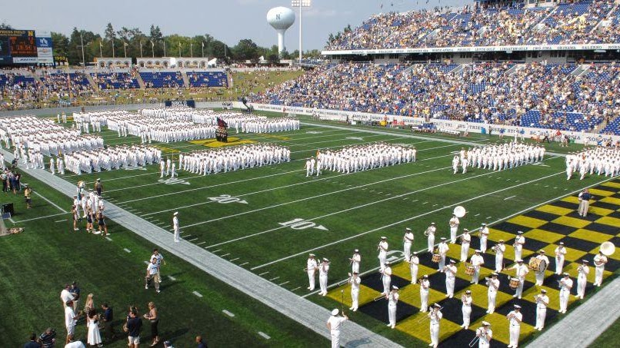

Navy-Marine Corps Stadium

The Navy-Marine Corps Memorial Stadium is home to the Navy football and lacrosse teams as well as local, regional and state sports tournaments. The stadium also hosts a multitude of local, regional, national, and international events. Within the past few years, the stadium has been completely renovated into a state-of-the-art complex that provides an amazing sporting event experience for both players and spectators. Four home contests on the schedule for October and November--most notably, the contest against Navy archrival Air Force (Oct. 5) -- offer an equal number of opportunities to take in the pregame (and postgame) pageantry unfolding outside the gates of the stadium proper.

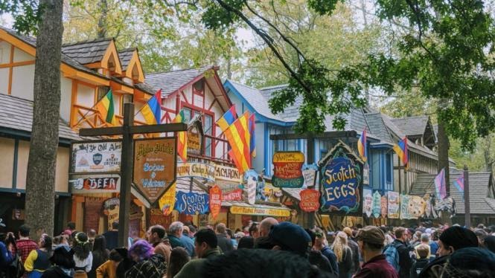

Maryland Renaissance Festival

Hear ye! Hear ye! Leave your modern woes behind and step into 16th-century Revel Grove— the 27-acre village overseen by King Henry VIII. Beginning in August and lasting through the end of October, Lords, and Ladies from faraway lands gather to experience one of Maryland's most extravagant events: The Maryland Renaissance Festival!

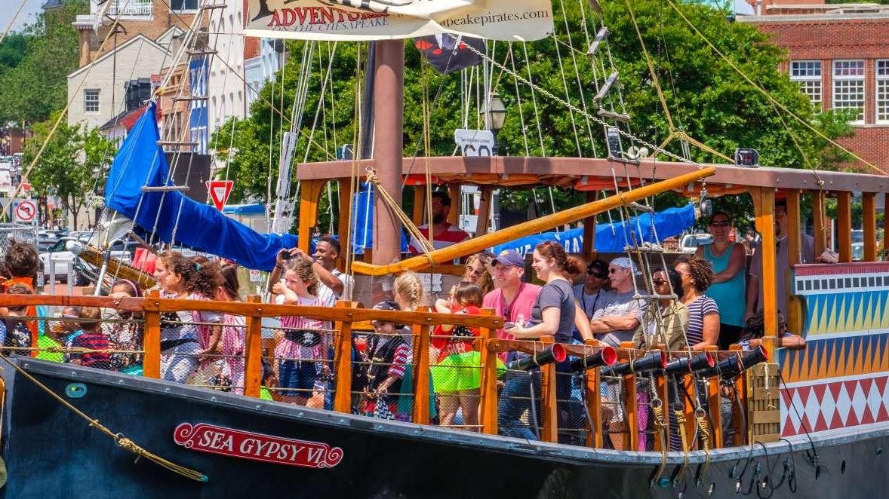

Bay Cruises

