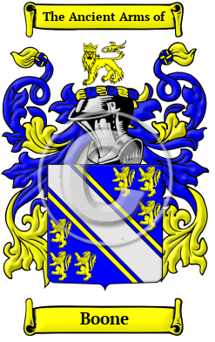

Boone
The surname Boone was first found in Sussex. Humphrey with the Beard (died c. 1113) was a Norman soldier and nobleman fought in the Norman Conquest of England of 1066 and is the earliest known ancestor of the de Bohun family. The variations of the surname Boone include Bohon, Bohun, Bone, Boon, Boone, Bohan, Bound and many more. In the United States, the name Boone is the 480th most popular surname with an estimated 59,688 people with that name



Boone Society
The Boone Society, Inc. is an association of descendants, genealogists, and historians who enjoy studying the lives and times of this remarkable family. It was formed as a reference service for researchers, a conduit for genealogists, clearing-house for bibliographical works, and to host the biennial Boone Family Reunion. The Boone Society, which is open to the public, is a non-profit 501 (c)(3) organization.

