Ecumenical
This National Council of Churches members include Evangelical Lutheran Church in America, American Baptist Churches USA, Moravian Church in America, Polish National Catholic Church, Presbyterian Church USA, Friends United Meeting, Philadelphia Yearly Meeting, United Church of Christ, Reformed Church in America, United Methodist Church and the Episcopal Church USA
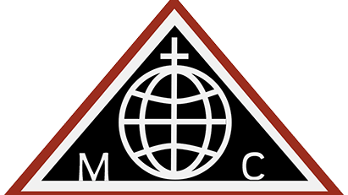
World Methodist Council
The World Methodist Council (WMC), founded in 1881, is a consultative body and association of churches in the Methodist tradition. It comprises 80 member denominations in 138 countries which together represent an estimated 80 million people; this includes approximately 60 million committed members (of Methodist and united and uniting churches) and a further 20 million adherents. But there is also another, contradictory, number of members of the member churches on the WMC's website: about 40 million. It is the fifth-largest Christian communion after the Roman Catholic Church, Eastern Orthodox Church, Anglican Communion, and World Communion of Reformed Churches
List of Historical Churches
Strawbridge Shrine
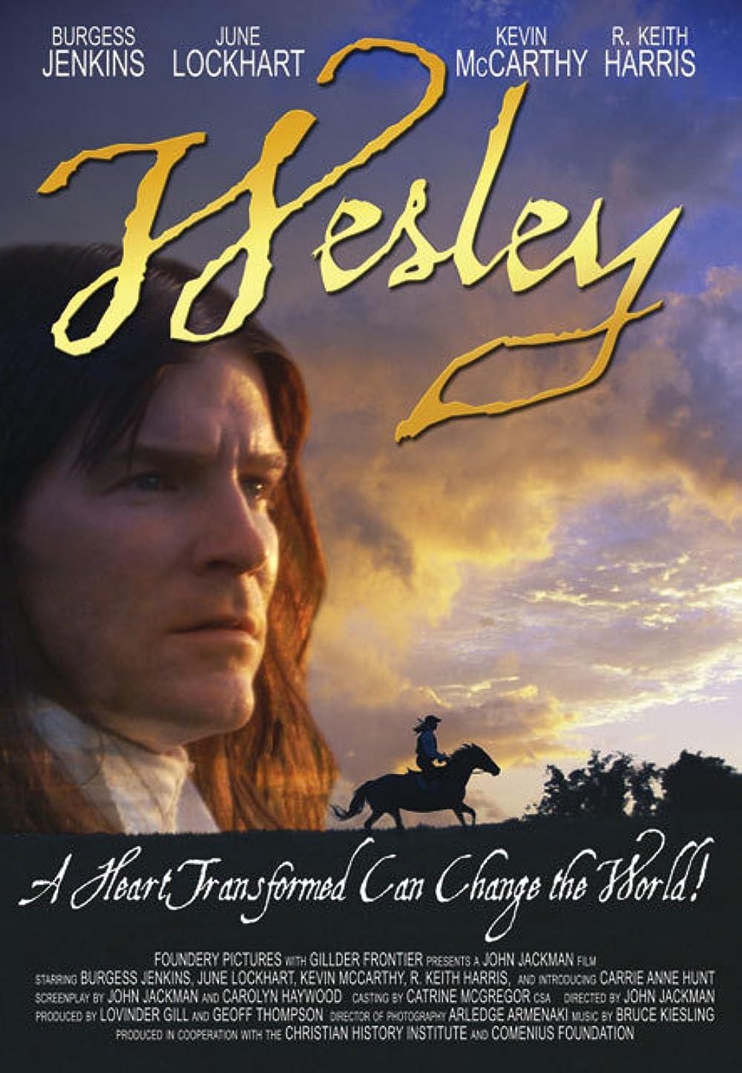
John Wesley
Aldersgate Day: 24 May
On 24 May 1738 John Wesley experienced his "heart strongly warmed." This Aldersgate experience was crucial for his own life and became a touchstone for the Wesleyan movement.
Methodist Catechism
Book of Discipline
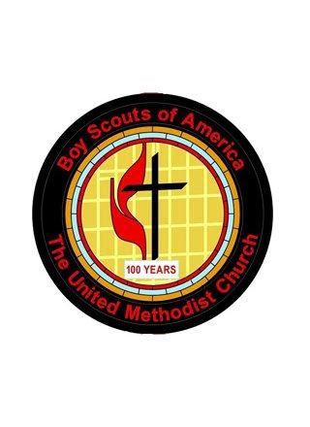
Methodist Scouting
Scouting is a ministry of The United Methodist Church. It puts caring adults and the church in contact with youth in a structured, safe, and vetted program. Our relationship with Scouting predates the forming of The United Methodist. Much has changed since the Feb.12,1920 letter that first established the formal relationship with BSA. Change has arrived again. The mission of the church is to reach out to those within the community, receive them as they are, relate them to God, nurture and equip them, and send them back into the community in order to make the community a more loving and just place in which to live. With that in mind, the United Methodist Men’s Foundation established an Office of Civic Youth-Serving Agencies/Scouting Ministries. The purpose of this office is to promote the use of programs across the Church and to help local congregations understand how they might use civic youth-serving agencies as an outreach ministry within their community.

