Ecumenical
This National Council of Churches members include Evangelical Lutheran Church in America, American Baptist Churches USA, Moravian Church in America, Polish National Catholic Church, Presbyterian Church USA, Friends United Meeting, Philadelphia Yearly Meeting, United Church of Christ, Reformed Church in America, United Methodist Church and the Episcopal Church USA .
Moravians accept the Lutheran Augsburg Confession and the Anglican 39 Articles of Religion
Historic Churches
Graceham Moravian Church in Frederick County, Maryland
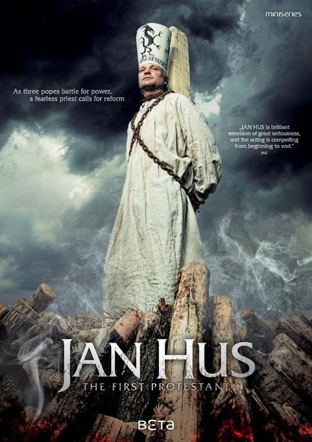
Jan Hus
Jan Hus (/hʊs/; Czech: c. 1370 – 6 July 1415), sometimes anglicized as John Hus or John Huss, and referred to in historical texts as Iohannes Hus or Johannes Huss, was a Czech theologian and philosopher who became a Church reformer and the inspiration of Hussitism, a key predecessor to Protestantism, and a seminal figure in the Bohemian Reformation. Hus is considered by some to be the first Church reformer, even though some designate the theorist John Wycliffe. His teachings had a strong influence, most immediately in the approval of a reformed Bohemian religious denomination and, over a century later, on Martin Luther. Hus was a master, dean and rector at the Charles University in Prague between 1409 and 1410.

