Ecumenical

This National Council of Churches members include Evangelical Lutheran Church in America, American Baptist Churches USA, Moravian Church in America, Polish National Catholic Church, Presbyterian Church USA, Friends United Meeting, Philadelphia Yearly Meeting, United Church of Christ, Reformed Church in America, United Methodist Church and the Episcopal Church USA

Westminster Savoy Philadelphia Confessions of Faith

In England in 1646 the Presbyterians wrote the Westminster Confession of Faith. In 1658 the Congregationalists took the Westminster Confession of Faith and added "Congregational governance" and called it the Savoy Declaration of Faith. In 1689 the Baptist took the Savoy Declaration of Faith and added "Believers Baptism" and called it the London Baptist Confession of Faith. In Pennsylvania, in 1742 the Baptist took the London Baptist Confession of Faith and added 2 more ordinances: "Signing" and the "Laying on of Hands" and called it the Philadelphia Confession of Faith.

List of Historical Churches
Bullock Creek Presbyterian Church Sharon, SC

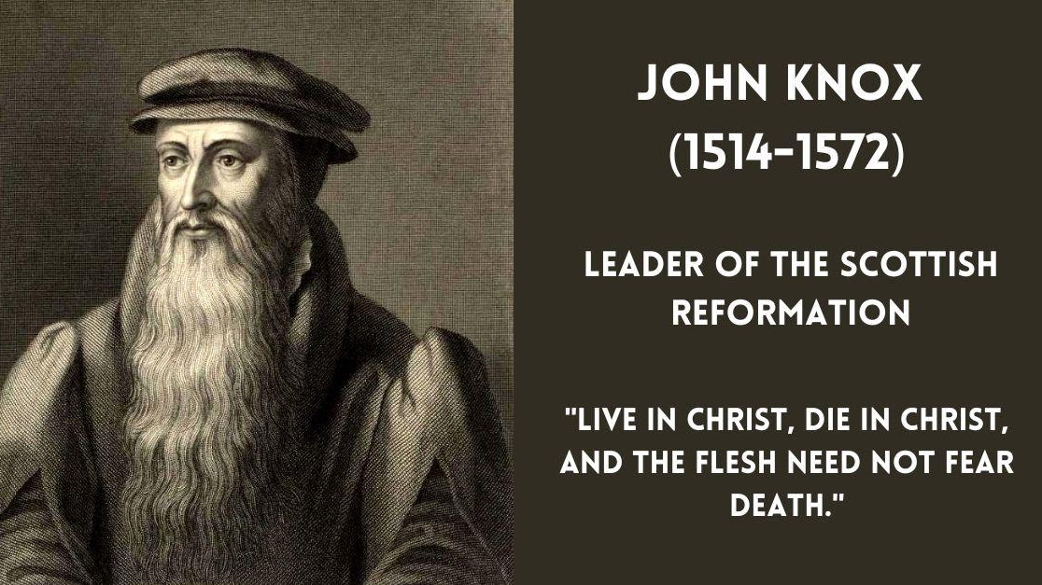

John Knox

John Knox (1514 – 24 November 1572) was a Scottish minister, Reformed theologian, and writer who was a leader of the country's Reformation. He was the founder of the Presbyterian Church of Scotland.
Westminster Catechism
Book of Common Worship

Book of Confessions

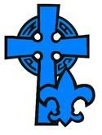

National Association of Presbyterian Scouters

To have SCOUTING at every level for all ages up to age 21 in every Presbyterian Church; to have SCOUTING for all levels for the youth of our Church and our community; to have our membership available to help in the development of our youth in every congregation, presbytery,synod, and national faith organizations as well as in BSA.

