Washington Family Driving Tour
https://maps.app.goo.gl/y1EL1t6r1vGrfgR66
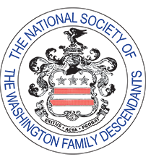
National Society of the Washington Family Descendants
We are a group of over 500 members who can all trace their ancestry to a few of the founding families. We provide leadership in the collection and recording of data, documents and materials relating to the Colonial and Federal periods of the Washington Family. NSWFD also contributes financial assistance to selected organizations with related aims and purposes.

