Research Resources
https://www.familysearch.org/en/wiki/Anne_Arundel_County,_Maryland_Genealogy
https://en.wikipedia.org/wiki/Anne_Arundel_County%2C_Maryland
Anne Arundel Genealogical Society

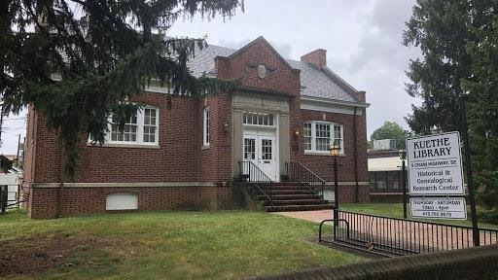

Kuethe Library
5 Crain Hwy S Glen Burnie, MD 21061
410-769-9679
Winter Hours (Labor Day-Memorial Day): Thursday, Friday, and Saturday 10 am - 4 pm.
Summer Hours (Memorial Day-Labor Day): Thursday, Friday, and Saturday 10 am - 2 pm.
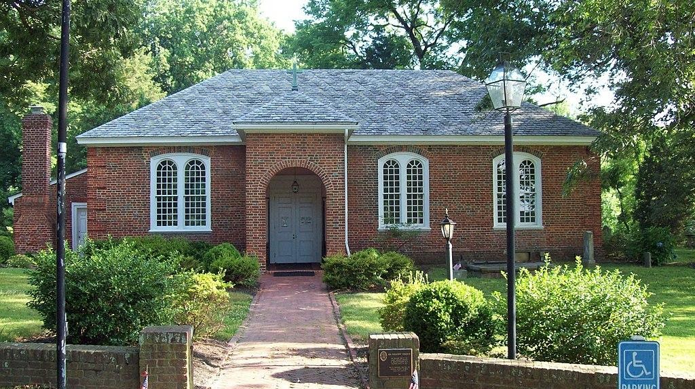

All Hallows Parish
All Hallows' Church was listed on the National Register of Historic Places
Services:
5:00 pm Saturdays, “come-as-you-are” Holy Eucharist at the Chapel.
8:30 am Sundays, Rite I Holy Eucharist at the Chapel — a quiet contemplative service.
10:30 am Sundays, Rite II Holy Eucharist at the Brick Church —broadcast via Facebook Live.
3600 Solomons Island Road Edgewater, Maryland 21037

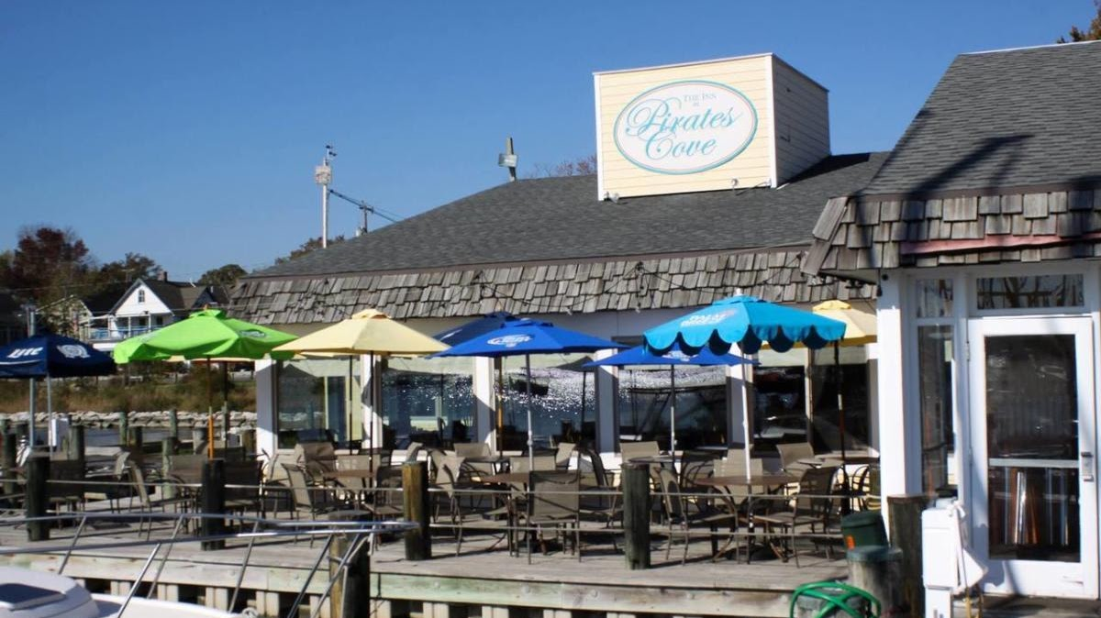

Pirates Cove Restaurant
At Pirates Cove we provide a lively and interesting selection of musical entertainers on Wednesday, Thursday, Friday and Saturday evenings, as well as Sunday afternoons, all year round. During the summer months while the weather is warm and our Dock Bar is open, music moves outdoors. You can hear great local singer/songwriters and all around entertainers who can keep you singing along with covers of rock and folk favorites. We've got specials in food and drink, and, as always, a great waterfront dining and entertainment experience.
4817 Riverside Dr. Galesville, MD 20765
(410) 867-2300

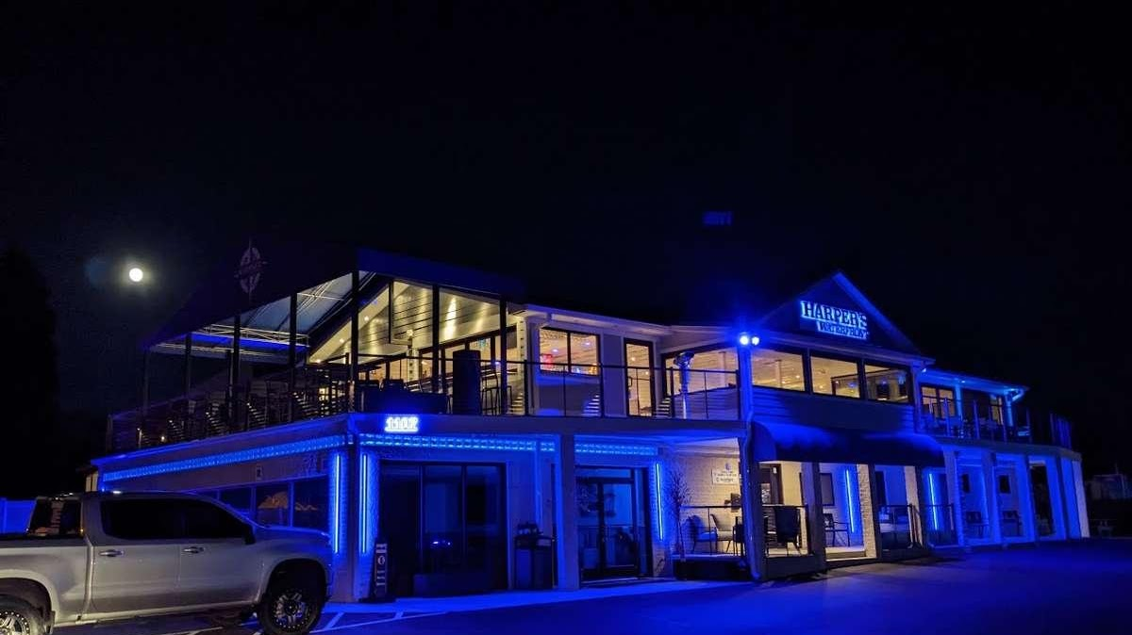

Harper's Waterfront Restaurant
+14107988338
1107 Turkey Point Rd, Edgewater, MD 21037

