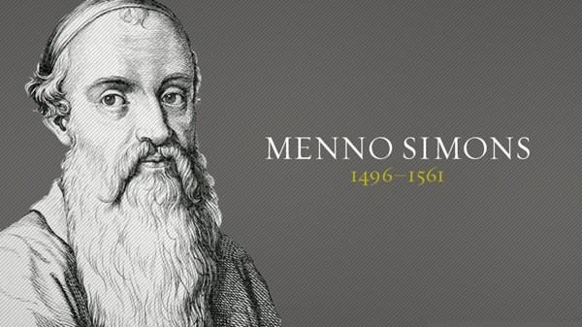

Menno Simons

Mennonites are groups of Anabaptist Christian church communities of denominations. The name is derived from one of the early prominent leaders of the Dutch Anabaptist movement, Menno Simons (1496–1561) of Friesland. Through his writings about Reformed Christianity during the Radical Reformation, Simons articulated and formalized the teachings of earlier Swiss founders, with the early teachings of the Mennonites founded on the belief in both the mission and ministry of Jesus, which the original Anabaptist followers held with great conviction, despite persecution by various Roman Catholic and Mainline Protestant states. The Mennonite World Conference was founded at the first conference in Basel, Switzerland, in 1925 to celebrate the 400th anniversary of Anabaptism

Rumspringa

Rumspringa , is a rite of passage during adolescence, translated from originally Palatine German and other Southwest German dialects to English as "jumping or hopping around", used in some Amish communities. The Amish, a subsect of the Anabaptist Christian movement, intentionally segregate themselves from other communities as a part of their faith. For Amish youth, the Rumspringa normally begins at age 16 and ends when a youth chooses either to be baptized in the Amish church or to leave the community. For Wenger Mennonites, Rumspringa occurs mostly between ages of 17 and 21.

