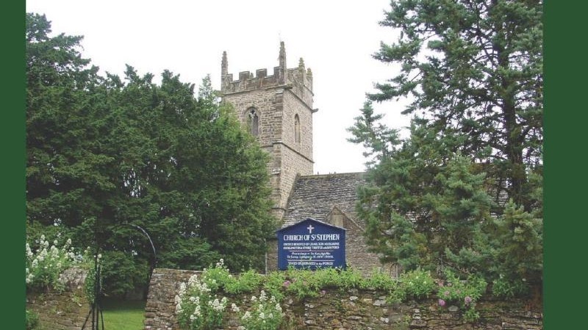

Haskell Family Association

William Haskell was Churchwarden at the Church of St. Stephen in Charlton Musgrove, England in 1627 – 1628. He married Elinor Foule in 1610. They had seven children who were baptised in Charlton Musgrove, Somerset, England. The three sons, Roger (bp. 6 Mar 1613/14), William (bp. 8 Nov 1618), and Mark (bp. 8 Apr 1621) emigrated to Massachusetts in the New World. Most Haskells in the U.S. are descended from one of these three brothers.

