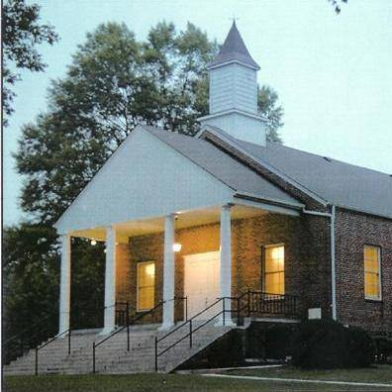

Cane Creek Friends Meeting

Cane Creek was established 1751. A delegation of Friends led by Abigail Pike and Rachel Wright rode horseback to Perquimans County to request permission to start the meeting. It was granted. The Perquimans Ministry and Counsel recorded Abigail Pike as a minister for Cane Creek. Friends have always recognized women as ministers and missionaries. Leadership is expected by all members. A minister’s roll is to encourage. Cane Creek held its first session of Monthly Meeting 10 month 7, 1751. The first Cane Creek Meetinghouse was not on the present site. It was about 2 miles east. William Marshall donated the land for the 1764 Meetinghouse to be built.
719 W Greensboro Chapel Hill Rd, Snow Camp, NC, United States, North Carolina

