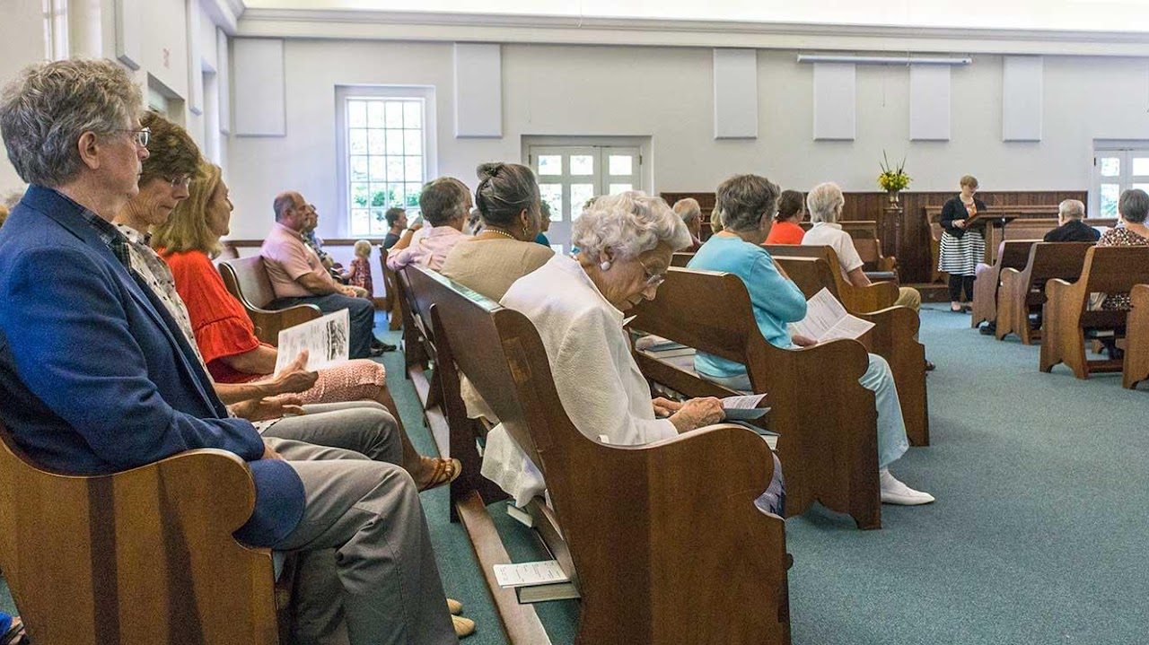

New Garden Friends Meeting

Friends first gathered here in the mid-1700s to worship outdoors on First Day (Sunday) while seated on fallen trees. In 1754, New Garden Friends Meeting was established as a Monthly Meeting (the Quaker term for a regular congregation).
801 New Garden Road Greensboro, N.C. 27410 336-292-5487

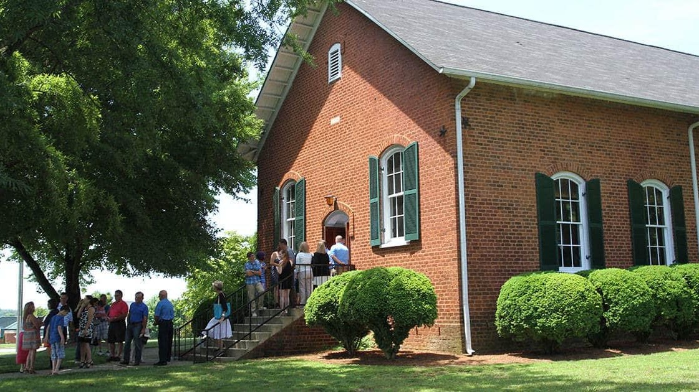

Deep River Friends Meeting

Deep River Friends Meeting, established in 1754, is a Quaker church in High Point, N.C. We gather for worship on Sundays at 11 a.m. In a world of greed, endless hurry and violence, we believe there is a better way of life. This is made possible by Jesus Christ who shows us the infinite love and mercy of God, and who accompanies us day-by-day, helping us find goodness among the difficult choices that constantly confront us.
5300 West Wendover Avenue, High Point, NC 27265
P: 336-454-1928 | E: office@deepriverfriends.com

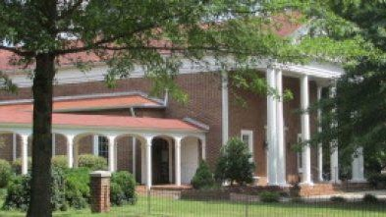

Springfield Friends Meeting

Friends were slower to settle in the Piedmont. Cane Creek Meeting was started in 1751, and New Garden followed in 1754. In the mid-1700’s, Quakers began settling in South Carolina. However, the economy there was deeply involved with slavery. Quakers started leaving South Carolina in the 1770’s, moving up to North Carolina. Many members of Bush River Friends (near Camden, SC) helped to start a new meeting at Springfield. Early Friends from South Carolina who helped to start Springfield include members of the English, Kersey, Mendenhall, Piggins, Ricks and Tomlinson families.
Another early group of settlers came from the island of Nantucket off the coast of Massachusetts. Many Quakers there had made a living from whaling, but the island was overcrowded and whales were becoming scarce near the coast. Many Quaker families moved to New Garden before coming down to Springfield. Prominent family names from Nantucket are Coffin, Macy and Petty.
A third stream of early settlers came here from the Philadelphia area, which was founded in 1681 by William Penn as a refuge for Friends and others who were suffering from religious persecution back in the Old World. They came to Pennsylvania and prospered, but again, the colony was getting crowded. So, many Friends headed down to North Carolina, where they found other Quakers, often with family connections. Land here was inexpensive and there was plenty of room for families to buy large farms. By the time of the American Revolution, there were almost 15,000 Quakers in North Carolina. Family names of Springfield settlers from Pennsylvania include Anderson, Beals, Blair, Carter, Clark, Frazier, Haworth, Hiatt, Hoggatt, Hunt, Millikan and Piggott (often spelled in later years as Pickett).

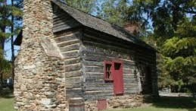

High Point Museum

The Hoggatt House is a rare example of houses built by the early settlers of the Piedmont back-country. Originally a single room log cabin with a large stone fireplace, the house was built around 1801 and enlarged with a second room around 1824. It was moved to the Historical Park in 1973 from its original location at the corner of Phillips Avenue and Rotary Drive in High Point. The Hoggatt House was restored after a fire caused by a lightning strike in December 2004. Visit the Park Staff here to learn about the everyday lives and activities of settlers in the early 1800s. To learn more about the Hoggatt House’s history, architecture and restoration, see a presentation by Salem College student Victoria Chaffers.
1859 East Lexington Avenue High Point, NC 27262
Phone: 336-885-1859

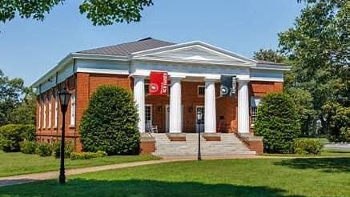

Guilford College

Guilford College is a private liberal arts college in Greensboro, North Carolina. Guilford has both traditional students and students who attend its Center for Continuing Education (CCE). Founded in 1837 by members of the Religious Society of Friends (Quakers), Guilford's program offerings include such majors as Peace and Conflict Studies and Community and Justice Studies, both rooted in the college's history as a Quaker institution. Its campus has been considered a National Historic District by the United States Department of the Interior since 1990
5800 West Friendly Avenue Greensboro NC 27410
336.316.2000
admission@guilford.edu

