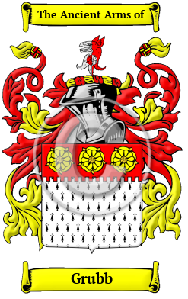

Grubb

The surname Grubb was first found in Berkshire, where the family was first referenced in the year 1176 when Richard and John Grubb held estates in that shire. Variations of this family name include: Grubb, Grub, Grubbe, Groube, Groub and others.
In the United States, the name Grubb is the 2,166th most popular surname with an estimated 14,922 people with that name.

Grubb Worth Mansion

Mount Hope Estate

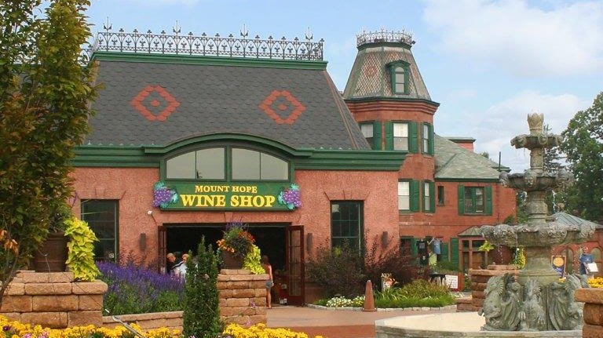

Mount Hope

Mount Hope began as the summer home for four generations of the Grubb family, an early American iron master family who found their way from England seeking their fortune. The properties that were to become the Estate were purchased in 1779 and Peter Grubb established an iron furnace at Mount Hope in 1784. His son, Henry Bates Grubb, built the original Federal Period Mansion between 1800-1805.
717.665.7021 WineShop@PaRenFaire.com
2775 Lebanon Road Manheim, PA 17545

