April is English Heritage Month!
English Facts:
Religion: Church of England
Patron Saint: St George
National Anthem: Land of Hope and Glory commissioned by King Edward VII
Patriotic Songs:
And did those feet in Ancient Times by Brother William Blake
I Vow to Thee, My Country by Sir Cecil Spring-Rice
God Save the Queen
Fun Facts:
- Free more slaves than any other country in human history!

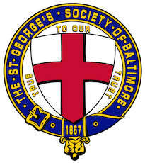

St. George's Society of Baltimore

The St. George's Society of Baltimore is a philanthropic and social organization founded in 1867 to afford relief and advice to the indigent natives of England and Wales and the British Colonies or to their wives, widows and children; and to promote social intercourse amongst its members. In recent years, through its 501(c)(3) Foundation, The St. George's Society of Baltimore has supported the Invictus Games Foundation, Help For Heroes, the Royal British Legion, and Prince's Trust USA, as well as providing hospitality to officers and ship's company of visiting Royal Navy ships. The Society also sponsors several events celebrating British culture and history annually to promote fellowship amongst its members and hospitality for their families, friends and guests.

