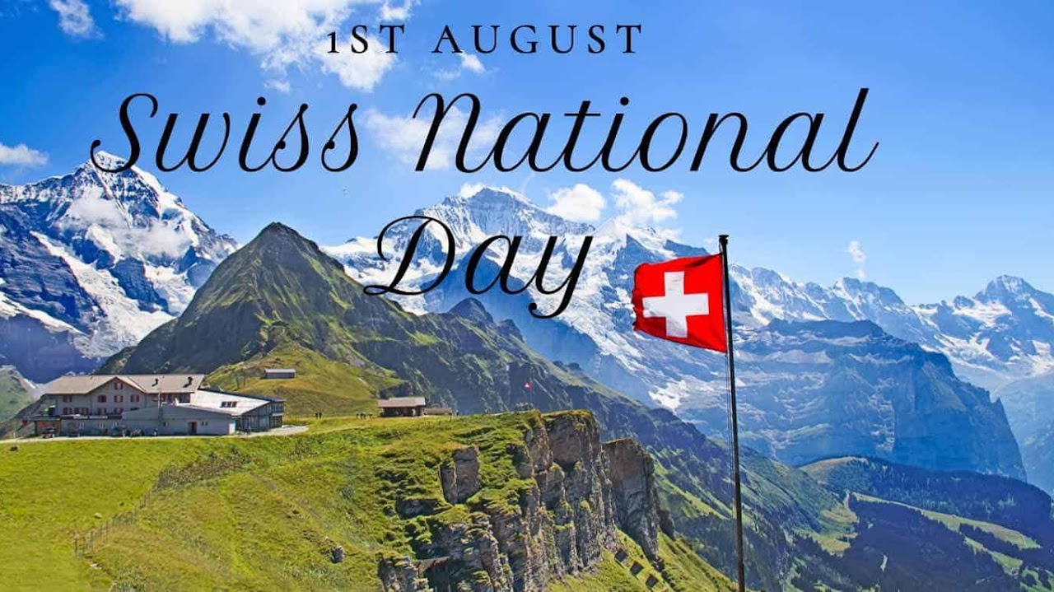

Swiss National Day
1 August

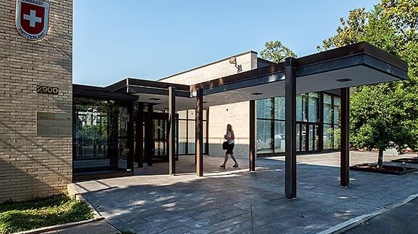
Embassy of Switzerland
Through the Embassy, the Consulates General, the Swiss Business Hub USA and the offices of swissnex, Switzerland promotes exchange between Switzerland and the US in the fields of business, politics, science, technology and culture. For Swiss living in the United States the Embassy and the Consulates General offer services of administrative matters and consular protection. As the official representation of Switzerland, the Embassy covers all matters concerning diplomatic relations between the two countries. It represents Swiss interests in the areas of political, economic, financial and legal affairs, as well as science, education and culture.

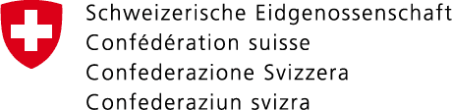

Academic internships
The Embassy of Switzerland is looking for motivated candidates for internships covering many departments and aspects of the work of the Embassy of Switzerland in Washington, D.C.
The Consulate General in New York offers 3 internship positions to qualified candidates in the following sections:
- Economic Affairs and Communication
- Culture and Education
- Swiss Business Hub in San Francisco
The purpose of these academic internships is to offer students or recent graduates an opportunity to discover the activities of a Swiss representation abroad and to become familiar with the diverse aspects of a diplomatic career. All positions are full-time (40 hours per week) and run for 6 months. Remuneration for the positions is USD 3,400 per month. For details and how to apply, read the document on internships.
Internships (PDF, 3 Pages, 665.3 kB, English)

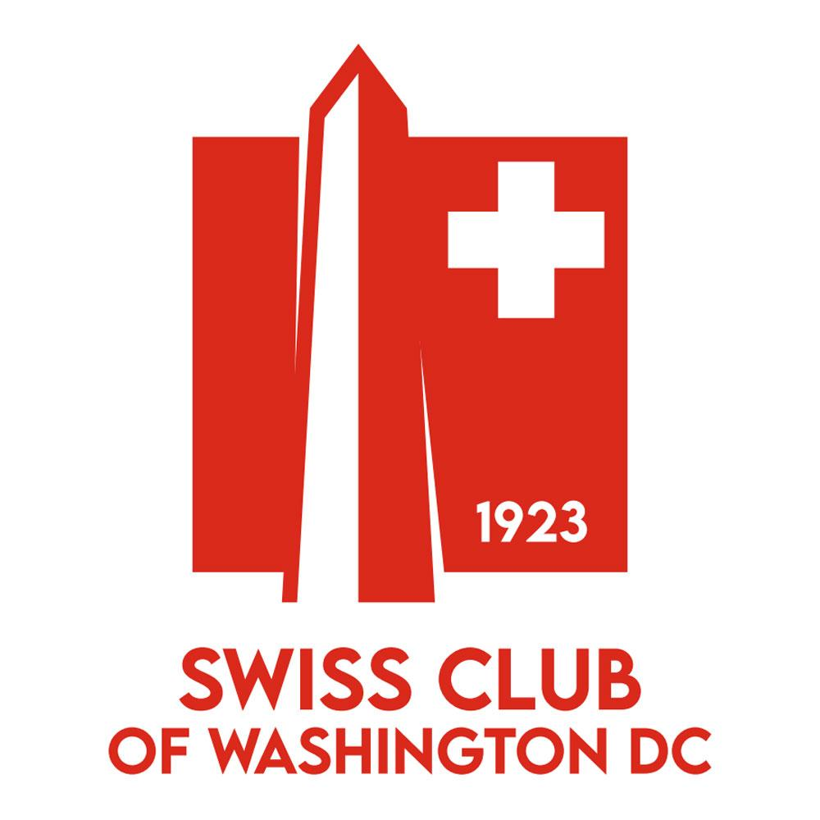

Swiss Club
We are a Club of Swiss people and friends of Switzerland in the Washington metropolitan area including Northern Virginia and Maryland. The Swiss Club of Washington, D.C., founded in January 1923 and incorporated on August 18th, 1924, is here to organize events and bring together people with Swiss heritage living around Washington, D.C. as well as any friends of Switzerland or people interested in the culture and history. We organize many events throughout the year for both families and adults to get together and enjoy themselves. Our activities give people, both young and old, the chance to experience a bit of Switzerland. Our family oriented activities such as the Easter Egg Hunt, Samiclaus, and Jass Tournaments bring traditional Swiss events to DC, while the Fondue and Raclette evening bring back delicious memories of Switzerland.

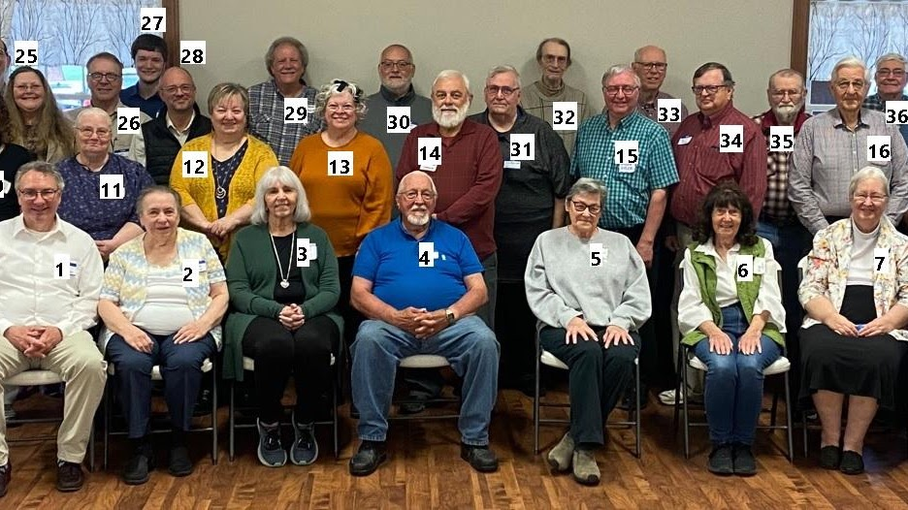

Swiss Anabaptist
Genealogical Association
The Swiss Anabaptist Genealogical Association is a volunteer organization that shares its research to other association members who have agreed to the high standards and ethics or our organization. There is an annual fee to belong which pays for some of our basic expenses (but not all) which amounts to less than 2 cents per day. I am sure you would agree that this meager amount is the best bargin that can be found for any genealogical web site. It may seem that the amount is insignificant, but it does go toward expenses associated with operating a web site. We are glad you are interested in the 6.6 million plus entries in our database. However, before you can access these databases, you need to join S.A.G.A. and agree to our ethics and standards

