February is Welsh History Month!

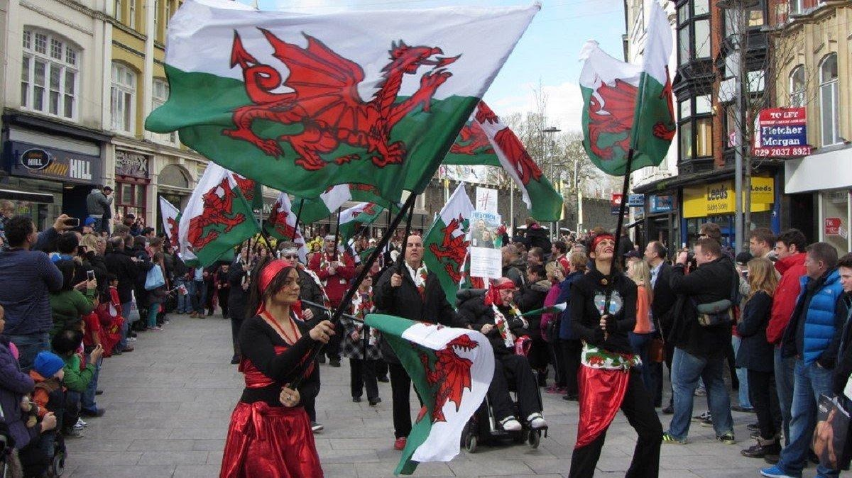

St. Davids Day
1 March
The Welsh Society of Philadelphia

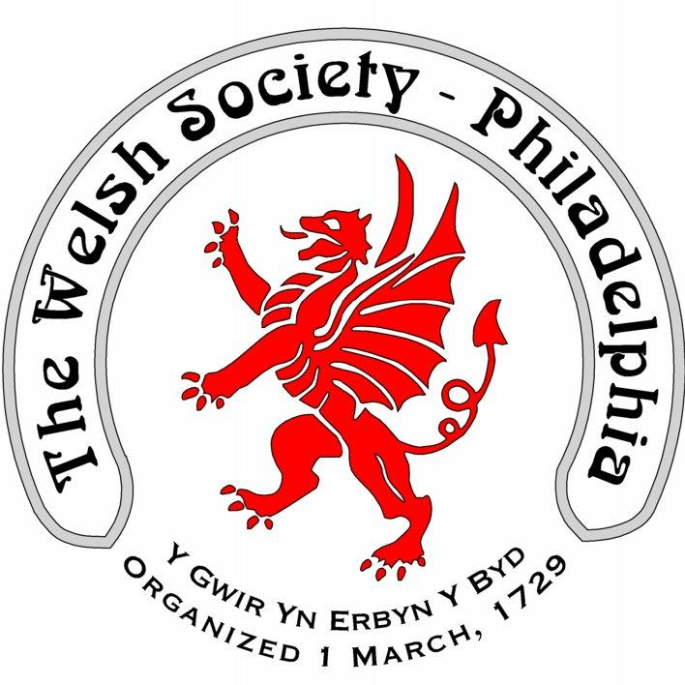

The Welsh Society of Philadelphia

The Welsh Society of Philadelphia has members that have a wide range of ages and interests. Everyone who shares our interest in keeping current with local Welsh American events is most welcome. Membership of the Welsh Society of Philadelphia provides the following opportunities:
A chance to participate in the historic and vibrant Welsh American community
Enjoy a variety of social and heritage events
Singing and community spirit at the Gymanfa Ganu
Receive notifications of upcoming events
Recognize outstanding Welsh Americans through the Robert Morris Award

