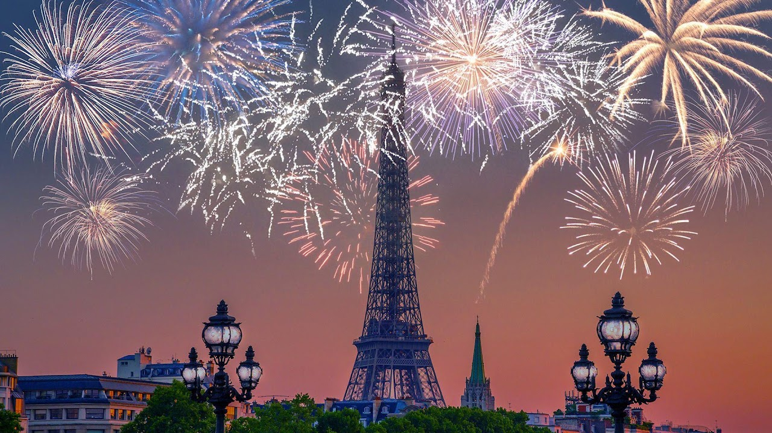

Bastille Day
14 July

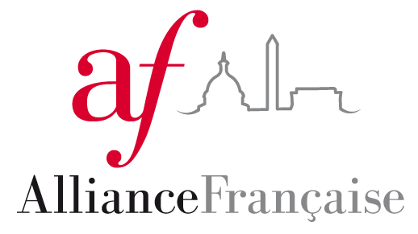

Alliance Française

Alliance Française is the largest and oldest network of French language and cultural centers in the world. It was founded in 1883 in Paris, France. The Alliance Française chapters across the world are dedicated to promoting French language and francophone culture in order to foster relationships between people of all nationalities, ethnicity, and backgrounds. Alliance Française of Washington, D.C. is one of the 850 chapters in the world, and one of 114 chapters in the US. The American network of Alliance Française chapters is the most important of all the Alliance Française’s networks.

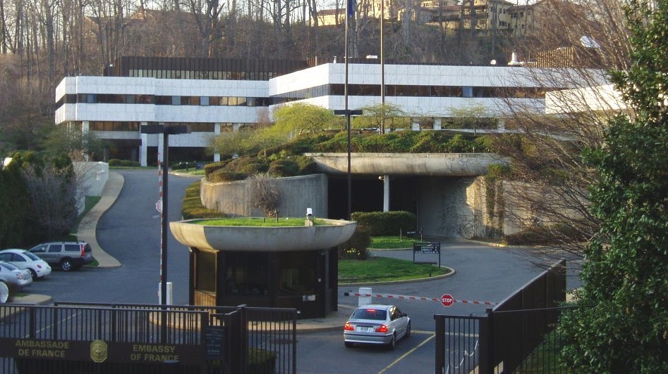

French Embassy DC

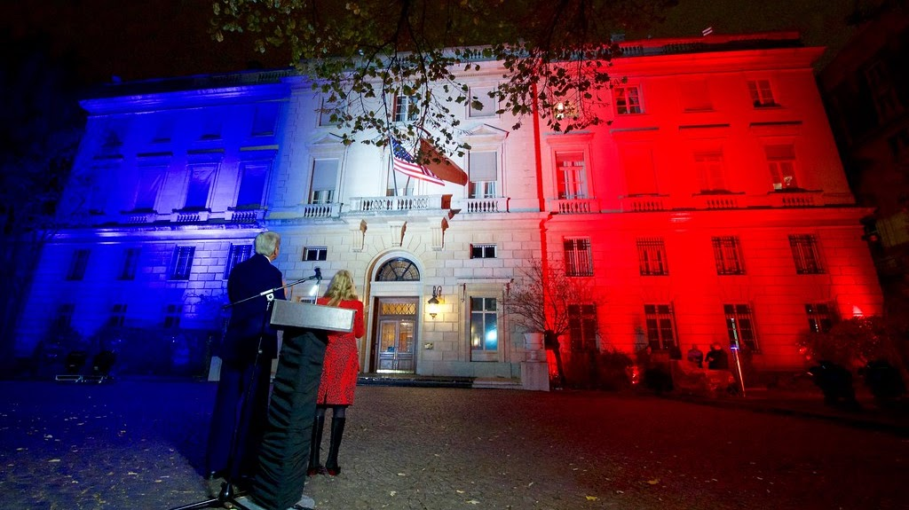

Internships at the Embassy of France

Only Students from a local school/university, whatever the nationality (including French) or those candidates studying within an American institution, can apply to one of the open positions. The procedure for students in France is different (please see below).
The Press and Communication Office accepts interns adherent to the fall, spring and summer semester schedule. Interns must be currently enrolled, full-time students in an American university to be considered. A proficiency in French and native speaking/ writing level in English is required.

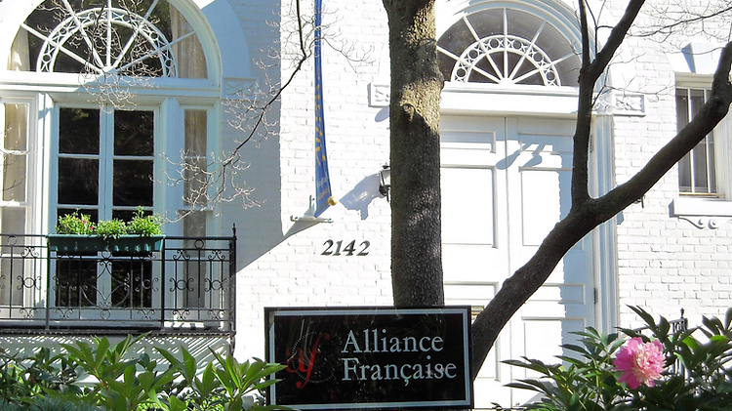

Franciphonie

The D.C. Francophonie Cultural Festival celebrates the diversity and richness of the French language and Francophone communities around the world through a series of cultural events and outreach programs presented every spring in the capital of the United States. Since 2001, more than 40 embassies and partners (including the Alliance Française de Washington DC and the Smithsonian Associates) have collaborated each year to present an array of experiences all rooted in the Francophone culture -- from Africa, to the Americas, to the Middle East -- through concerts, cuisine, films, literary salons, and lectures for all ages.

