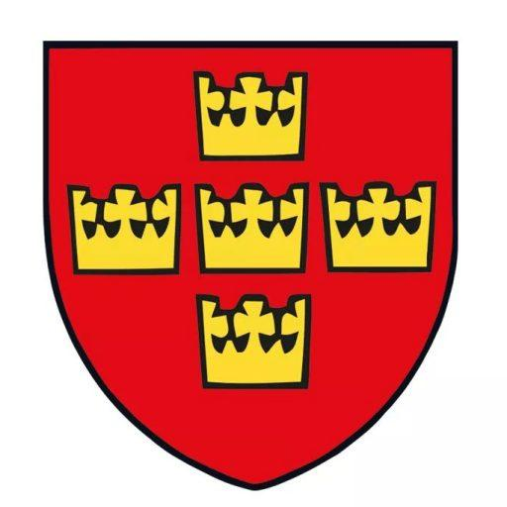
Societas Heraldica Scandinavica
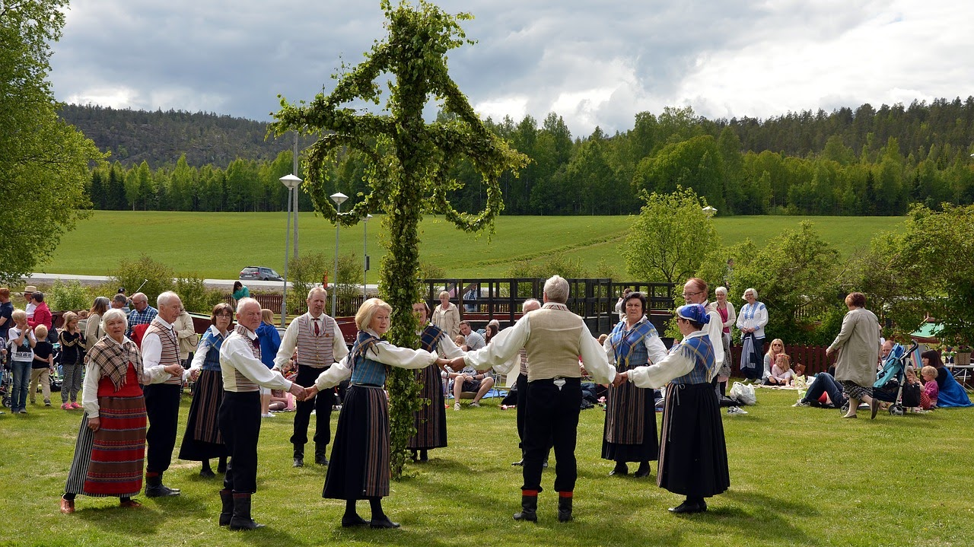
Midsummer
June 21
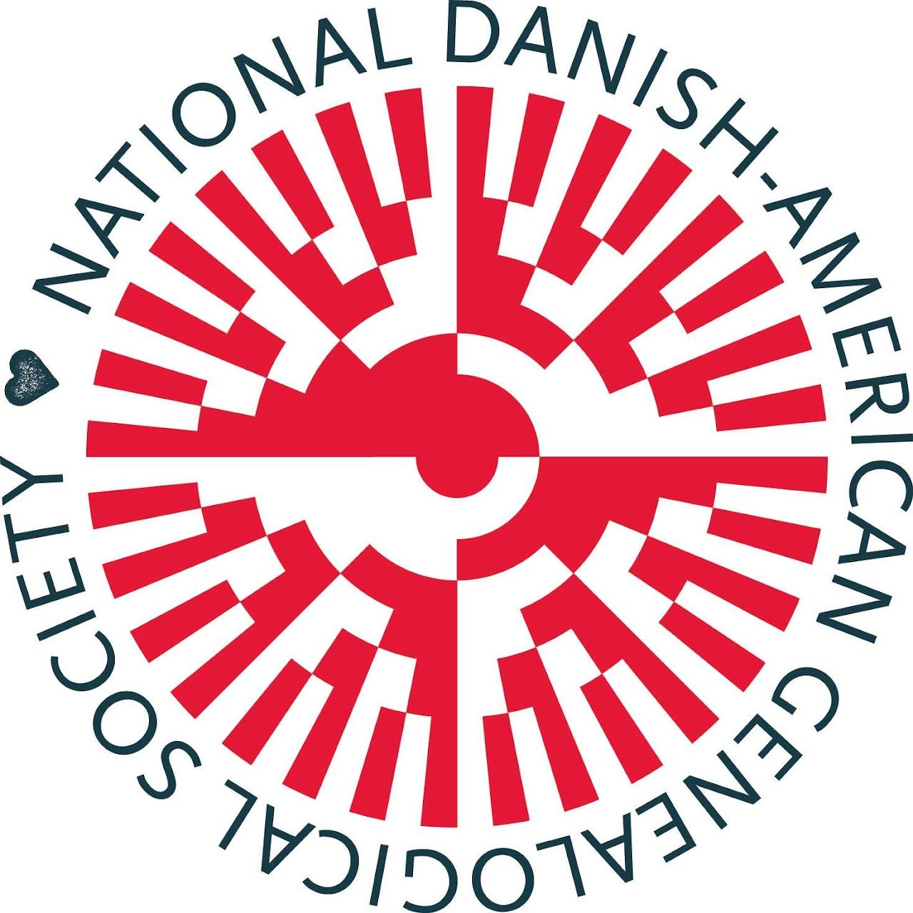
National Danish-American Genealogical Society
Provide an organization that people interested in Danish genealogy and family history can join no matter where they live. Exchange ideas related to both Danish genealogy and general genealogy research and methodology, with a network of members ranging from new beginners to seasoned experts. Provide informative instruction on a range of genealogy topics Encourage interest in Danish heritage and culture. Encourage research and writing of family, emigration, immigration, and settlement histories
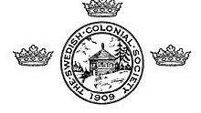
Swedish Colonial Society
The 17th century saw Sweden as an European “Great Power” and one of the major military and political combatants on the continent during the Thirty Years’ War. By mid-century, the kingdom included part of Norway, all of Finland and stretched into Russia. Sweden’s control of portions of modern Poland, Latvia, Estonia, Lithuania and Germany made the Baltic Sea essentially a Swedish lake. Perhaps inspired by the riches other Great Powers gathered from their overseas colonies, Sweden too sought to extend its influence to the New World. In 1637, Swedish, Dutch and German stockholders formed the New Sweden Company to trade for furs and tobacco in North America. Under the command of Peter Minuit, the company’s first expedition sailed from Sweden late in 1637 in two ships, Kalmar Nyckel and Fogel Grip. Minuit had been the governor of the Dutch colony, New Netherland, centered on Manhattan Island, from 1626 to 1631. The ships reached Delaware Bay in March 1638, and the settlers began to build a fort at the site of present-day Wilmington, Delaware. They named it Fort Christina, in honor of Sweden’s twelve-year-old queen. It was the first permanent European settlement in the Delaware Valley.

