November is Scottish Heritage Month!

St Andrews Day
30 November

Tartan Day
6 April

St. Andrew's Society
Founded over 250 years ago, we are a fraternity of Scottish descendants from around the Nation’s Capital who celebrate our Scottish culture and heritage. Our mission to “Relieve the Distressed” is fulfilled through charitable works through the Washington Scots Charity & Education Fund.
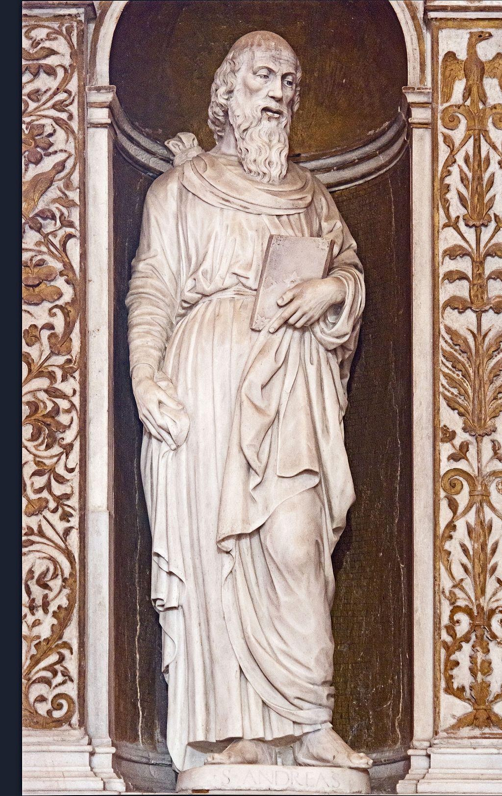
St Andrew's Socitieties
Wherever they’ve settled, Scots have taken with them the traits that their homeland is so well known for. Find out how the charitable institutions they set up all those years ago are helping spread Scotland’s values across the globe

Every year, on 30 November, Scots and Scots at heart come together to celebrate St Andrew’s Day – Scotland’s national day.

