Octoberfest

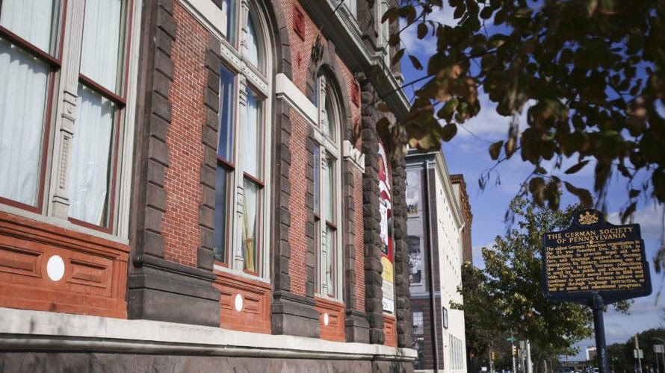

German Society of Pennsylvania

611 Spring Garden Street - Philadelphia, PA 19123
(P) 215-627-2332 (F) 215-627-5297
info@germansociety.org

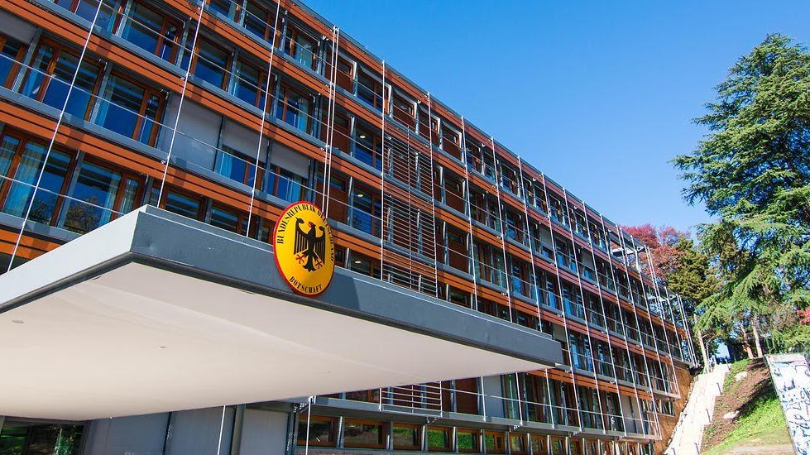

German Embassy

The embassy is the official representation of the Federal Government of Germany in the United States. Our Visa, Passport and Legal Section provides services for US residents and German citizens within the Embassy's area of consular jurisdiction: Delaware, Maryland, Virginia, West Virginia and the District of Columbia.

