Resources
Kennebec County, Maine - Wikipedia
Kennebec County, Maine Genealogy • FamilySearch
National Register of Historic Places listings in Kennebec County, Maine - Wikipedia
China, Maine - Wikipedia
China Village Historic District
China, Kennebec County, Maine Genealogy • FamilySearch
Vassalboro, Maine - Wikipedia
Vassalboro Historical Society & Museum



Majek Seafood & Grill
239 Lakeview Dr, China, ME 04358
+12074458043

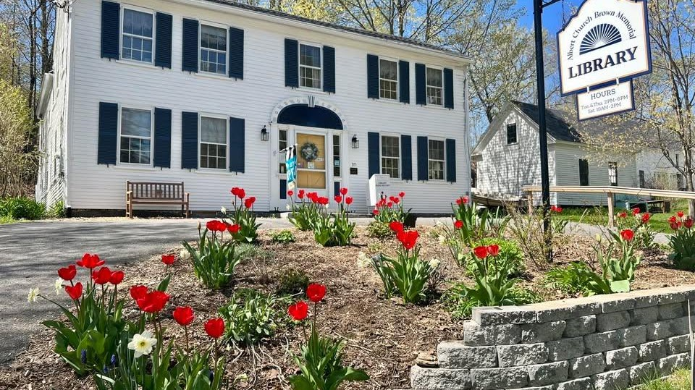

Albert Church Brown Memorial Library
35 Main St, China, ME, United States, Maine
chinalibraryacb@gmail.com
1 207-968-2926



China Lake
571 Lakeview Dr, China, ME 04358



Haskell Cemetery
CF92+96 China, Maine

