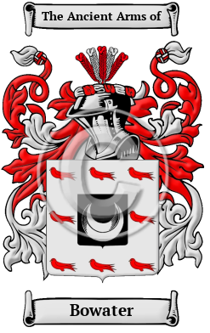
Bowater
The surname Bowater was first found in Middlesex where they held a family seat as Lords of the Manor. The Saxon influence of English history diminished after the Battle of Hastings in 1066. The language of the courts was French for the next three centuries and the Norman ambience prevailed. But Saxon surnames survived and the family name was first referenced in the 13th century when they held estates in that shire. Variations of this family name include: Bowater, Boewater, Bowatar, Boughwater and others.

