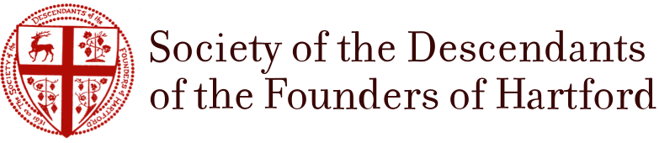

Descendants of the Founders of Hartford

The Society of the Descendants of the Founders of Hartford is a charitable and educational society organized in 1931. Among its purposes are: To foster literary, cultural, historical and other research aimed at strengthening the public understanding of the history and traditions of the City of Hartford; To celebrate appropriate anniversaries in the history of the City; To erect appropriate memorials in public places to commemorate the founding of the City; To promote the widest possible public interest in the history of Hartford; And to make grants to other organizations in support of the above. There are more than 300 living members, in almost every state and in several foreign countries. We meet once a year in Hartford for the annual Court and Dinner, which features a guest speaker and the introduction of new members.

