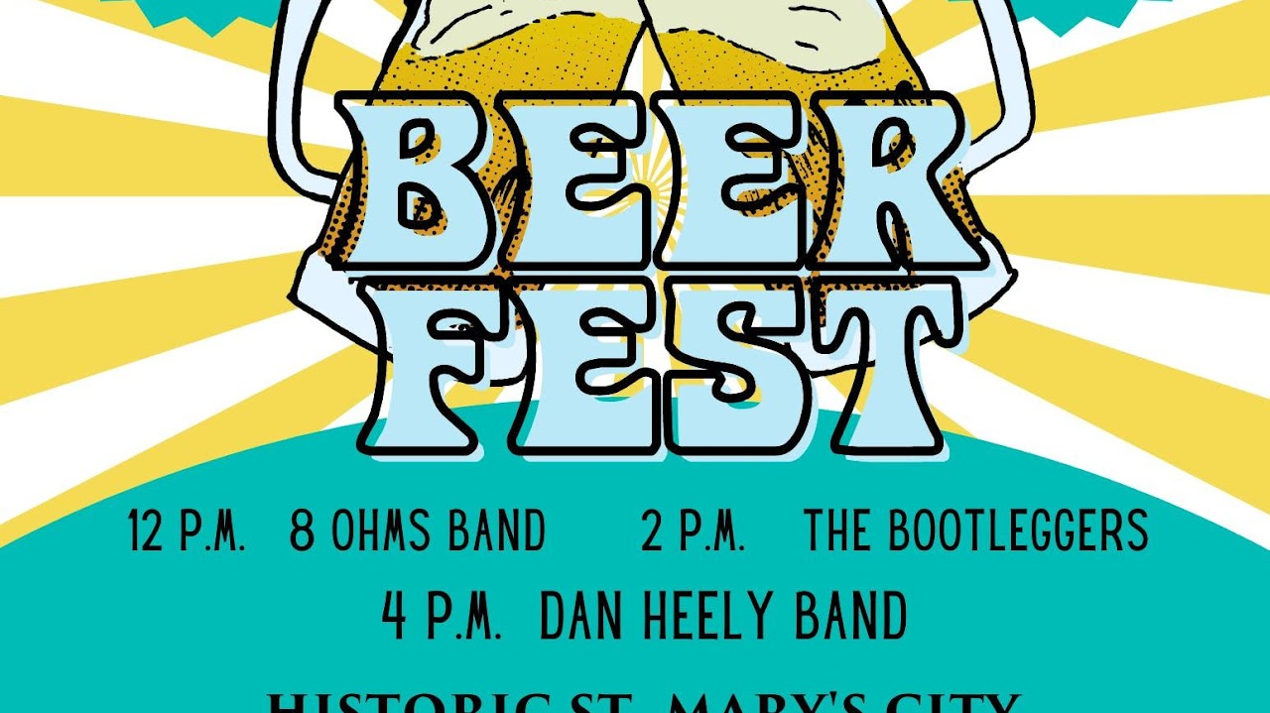

Beer Fest
Join HSMC Saturday, June 24, 2023, from noon to 6 p.m. for live music, food samples from local cuisine, and various regional craft brews. This is a fun, family-friendly event. Enjoy a beer while supporting further education and research at Historic St. Mary’s City. The festivities and live music begin at noon with local food and BEER!

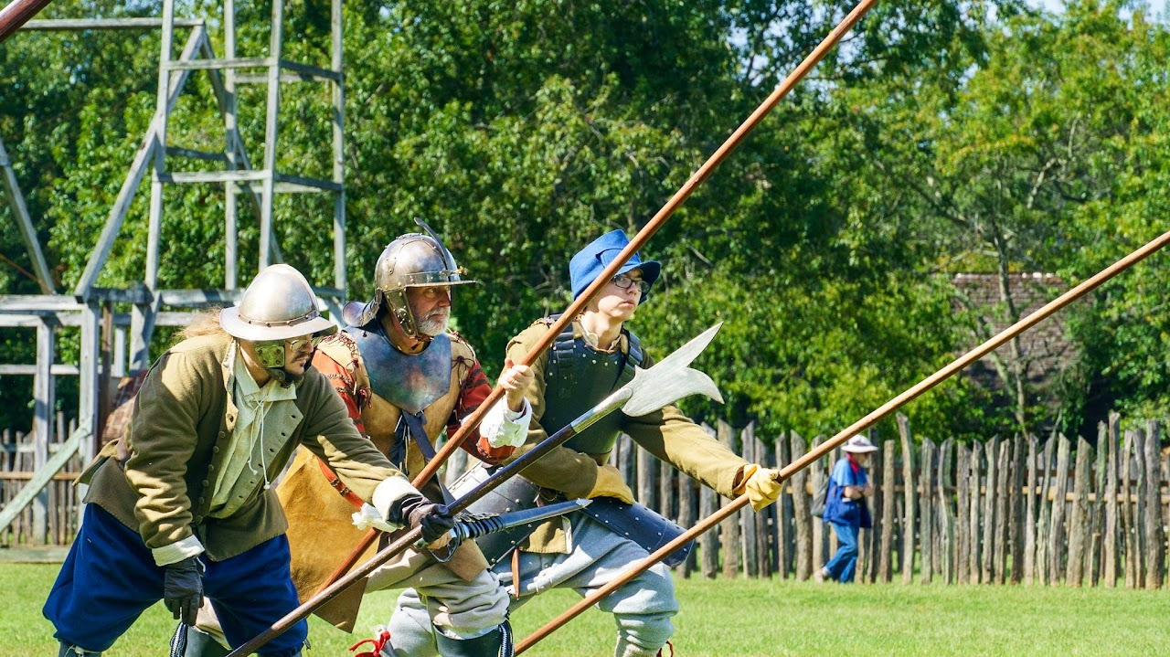

Militia Muster
The St. Maries Citty Militia, our host militia, is a volunteer group of men, women, and children who re-create a colonial Maryland “armed band” at Maryland’s first capital. This living history encampment features 17th-century re-enactment units from nearby and far away. Enjoy the camp activities of cooking, gossiping, trades, games, etc. Free admission includes grounds and activities. Info
47414 Old State House Road
St. Mary's City , 20686

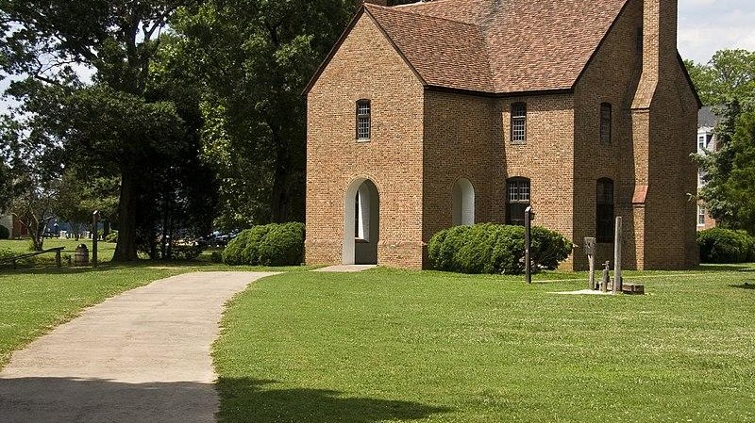
Maryland First Capital
Former Inn Elizabeth Hewitt Lee

