National Council of Churches
All NCC member organizations subscribe to the NCC's statement of faith, which forms the preamble to the NCC's charter:

"The National Council of Churches is a community of Christian communions, which, in response to the gospel as revealed in the Scriptures, confess Jesus Christ, the incarnate Word of God, as Savior and Lord. These communions covenant with one another to manifest ever more fully the unity of the Church. Relying upon the transforming power of the Holy Spirit, the communions come together as the Council in common mission, serving in all creation to the glory of God."

List of National Council of Churches members: American Baptist Churches USA; Episcopal Church in the United States of America; Evangelical Lutheran Church in America; Moravian Church in America; Presbyterian Church (USA); Reformed Church in America; Friends United Meeting; Philadelphia Yearly Meeting; United Church of Christ; United Methodist Church

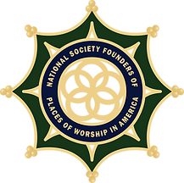

National Society Founders of Places of Worship in America
Membership is open to males and females of good moral character and reputation, at least eighteen years of age, who can prove lineal descent from a person who, in the timeframe prior to and including 1850 and within the territory that became the forty-eight contiguous states of the United States of America, contributed in one of the following categories:
A founding signer of a Covenant, doctrine, named in town minutes or referenced in historical documents as having met in faith or began a new house of worship in any faith.
Held membership within first year of founding or meeting.
Donated land or monies which were used to build a meeting place/building for worship.
Permitted property (land, home or building) to be used for the purposes of holding worship.
Circuit Rider and mobile Ministries, in which clergy traveled to more than one location to hold service.

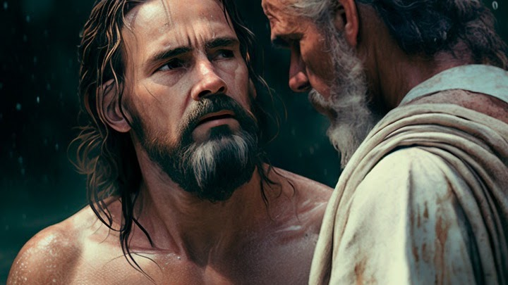

Baptists
Baptist Catechism

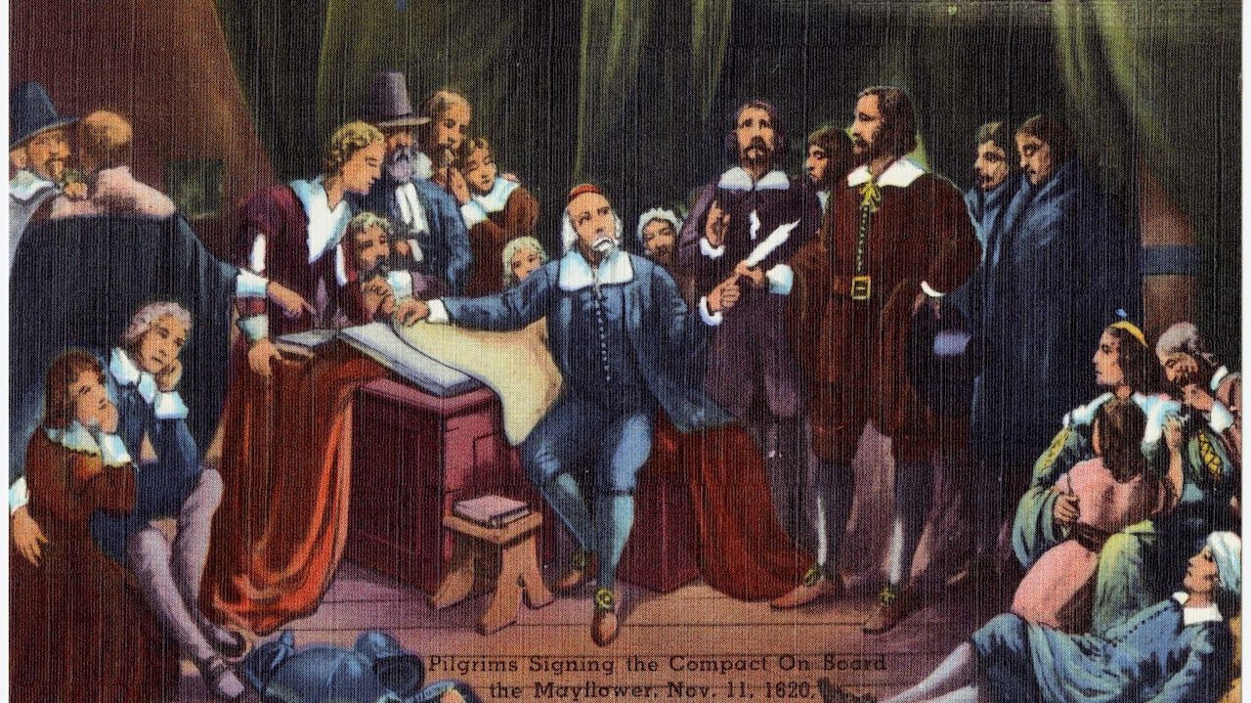
Congregationalism
Smaller Westminster Catechism Geneva Bible

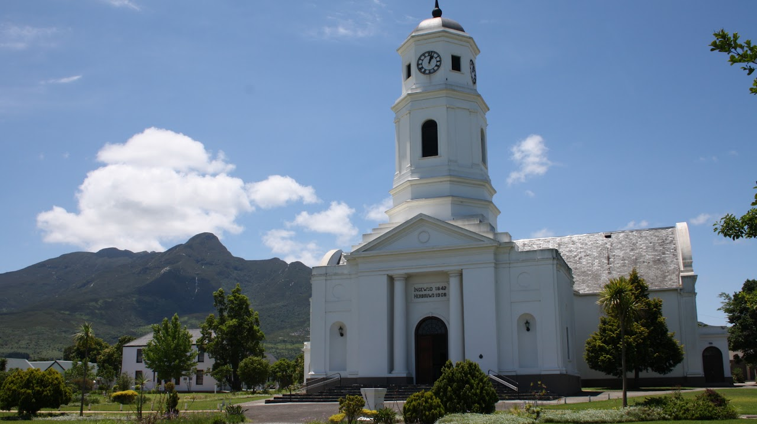

Dutch Reformed
Heildelberg Catechism

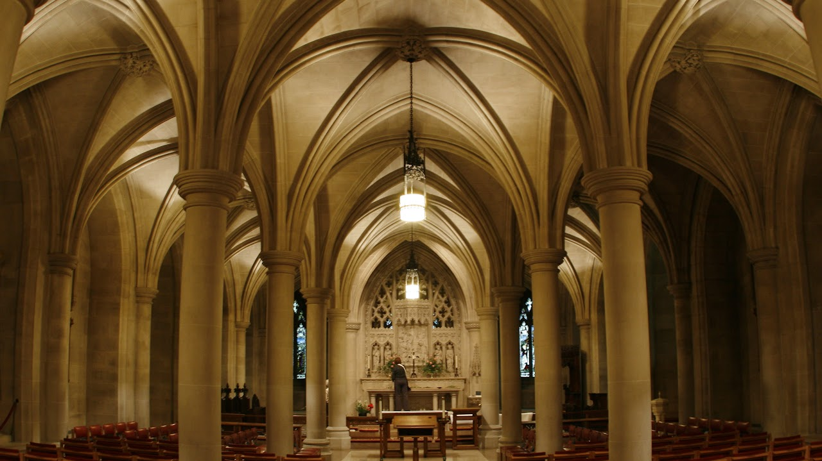

Episcopalian
Feel free to download the following books
King James Bible Book of Common Prayer 1662 Episcopalian Catechism

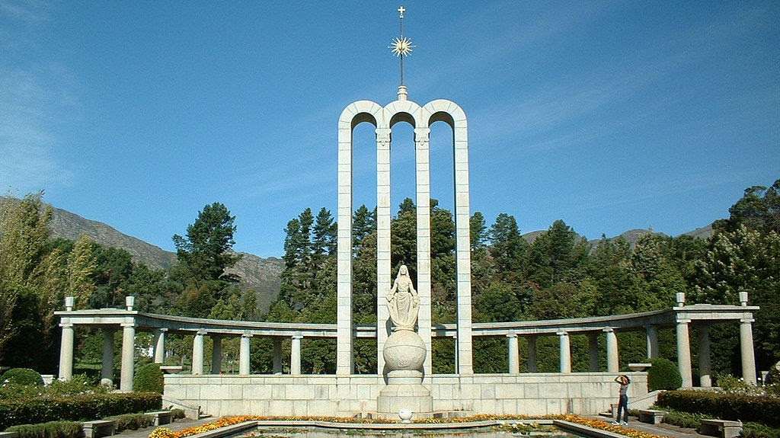

Heguenots
Liturgy.

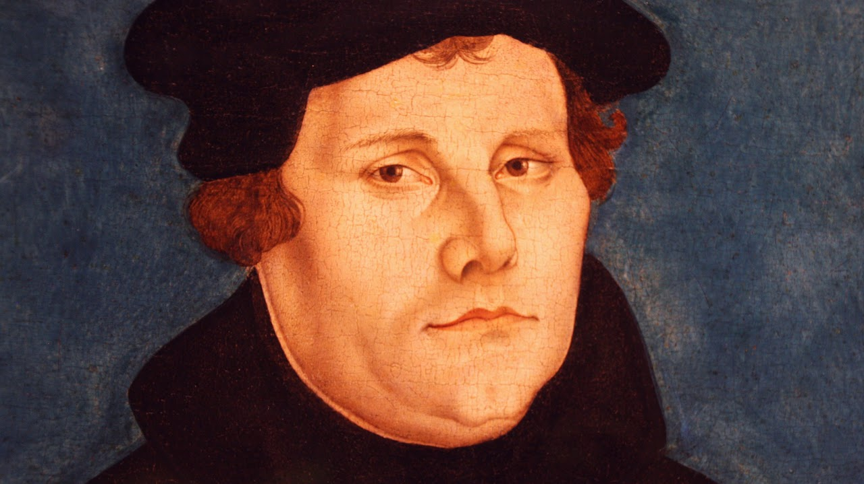

Lutheran
Luther's Small Catechism Book of Concord

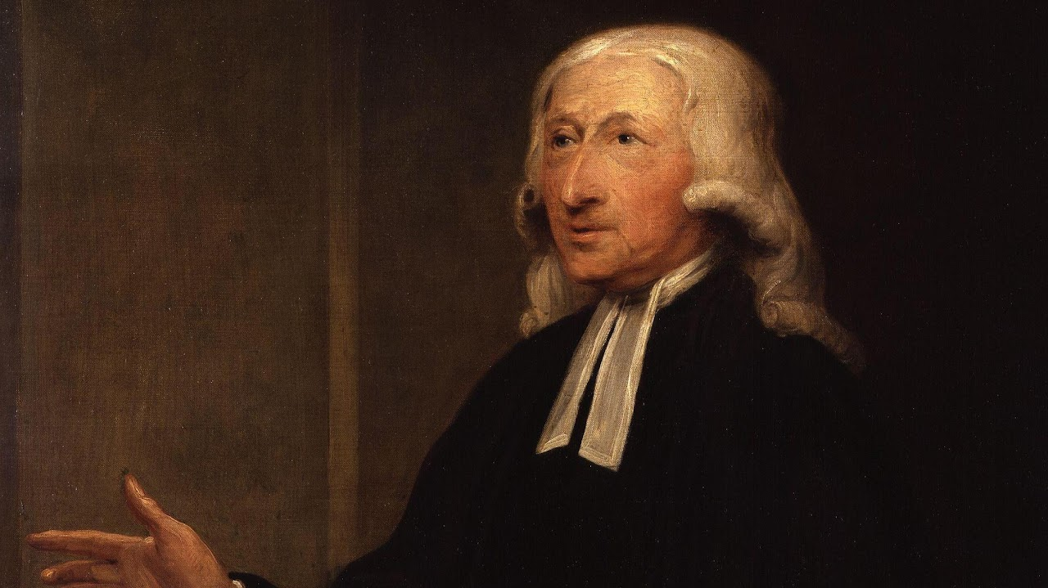

Methodist
Methodist Catechism Book of Discipline

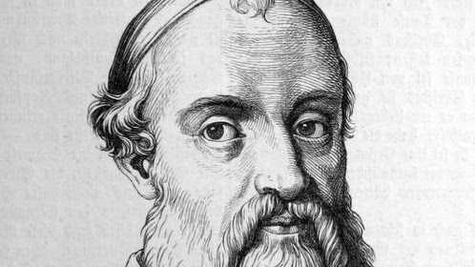

Mennonites
Elbing Catechism

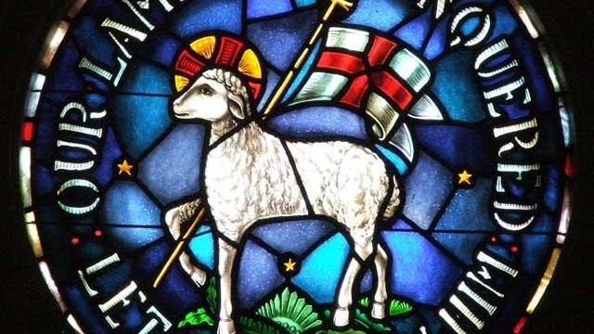

Moravian Church
Augsburg Confession Luther's Small Catechism Thirty-nine Articles of Faith Heidelberg Catechism

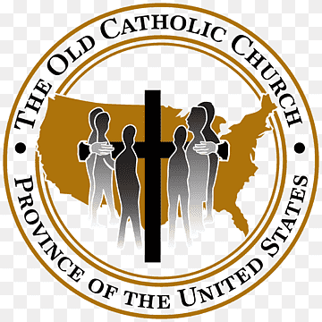

Old Catholics

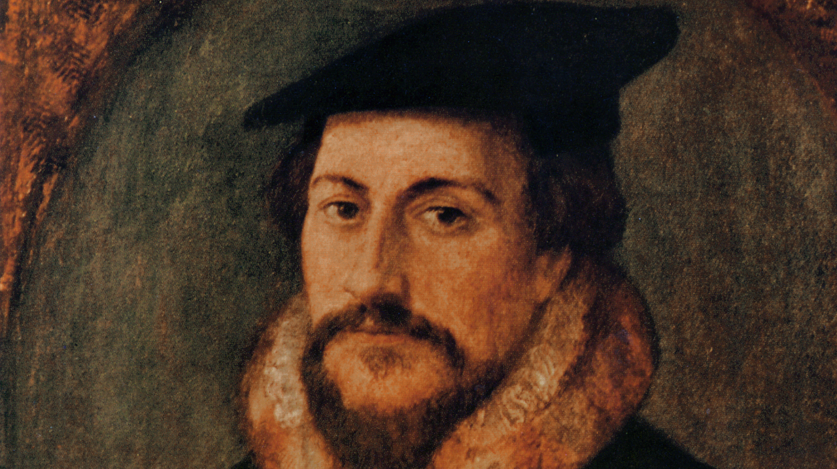

Presbyterians
Large Westminster Catechism Book of Confessions
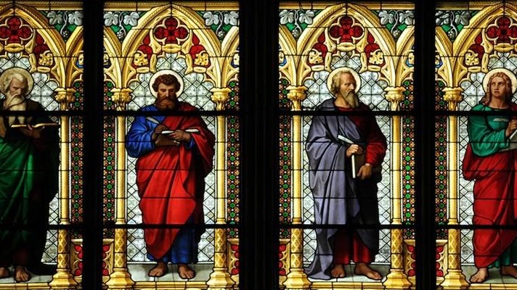

National Society of Saints
Welcome to the National Society of Saints and Sinners website. We are adding new information daily. Please check back with us often, as we enlarge our list of approved Saints. Our first Council meeting on 14 April 2011, was a tremendous success. Several items of import to our members were discussed and resolved. We extend a heartfelt thank you to our members for helping us make the Society an even greater pleasure to join.

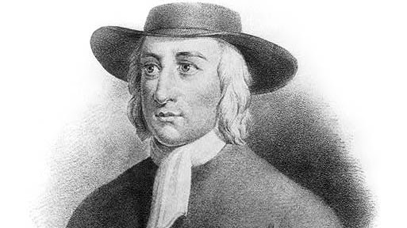

Quakers
Barclay Catechism Faith and Practice

I believe in God the Father, who hath made me, and all the world.
And in His only Son, Jesus Christ, who hath redeemed me, and all mankind.
And in the Holy Spirit, who sanctifies me, and all the Elect people of God.

