As the hometown of George Washington, Alexandria and its surrounding areas is no stranger to history. Washington, D.C., beautiful Mount Vernon, Arlington Cemetery and the National Masonic Temple are all just minutes away. Before or after their visit, guests have easy access to famous Old Town sites such as Robert E. Lee's boyhood home, George Washington's Townhouse and Market Square, one of the oldest market places in the whole country.

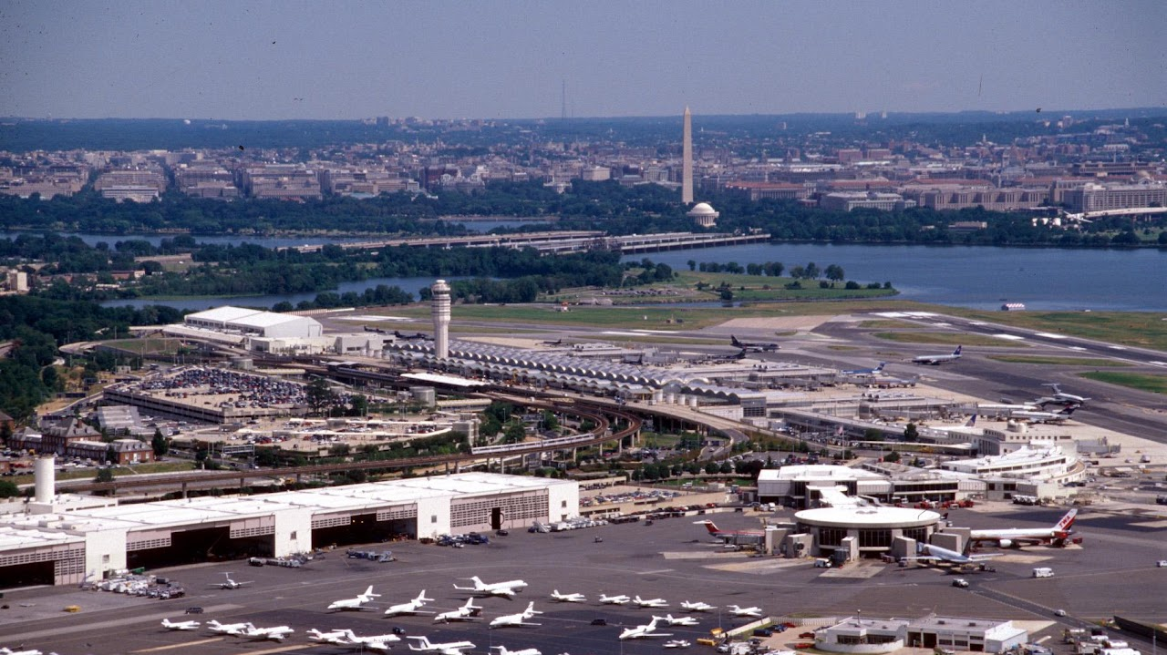

Reagan National Airport
From here you can go just about anywhere in the greater Washington DC area



Pentagon Visitor Center
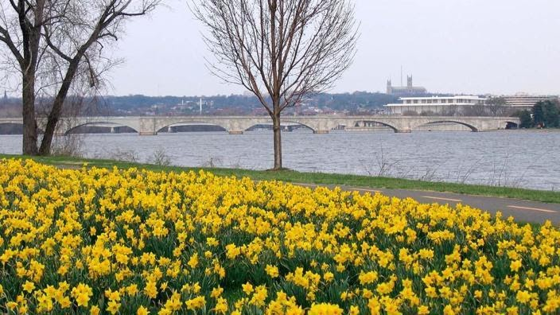

George Washington Memorial Parkway

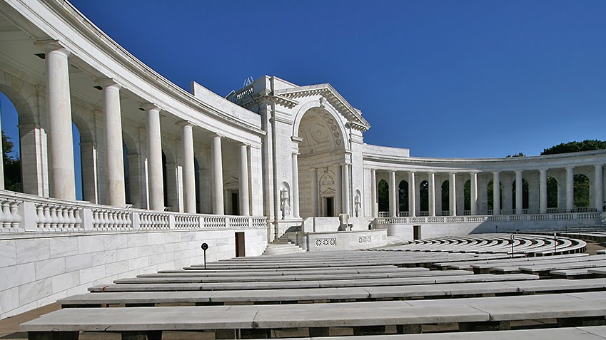

Arlington National Cemetery
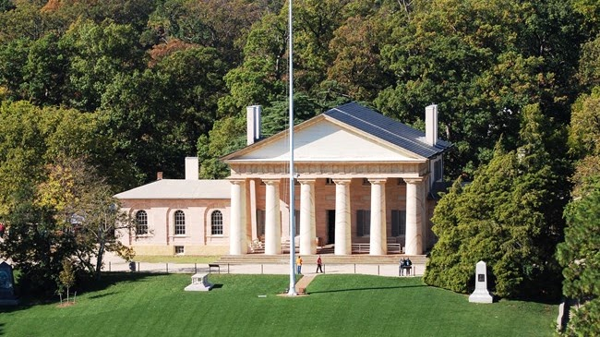

Arlington House

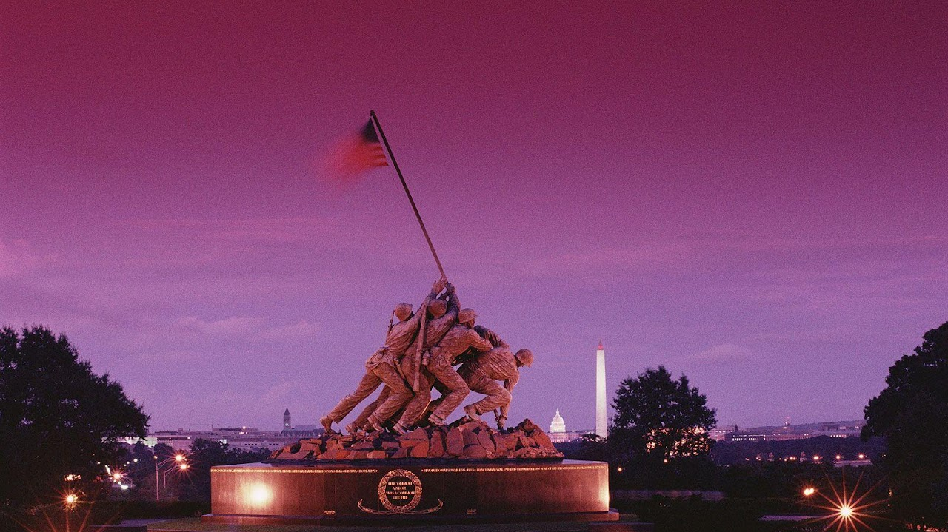

Marine Corps War Memorial

The United States Marine Corps War Memorial (Iwo Jima Memorial) is a national memorial located in Arlington County, Virginia. The memorial was dedicated in 1954 to all Marines who have given their lives in defense of the United States since 1775. It is located in Arlington Ridge Park within the George Washington Memorial Parkway

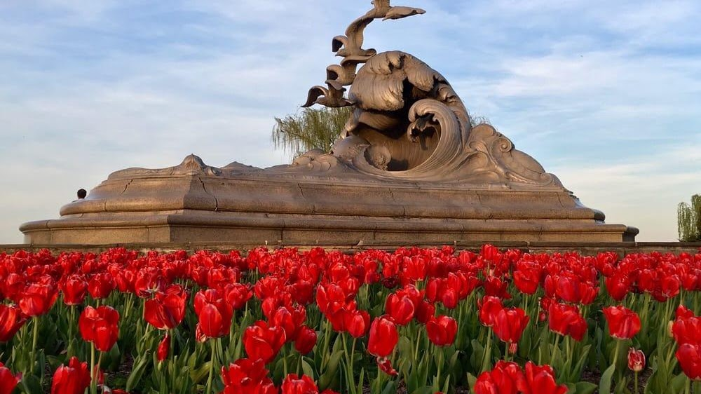

Merchant Marine Memorial

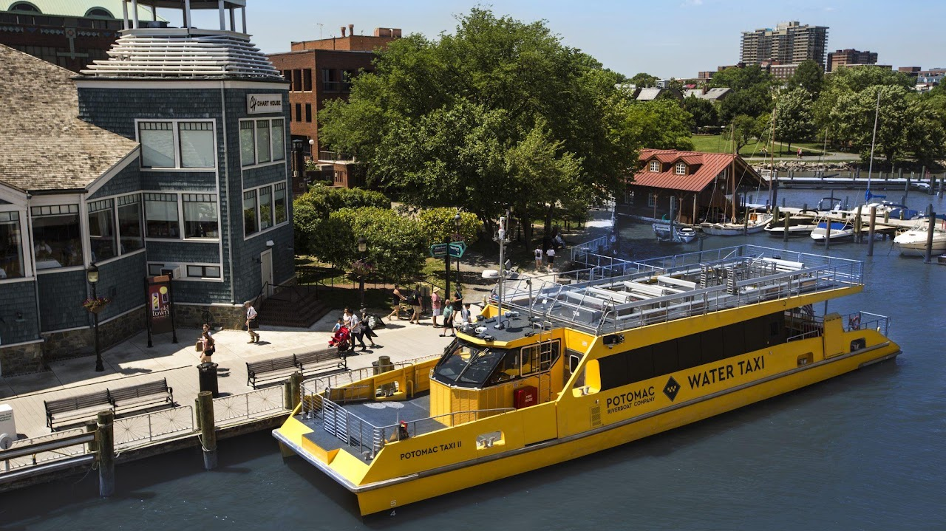

Water Taxi
Starting at $22 hour per person. To book.

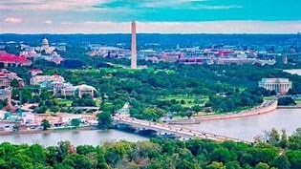

The View of DC

The View of DC is pleased to welcome the general public with free admission to experience the Observation Deck for yourself. Please note: Each visitor to the Observatory will need to present a valid form of identification for admission.
1201 Wilson Blvd., Suite 115, Arlington, VA 22209 (Entrance: 1731 N. Moore Street

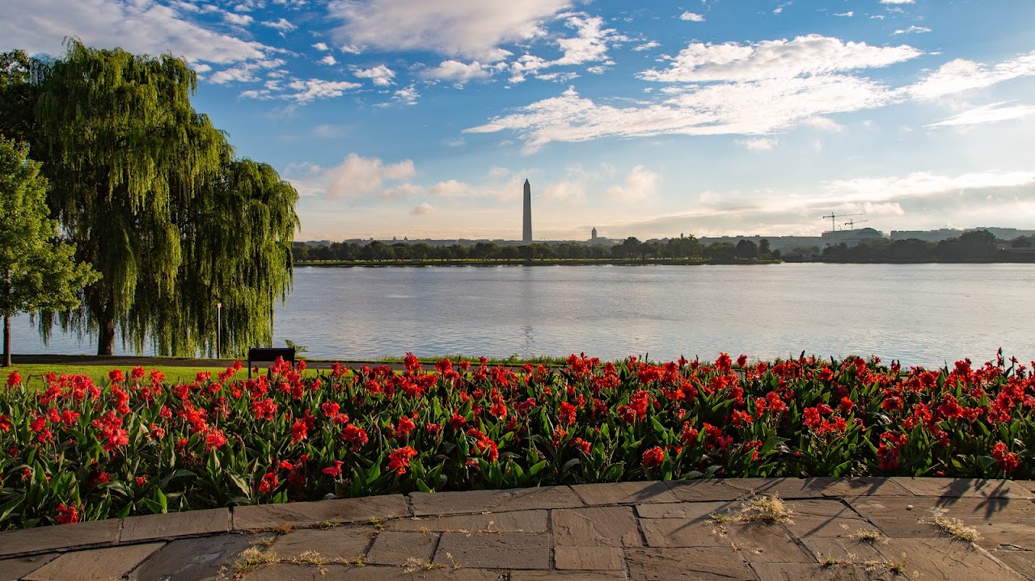

Lady Bird Johnson Park
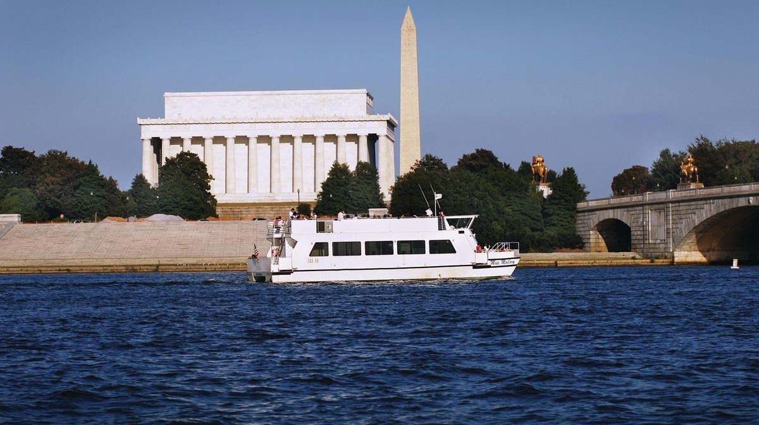

Monuments Sightseeing Tour From Alexandria
See the famous monuments of Washington, D.C. from an entirely new perspective on this narrated sightseeing cruise. Travel along the Potomac River to see the plethora of famous monuments and landmarks, with stunning reflective views of the Thomas Jefferson Memorial, the John F. Kennedy Center for the Performing Arts, the Washington Monument, the Arlington Memorial Bridge, and more. The docks for this tour are not ADA Compliant. Please visit our Potomac Water Taxi page which offers cruise options to the Wharf and National Harbor. We also offer an option to Mount Vernon From DC.

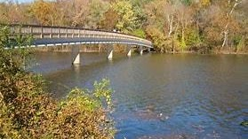

Theodore Roosevelt Island

