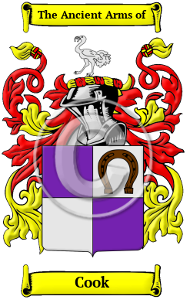

Cook

The saga of the name Cook follows a line reaching back through history to the days of the Anglo-Saxon tribes in Britain. It was a name for someone who worked as a cook, a seller of cooked meats, or a keeper of an eating-house. The surname Cook is derived from the Old English word coc, which means cook. Over the years, many variations of the name Cook were recorded, including Cooke, Cook, Cocus and others.
In the United States, the name Cook is the 56th most popular surname with an estimated 298,440 people with that name.
Cook's Old Mill is located in Monroe County West Virginia

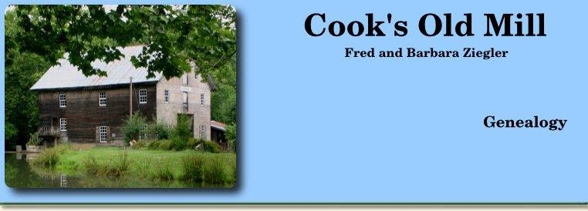

Cook's Old Mill

Cook's Old Mill is a mid-1800's gristmill on route 122, just ¼ mile west of Greenville, West Virginia. It is a privately owned park-like venue for tourists, history buffs, Cook descendants and mill enthusiasts. The mill is an anchor point on the Farm Heritage Road, one of Monroe County's Scenic Byways. The National Registry of Historic Places describes the mill as follows: Cook's Mill was built in 1857 on the original foundation and site of an earlier mill constructed in approximately 1796. The property surrounding this mill includes dam, mill pond, tail race and stream, and consists of 3 ½ acres. The mill was an important part of the community, serving as a gathering place. Construction elements include massive hand-hewn, mortise and tenon posts and beams.

