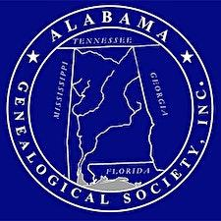

Alabama Genealogical Society

First Families of Alabama is a certificate program offered by the Alabama Genealogical Society to its members and is designed to identify and honor the memory of early residents of the state of Alabama. Early residents are those settlers who resided within the present boundaries of Alabama prior to statehood, 14 December 1819. Criteria for the certificate are:
- Membership* in Alabama Genealogical Society
- Completion of Application and Proof of Descent
- Attached copies of documented proof of descent for each generation
- A check for $20.00 for each certificate payable to Alabama Genealogical Society
The application and documentation is submitted to the First Families of Alabama Committee for verification of the information. Approved applications and documentation will be deposited in the Special Collection Department, Samford University Library, to help preserve the history of your ancestors and aid others in their research. This safe location prevents the possible loss of your valuable family research and preserves your lineage for easy retrieval by researchers. This program is one sure way to preserve your lineage as each member qualifying for the First Families of Alabama will receive a beautiful signed and numbered certificate, suitable for framing.
*Membership information can be found in the membership section

