Resources
https://www.familysearch.org/en/wiki/Overwharton_Parish,_Virginia
https://www.familysearch.org/en/wiki/Stafford_County,_Virginia

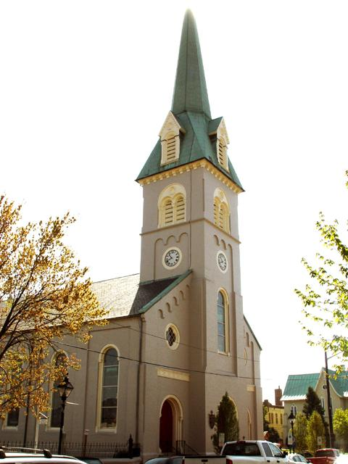

St George Parish
St. George's Episcopal Church is a church in Fredericksburg, Virginia. The church, built in the 18th century and re-built in 1815 and 1849, is a part of the Episcopal Diocese of Virginia. The building was listed on the National Register of Historic Places in 2019.
905 Princess Anne Street, Fredericksburg
Events - St. George's Episcopal Church (stgeorgesepiscopal.net)
- 7:45 am: Quiet and traditional, this spoken Eucharist service begins the day with prayers ancient and modern from our Book of Common Prayer Rite I.
- 9:00 am: A welcoming, multi-generational Eucharist using supplemental worship texts and led by our Jazz Ensemble and choir. Children and youth are encouraged to participate as lectors or acolytes. ASL Interpreting is available upon request. This service is also livestreamed on YouTube Live. Contact the church office for more information.
- 11:15 am: A Book of Common Prayer Eucharist rich in Anglican tradition, this service is led by the Choir of St. George’s with organ and the Chamber Ensemble. As at 9 am, children and youth are encouraged to participate as leaders.
- 5:30 pm: Candlelight, silence, quiet reflection and prayer, and music from the Celtic tradition are all part of our Celtic Evensong + Communion service.
- 8:00 pm: The Compline choir chants the this service for the end of the day. This service is livestreamed on Facebook Live.

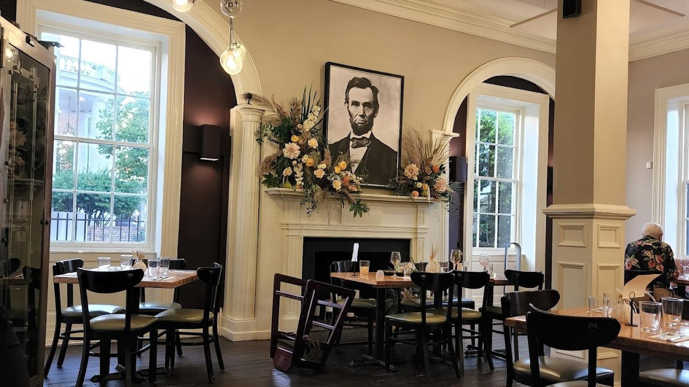

Foode
900 Princess Anne St Fredericksburg VA
Tel: 540-479-1370

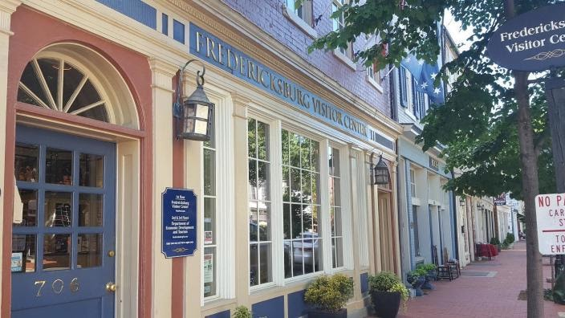

Visitor Center
706 Caroline Street Fredericksburg, VA 22401
5403731776

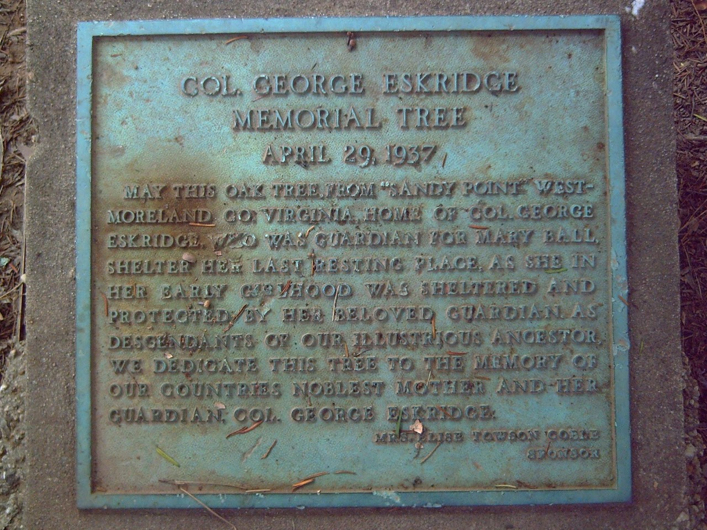
Eskridge Marker
Location. 38° 18.356′ N, 77° 28.144′ W. Marker is in Fredericksburg, Virginia. Marker can be reached from the intersection of Washington Avenue and Pitt Street. Touch for map. Marker is in this post office area: Fredericksburg VA 22401, United States of America. Touch for directions.

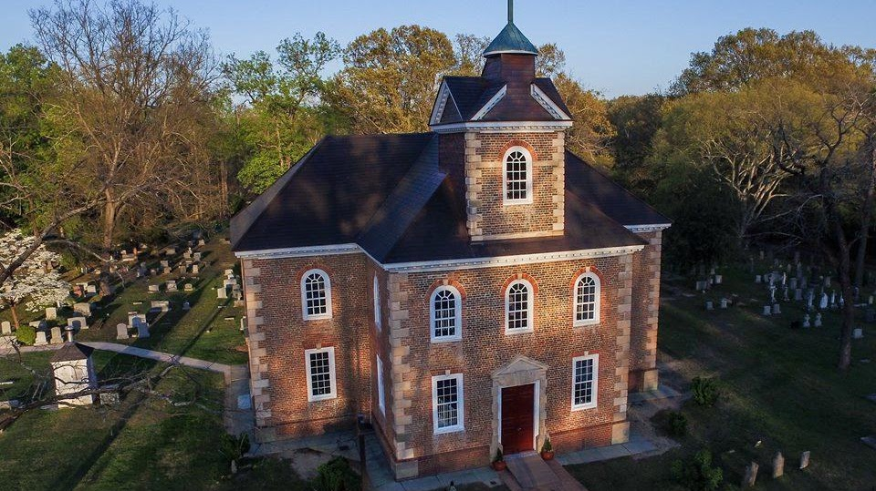

Aquia Episcopal Church
2938 Richmond Highway Stafford, VA 22554
(540) 659-4007 office@aquiachurch.org
Heritage Day and Homecoming are special services celebrated once a year, Heritage Day in May and Homecoming in September. Both services use the 1662 Book of Common Prayer, the BCP used when the church was founded and built in the Colonial era and include music that is appropriate to the time. The service also is an opportunity for the congregation to see the 1738 communion set given to the church by The Reverend Alexander Scott (1686-1738). We welcome anyone interested in attending the services in period attire. We also welcome The Peyton Society of Virginia, who visits Aquia Church on Heritage day.

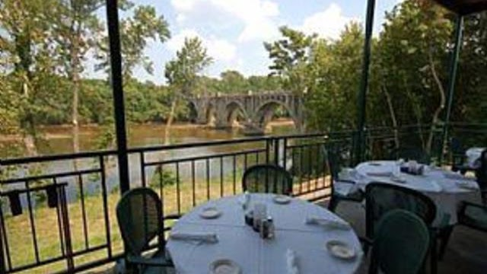

Brock's Riverside Grill
Location: 503 Sophia Street, Fredericksburg VA 22401
Phone Number: 540-370-1820

