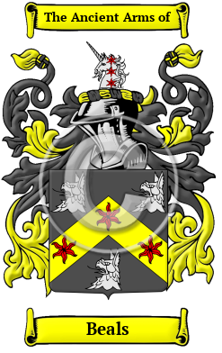

Beals

The Beals surname is thought to have been created from one of the places so named (in Northumberland, and in West Yorkshire). The place name derives from the Old English "beo," meaning "bee" and "hyll," meaning "hill." There is also a Norman name Beals derived from the Old French "bel." The name Beals, appeared in many references, and from time to time, the surname was spelt Beal, Beale, Beall, Bealle, Beel, Beele, Beales, Bealer and many more.
In the United States, the name Beals is the 4,142nd most popular surname with an estimated 7,461 people with that name

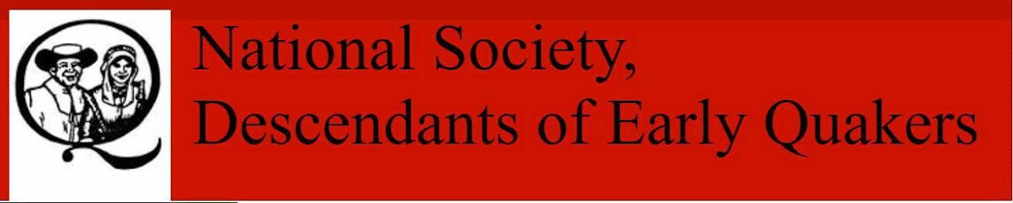

Early Quakers
Beal, William m Elizabeth X, settled in PA
Beal, William m Grace Gill, settled in PA
Beals, John m Margaret Hunt, settled in NC
Beals, John m Mary Clayton, settled in PA
Beals, Mary (Clayton) m John Beals, settled in PA
Beals, Thomas m Sarah Antrim, settled in OH
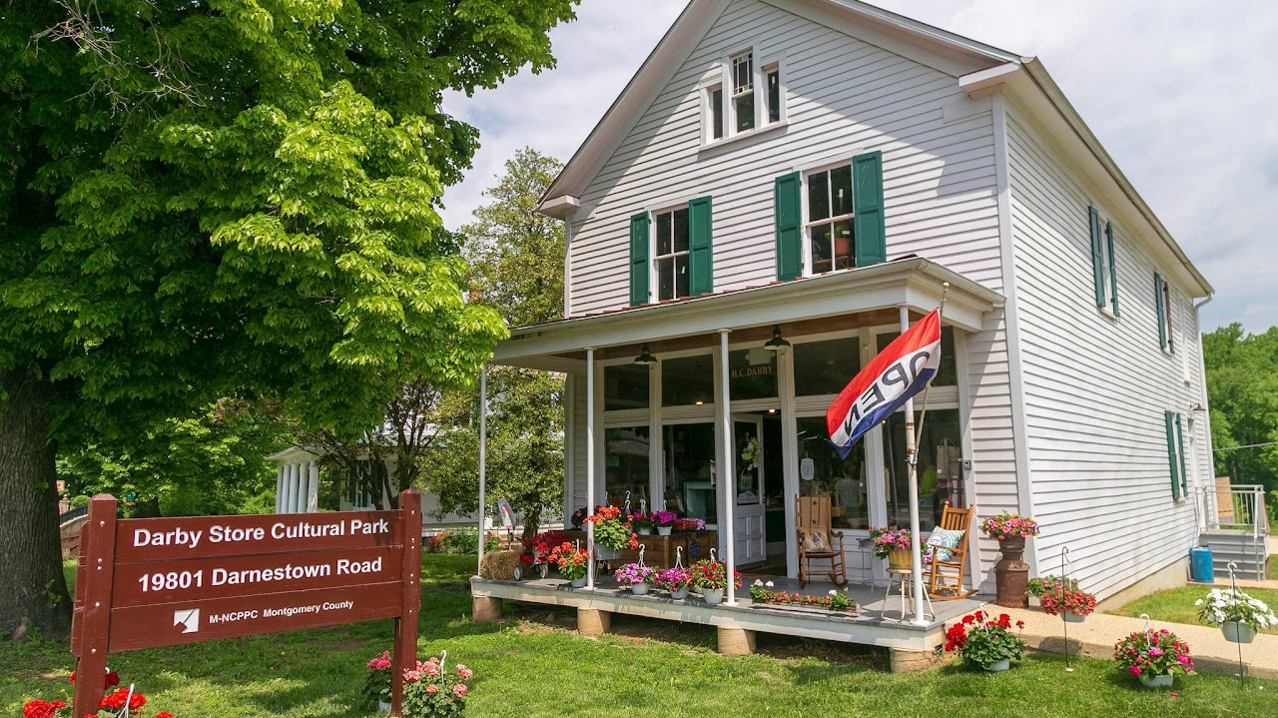

Beallsville Historic District
Park Hours - Sunrise to Sunset
19801 Darnestown Road Beallsville, MD
301-495-2595
Info@MontgomeryParks.org

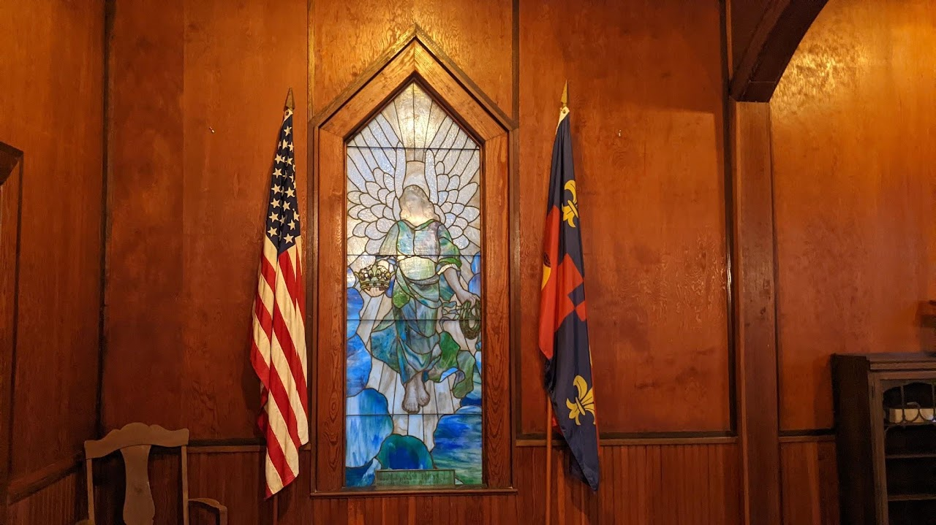

Monocacy Chapel

Monocacy Cemetery is located at 19801 W Hunter Rd. Beallsville, Montgomery County, Maryland
Monocacy Chapel, which was built in 1915 by the E.V. White Chapter of the United Daughters of the Confederacy to replace an earlier chapel. The original structure at the site, built sometime between 1734 and 1747, was a Chapel of Ease for early Anglican parishioners. A second chapel on the site was built circa 1760. During the Civil War, Union soldiers reportedly used this chapel as a stable for their horses and destroyed it beyond repair.

