Ecumenical

This National Council of Churches members include Evangelical Lutheran Church in America, American Baptist Churches USA, Moravian Church in America, Polish National Catholic Church, Presbyterian Church USA, Friends United Meeting, Philadelphia Yearly Meeting, United Church of Christ, Reformed Church in America, United Methodist Church and the Episcopal Church USA

Westminster Savoy Philadelphia Confessions of Faith

In England in 1646 the Presbyterians wrote the Westminster Confession of Faith. In 1658 the Congregationalists took the Westminster Confession of Faith and added "Congregational governance" and called it the Savoy Declaration of Faith. In 1689 the Baptist took the Savoy Declaration of Faith and added "Believers Baptism" and called it the London Baptist Confession of Faith. In Pennsylvania, in 1742 the Baptist took the London Baptist Confession of Faith and added 2 more ordinances: "Signing" and the "Laying on of Hands" and called it the Philadelphia Confession of Faith.

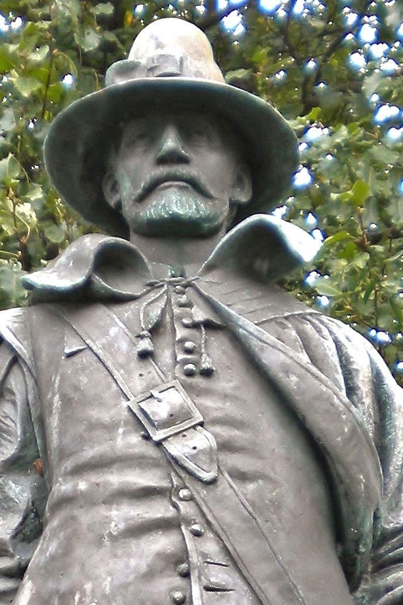

William Bradford

William Bradford (c. 19 March 1590 – 9 May 1657) was an English Puritan Separatist originally from the West Riding of Yorkshire in Northern England. He moved to Leiden in Holland in order to escape persecution from King James I of England, and then emigrated to the Plymouth Colony on the Mayflower in 1620. He was a signatory to the Mayflower Compact and went on to serve as Governor of the Plymouth Colony intermittently for about 30 years between 1621 and 1657. He served as a commissioner of the United Colonies of New England on multiple occasions and served twice as president. His journal Of Plymouth Plantation covered the years from 1620 to 1646 in Plymouth.

List of Historical Congregational Churches

First Parish Plymouth MA.
Evangelical Reformed United Church of Christ 15 West Church St. | Frederick, MD

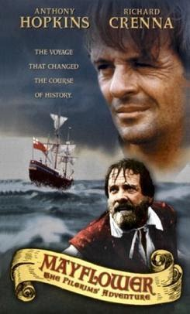

Mayflower Pilgrims

The Pilgrims, also known as the Pilgrim Fathers, were the English settlers who traveled to America on the Mayflower and established the Plymouth Colony in Plymouth, Massachusetts (John Smith had named this territory New Plymouth in 1616, coincidentally sharing the name of the Pilgrims' final departure port of Plymouth, Devon.). The Pilgrims' leadership came from the religious congregations of Brownists, or Separatist Puritans, who had fled religious persecution in England for the tolerance of 17th-century Holland in the Netherlands.

Geneva Bible

Evangelical Catechism

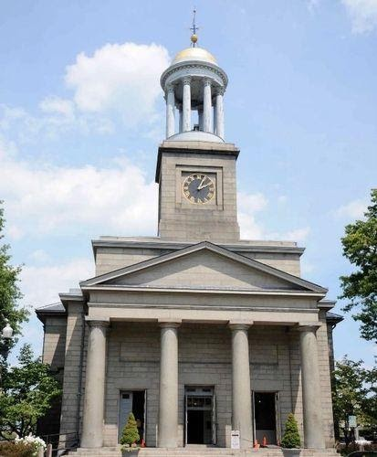

United First Parish Church

Honoring the Adams Presidents as a part of a national wreath-laying tradition. Twice each year the President of the United States sends a wreath to the United First Parish Church to be placed on the tomb of the Adams Presidents. This national tradition started during the administration of President Lyndon Johnson in 1967. Each year, wreaths of red, white and blue flowers are sent to the burial places of all deceased presidents on the anniversary of their birthday. The United First Parish Church, Church of the Presidents is the proud keeper of this important annual recognition of our Presidential heritage. Admission to the wreath-laying ceremony, the Adams Crypt and Church Sanctuary are free. Donations to support the History and Visitors Program are greatly appreciated. United First Parish Church is located at 1306 Hancock Street, Quincy, MA 02169.

For more information about the ceremonies, please email office@ufpc.org or call 617-773-1290.

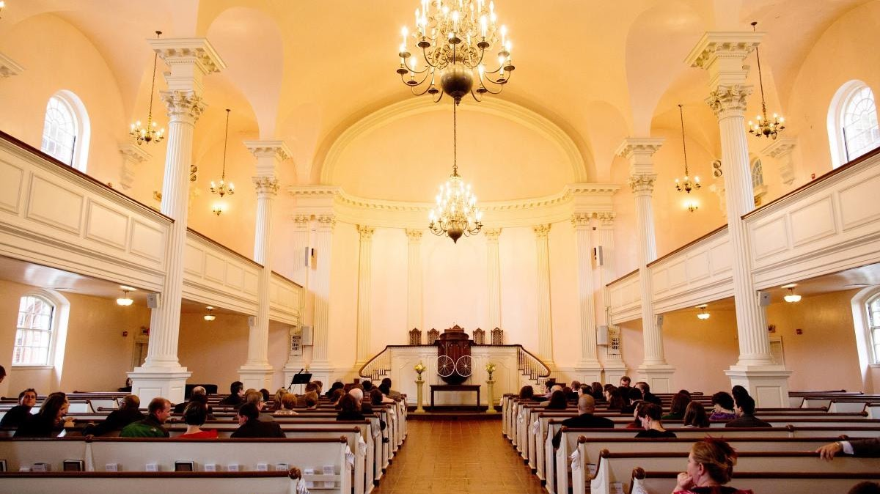

All Souls Church DC (Unitarian)

Founded by President John Quincy Adams and Vice President John C. Calhoun. Listed in the National Register – Reference number 100005905. 1500 Harvard St. NW Washington DC

