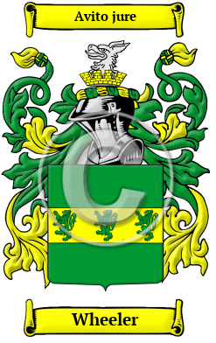
Wheeler
The many generations and branches of the Wheeler family can all place the origins of their surname with the ancient Anglo-Saxon culture. Their name reveals that an early member worked as a wheelwright. In medieval times wheels were wooden and quite fragile and high maintenance. Thus there was a high demand for both wheels and skilled people to make and repair them. Over the years, many variations of the name Wheeler were recorded, including Wheeler, Wheler, Wheller and others.
In the United States, the name Wheeler is the 208th most popular surname with an estimated 126,837 people with that name

