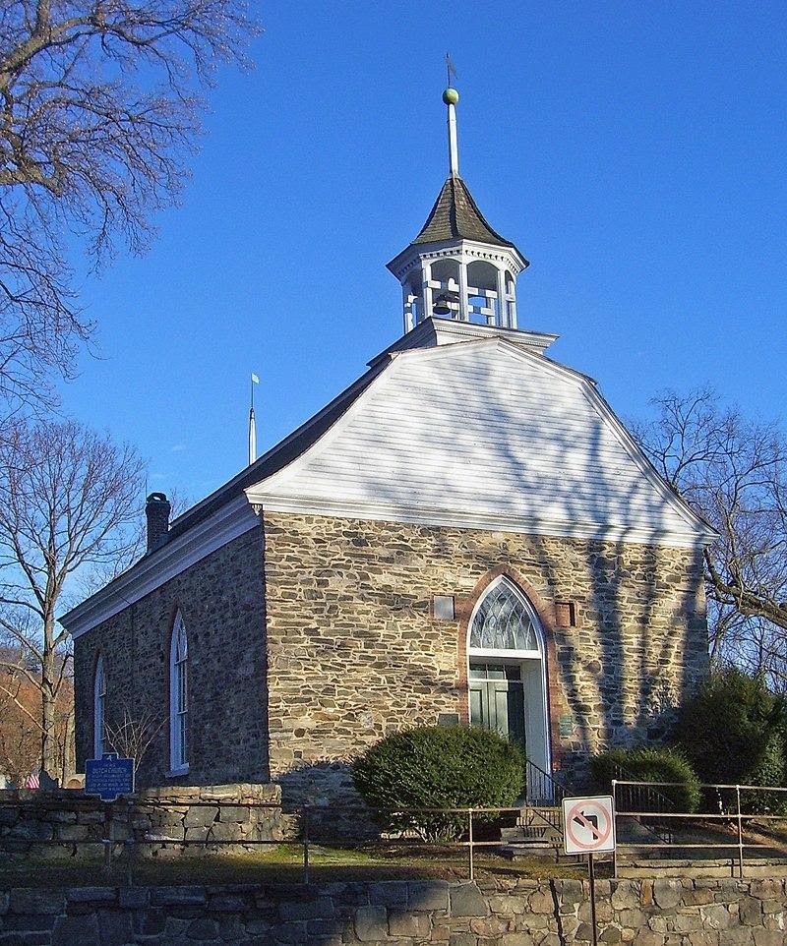

Old Dutch Church

The Old Dutch Church of Sleepy Hollow , listed on the National Register of Historic Places as Dutch Reformed Church (Sleepy Hollow), is a 17th-century stone church located on Albany Post Road (U.S. Route 9) in Sleepy Hollow, New York, United States. It and its three-acre (1.2 ha) churchyard feature prominently in Washington Irving's 1820 short story "The Legend of Sleepy Hollow". The churchyard is often confused with the contiguous but separate Sleepy Hollow Cemetery. It is the second oldest extant church and the 15th oldest extant building in the state of New York, renovated after an 1837 fire. Some of those renovations were reversed 60 years later, and further work was done in 1960. It was listed on the Register in 1966, among the earliest properties so recognized. It had already been designated a National Historic Landmark in 1961. It is still the property of the Reformed Church of the Tarrytowns, which holds summer services there, as well as on special occasions such as Christmas Eve.
From mid-June til after Labor Day we worship at the Old Dutch Church of Sleepy Hollow at 10:00 a.m. Sundays.
(914) 631-4497
Email us here
42 N. Broadway, Tarrytown, N.Y. 10591

