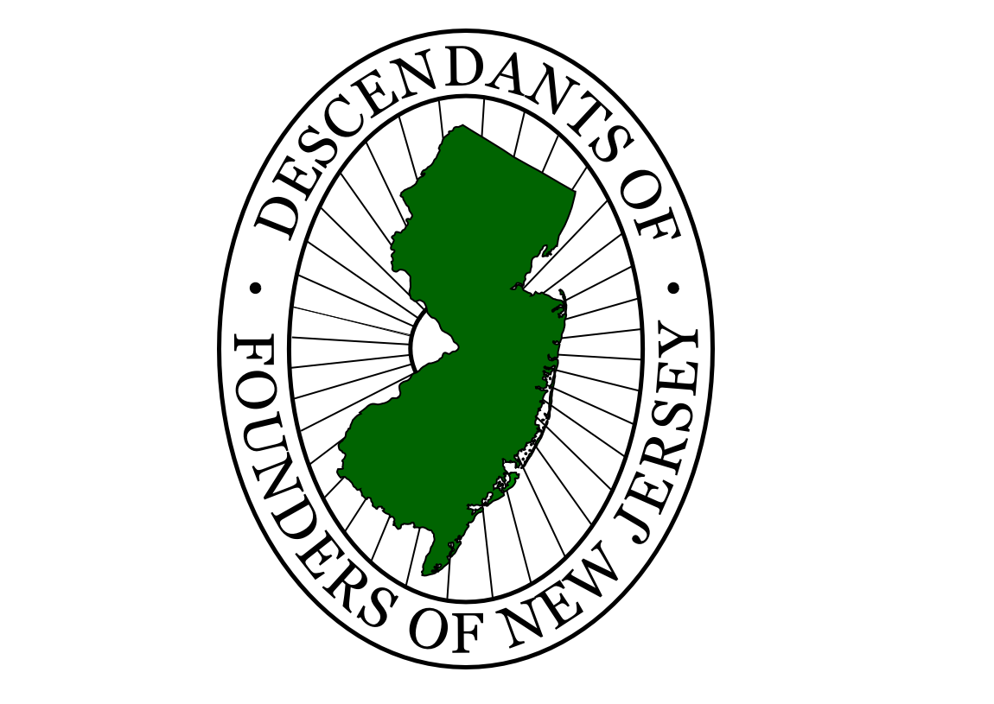

Descendants of Founders of New Jersey

Settlers came to East Jersey as early as 1618 when the Dutch from New Amsterdam settled at Bergen (now Jersey City), and in West Jersey as early as 1623 when Fort Nassau was established on the Delaware River. In March 1664, King Charles II formally granted the land to his brother, James, Duke of York. In June 1664, James divided the grant between Lord John Berkeley and Sir George Carteret. The two Jerseys were formally divided by the Quintipartite Deed of 1 July 1676 and governed as separate proprietary colonies until 17 April 1702.

