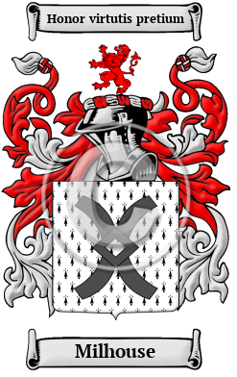
Milhouse
Milhouse is an ancient Norman name that arrived in England after the Norman Conquest of 1066. The Milhouse family lived at or near a mill having derived from the Old English word mylen, which meant mill. The name has been spelled Mills, Mylles, Meiles and others.

