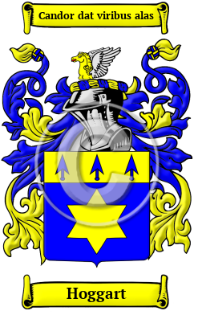

Hoggart

The name Hoggart is rooted in the ancient Anglo-Saxon culture. It was originally a name for someone who worked as a keeper of cattle and pigs. The surname Hoggart originally derived from the Old English words "hogg" + "hierde." The variations of the name Hoggart include Hogarth, Hoggart, Hoggarth, Hoggard, Hoggarde and others.

