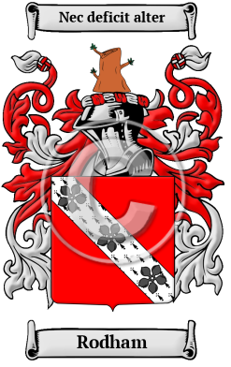

Rodham History, Family Crest & Coats of Arms
- Origins Available:
- England

Ireland
Early Origins of the Rodham family
The surname Rodham was first found in Northumberland where they held a family seat at Roddam Hall since 1296 when William Roddam had the hall built. "Roddam Hall is a handsome modern mansion, standing on a bold eminence which on the north forms the bank of a deep romantic dell watered by a tributary of the Till. A stone coffin and an urn were dug up here in 1796." 1
John of Roddam held land in Little Houghton in 1337. The Roddam family has held the hall until at least 1776 when it was owned by Admiral Robert Roddam (1719-1808).
Roddam is derived from the Old English word "rod" which means "clearing" 2. Alternatively, the name could have been derived from the place name Rodden in Shropshire. There is also a Rodden River in Shropshire.
Early History of the Rodham family
This web page shows only a small excerpt of our Rodham research. Another 127 words (9 lines of text) covering the years 1200, 1461, 1491, 1591, 1755 and 1890 are included under the topic Early Rodham History in all our PDF Extended History products and printed products wherever possible.
Rodham Spelling Variations
Spelling variations of this family name include: Roddam, Rodden, Roddan, Roddin, Rodan and others.
Early Notables of the Rodham family
Another 27 words (2 lines of text) are included under the topic Early Rodham Notables in all our PDF Extended History products and printed products wherever possible.
Migration of the Rodham family to Ireland
Some of the Rodham family moved to Ireland, but this topic is not covered in this excerpt.
Another 89 words (6 lines of text) about their life in Ireland is included in all our PDF Extended History products and printed products wherever possible.
Migration of the Rodham family
Some of the first settlers of this family name or some of its variants were: Edward, John, Mary Rodden, who all arrived in Philadelphia between 1840 and 1870; John Roddan settled in Philadelphia in 1833; Homer Rodan settled in Virginia in 1698..

Contemporary Notables of the name Rodham (post 1700) | +
- Hugh Edwin Rodham (b. 1950), American Democratic Party politician, Candidate for U.S. Senator from Florida, 1994 3
- Hillary Rodham Clinton (b. 1947), American Democratic Party politician, U.S. Senator from New York, 2001-; Delegate to Democratic National Convention from New York, 2004, 2008; U.S. Secretary of State, 2009- 4

Related Stories | +

The Rodham Motto | +
The motto was originally a war cry or slogan. Mottoes first began to be shown with arms in the 14th and 15th centuries, but were not in general use until the 17th century. Thus the oldest coats of arms generally do not include a motto. Mottoes seldom form part of the grant of arms: Under most heraldic authorities, a motto is an optional component of the coat of arms, and can be added to or changed at will; many families have chosen not to display a motto.
Motto: Nec deficit alter
Motto Translation: Another succeeds.

