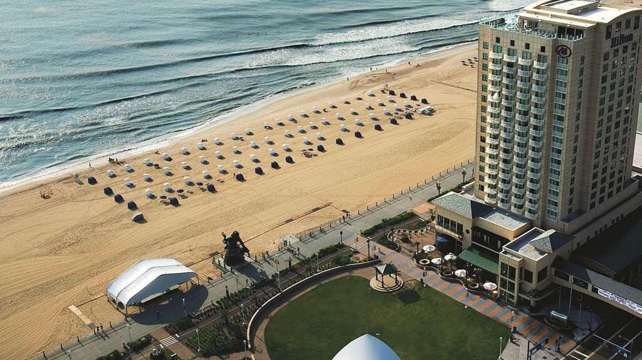

Hilton

Hey this is a vacation and you should have some fun. All of our ancestors would have passed by Virginia Beach regardless if their destination. If you can afford it you should definitely stay at the Hilton on Virginia Beach, if not at least stop there for Happy Hour. Many times the city will provide free entertainment next door at the Neptune statue and you can enjoy the music from the Hilton.

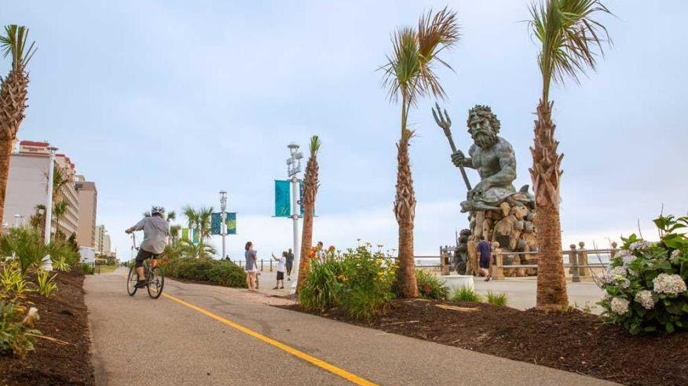

Neptune Park

Neptune's Park, a picturesque outdoor venue featuring nightly entertainment throughout the summer, is on the Virginia Beach oceanfront at 31st Street, part of the 31 Ocean Corridor. The Free Summer Concert Series includes a series of eight extremely talented and diverse national recording artists performing for the residents and guests of Hampton Roads to enjoy. All concerts are FREE and Open to the Public and begin at 7pm. The 31 Ocean Corridor at 31st Street and Atlantic Avenue offers a beautiful four-star hotel, two award winning restaurants, the only roof top bar at the oceanfront, a picturesque outdoor venue featuring nightly entertainment throughout the summer and fabulous boutiques all in one location, 31Ocean truly is a destination unto itself.

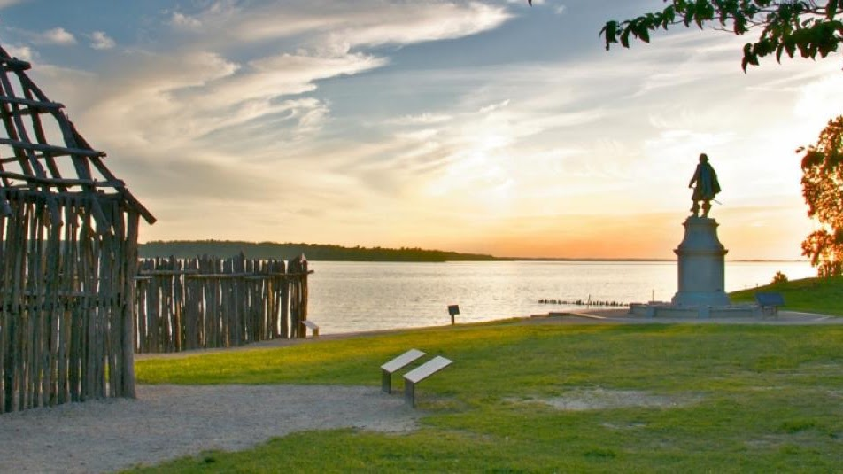

Jamestowne National Park

Walk in the footsteps of Pocahontas and John Smith at the original site of the first permanent English settlement in America. Witness the moment of discovery with Jamestown Rediscovery archaeologists as they excavate James Fort. Take a walking tour with an archaeologist, park ranger, or costumed living history character. View exhibits and galleries located in our award-winning archaeological museum. At the Glasshouse, costumed glassblowers demonstrate Jamestown's first industry, and the Island Loop Drive explores the natural environment.
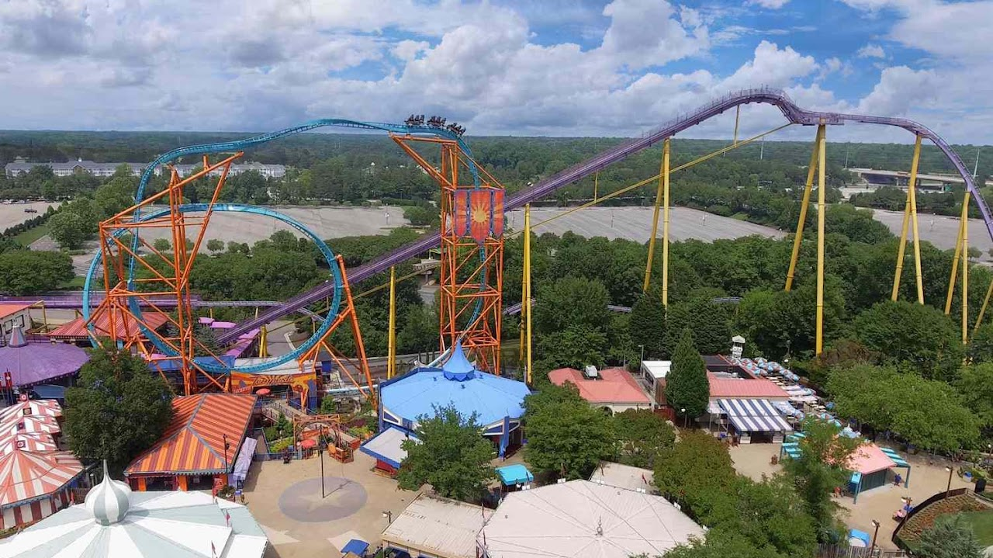

Busch Gardens Williamsburg
10:00 am - 8:00 pm

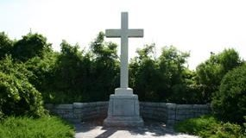

First Cross

First Cross. Virginia Beach, Virginia (great place to go swimming). Listed on: Seashore State Park Historic District, U.S. National Register of Historic Places, U.S. Historic district, Virginia Landmarks Register

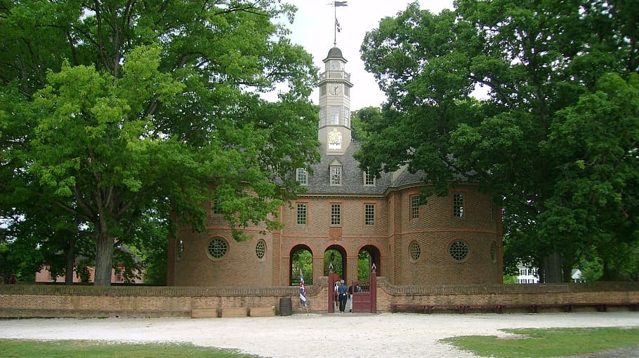

House of Burgesses

Where many of ancestors served. The House of Burgesses was the elected representative element of the Virginia General Assembly, the legislative body of the Colony of Virginia. From 1642 to 1776, the House of Burgesses was an instrument of government alongside the royally-appointed colonial governor and the upper-house Council of State in the General House.

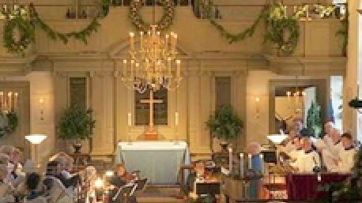

Bruton Parish

Bruton Parish, (Episcopalian). This is the church were so many of America’s Founding Fathers worshipped, including the Holy Trinity: George Washington, Thomas Jefferson and James Madison. Also our ancestors worshipped here. It is beautifully restored. Stop at least to sit in George Washington’s pew and give thanks to God.

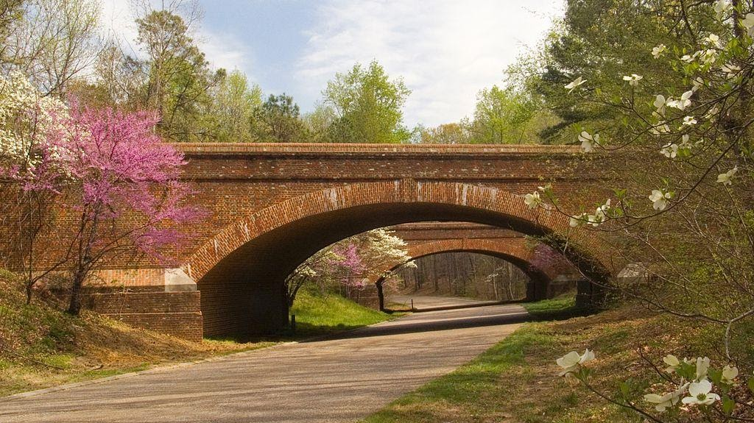

Colonial Parkway

scenic parkway linking the three points of Virginia's Historic Triangle, Jamestown, Williamsburg, and Yorktown. It is part of the National Park Service's Colonial National Historical Park.

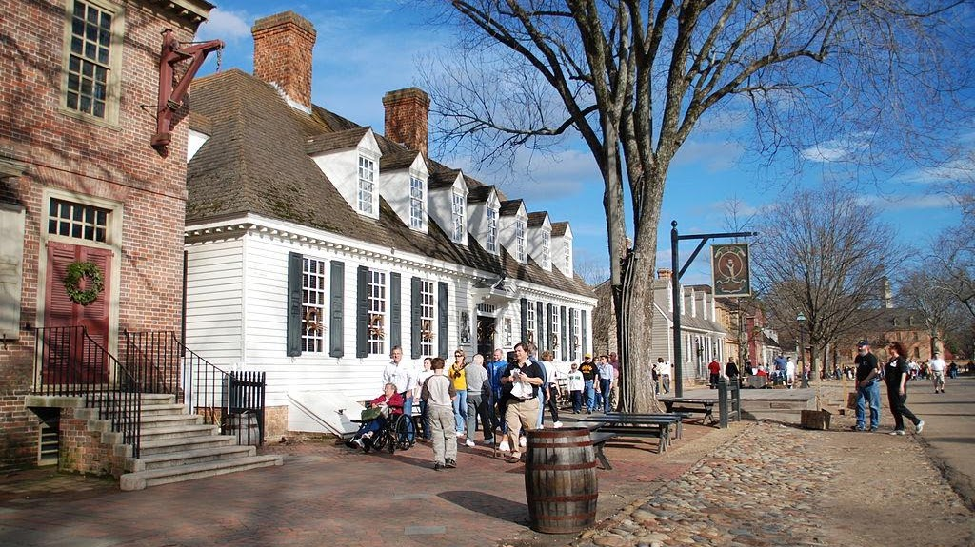

Colonial Williamsburg

Colonial Williamsburg is a living-history museum and private foundation presenting a part of the historic district in the city of Williamsburg, Virginia. Its 301-acre (122 ha) historic area includes several hundred restored or recreated buildings from the 18th century, when the city was the capital of the Colony of Virginia; 17th-century, 19th-century, and Colonial Revival structures; and more recent reconstructions. The historic area includes three main thoroughfares and their connecting side streets that attempt to suggest the atmosphere and the circumstances of 18th-century Americans. Costumed employees work and dress as people did in the era, sometimes using colonial grammar and diction

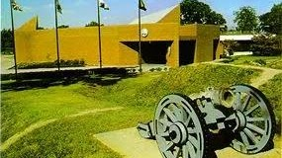

Yorktown National Park

The Yorktown Visitor Center is the orientation point for your visit to Yorktown and Yorktown Battlefield. At the visitor center information desk, you can obtain a park brochure with maps and information, an orientation to the park, and an opportunity to schedule your visit around the various interpretive programs going on throughout the day.

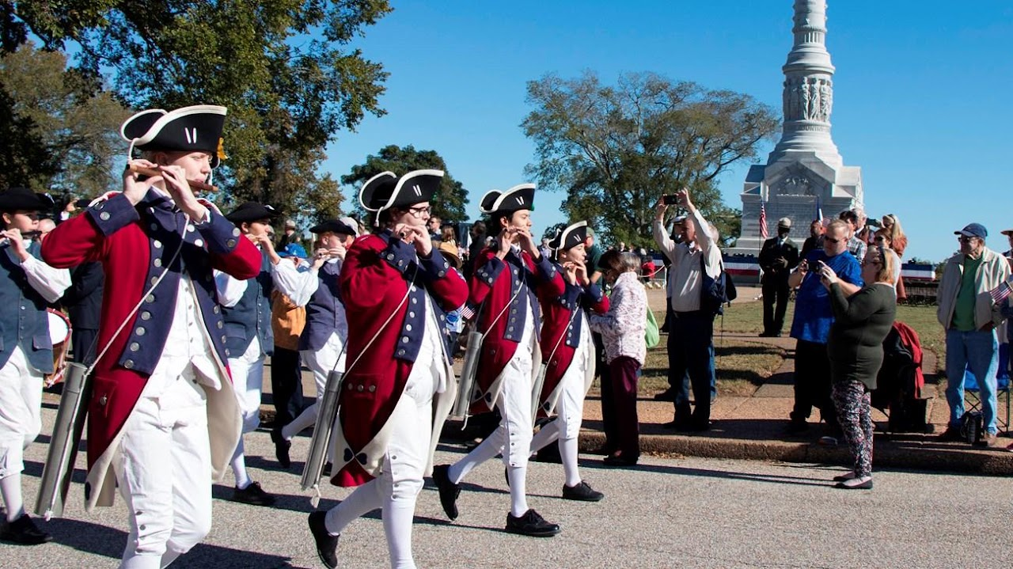

Yorktown Battlefield

Discover what it took for the United States to be independent as you explore the site of the last major battle of the Revolutionary War. Here at Yorktown, in the fall of 1781, General George Washington, with allied American and French forces, besieged General Charles Lord Cornwallis’s British army. On October 19, Cornwallis surrendered, effectively ending the war and ensuring independence.

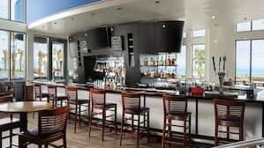

Catch 31

Located next to Neptune Park and overlooking the spectacular views of the Atlantic Ocean Catch 31 Fish House and Bar is the spot for the freshest local seafood and live entertainment. Whether you are dining on one of our many patios or indoors the views lure visitors and local alike. The menu boasts of wood fired fish, succulent steaks, and decadent desserts. Live nightly entertainment is the perfect backdrop for your night out May through September. Visit our website for full menu details and live entertainment schedule.

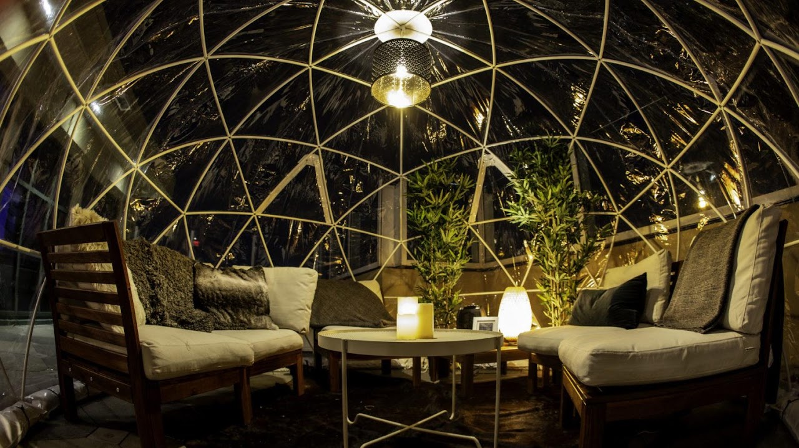

Sky Bar

OPEN TO THE PUBLIC | Doors open at 10pm | FREE ENTRY | Reserve VIP by emailing skybar@hiltonvb.com
Visit The Rooftop Guide to learn everything you need to know about our rooftop!

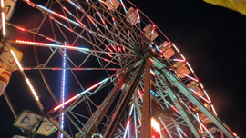

Atlantic Fun Park

Calling all families! Are you ready to experience FUN? If so then Atlantic Fun Park located in Virginia Beach, Virginia is exactly what you're looking for! Come experience Midway Games, 16 Family Fun Rides, and all the Fun Foods you can handle! We offer some of the most thrill seeking rides around with the most famous of them including the Gravitron, Flying Bob's, 100 ft tall Skyflyer and the Sea Dragon! Test your wits against these rides that are sure to leave you with one of the biggest adrenaline rushes of your life. You wont be able to resist another ride ever again! On top of all the rides we also offer a wide variety of kiddy and family rides such as the Ferris Wheel (biggest in Virginia Beach!) and the Kiddy Elephants. Atlantic Fun Park in Virginia Beach is family safe and friendly and great for all ages. Come check us out!

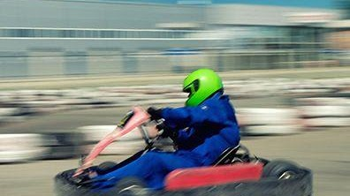

Motor World

Motor World features 11 Go- Kart tracks, 250 Karts with 16 different style Go Karts. Be sure to check out Virginia Beach’s most challenging Shipwreck Mini Golf Courses, Bumper Boats, Kiddie & Thrill Rides.

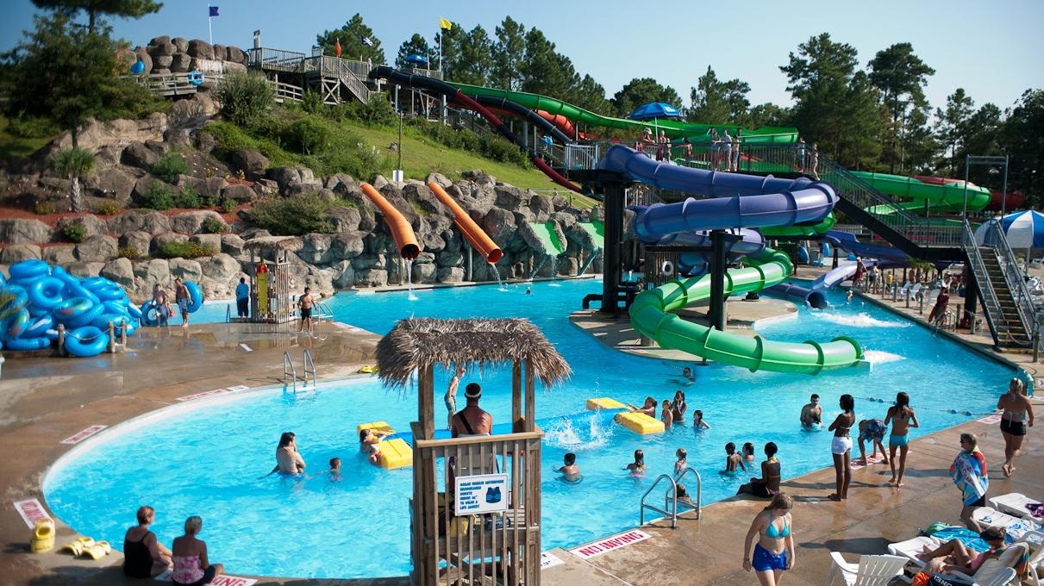

Ocean Breeze Waterpark

At Ocean Breeze enjoy the million gallon WAVE POOL with a new big screen, WATER SLIDES like the all new six story family raft ride Operation Splashdown, a quarter mile WINDING RIVER, and a WATER PLAYGROUND for the littlest buccaneers. WAHOOOO! Don't forget about those beautiful poolside cabanas, treats like DOLE WHIP and a visit with our mascot Hugh Mongous. Are you ready?



Jamestowne Society

Members of the Jamestowne Society are descended from early settlers who lived or held colonial government positions in Jamestowne, Virginia prior to 1700, or who invested in its establishment. The Jamestowne Society was organized for educational, historical, and patriotic purposes. The Society has a range of activities, from visiting early American sites, providing an annual graduate fellowship for research on Colonial Virginia prior to 1700, funding the restoration of records, and supporting preservation of Colonial sites. Want to learn more about Jamestowne during the period 1607-1700, the Jamestowne Society, and its members? You are in the right place!

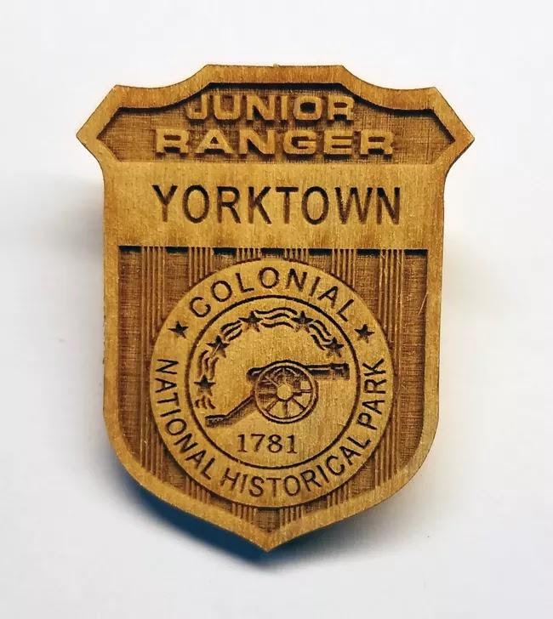

York Town Junior Ranger

Yorktown Battlefield has a Junior Ranger Program. The program was developed to allow families to learn together and are designed for children through age of 12. Each Junior Ranger Program takes about two hours to complete. Booklets can be picked up at the Yorktown Battlefield front desk. Experience the end of colonial America with the final major battle of the American Revolution to become a Yorktown Junior Ranger. Successful completion of the program earns a Certificate of Merit and a badge.

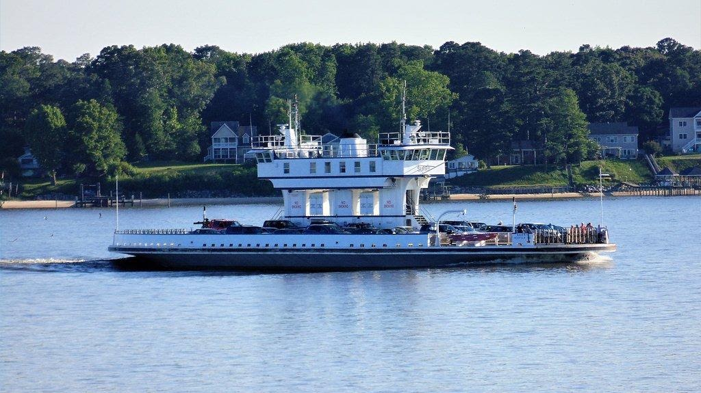

Jamestown Ferry

The Jamestown Ferry (also known as the Jamestown-Scotland Ferry) is a FREE automobile and bus ferry service across a navigable portion of the James River in Virginia. It carries State Route 31, connecting Jamestown in James City County with Scotland Wharf in Surry County. The service provides the only vehicle crossing of the river between the James River Bridge downstream at Newport News and the Benjamin Harrison Memorial Bridge upriver near Hopewell. It is toll-free and operated 24 hours a day, 7 days a week by the Virginia Department of Transportation (VDOT). The vessels carry over 900,000 passengers annually. Operations are based at the Scotland Wharf in Surry County.

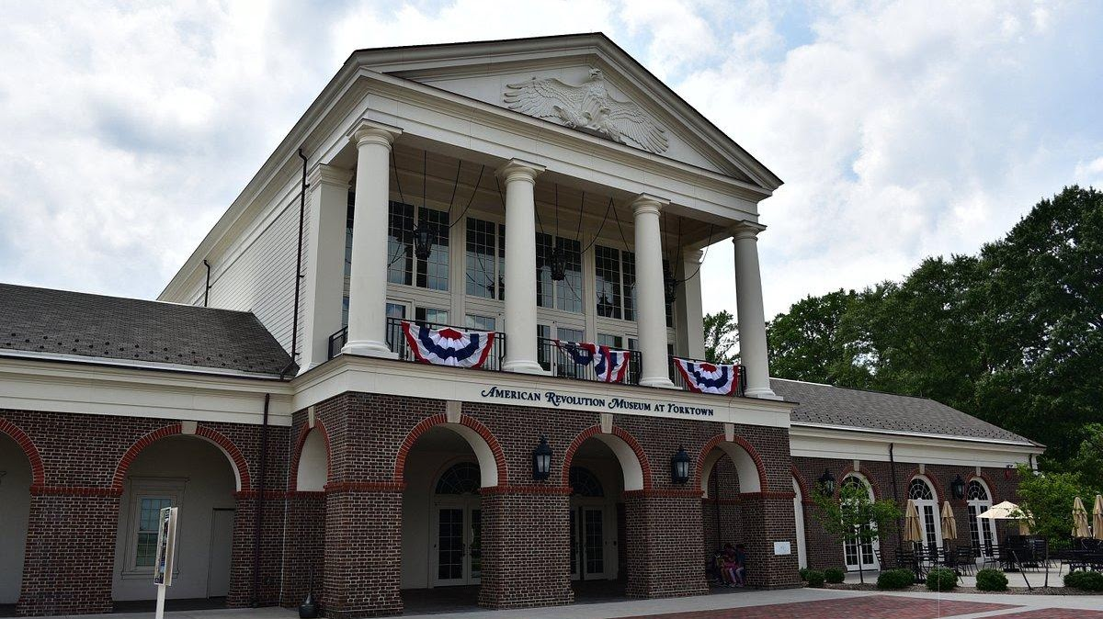

American Revolution Museum at Yorktown

Journey to the American Revolution Museum at Yorktown and learn the story of the nation’s founding, from the twilight of the colonial period to the dawn of the Constitution and beyond. Explore period artifacts, immersive environments and films, with a 180-degree surround screen and dramatic special effects. In the outdoor living-history areas, visitors can learn about the rank and file of a soldier’s life at a re-created Continental Army encampment and explore a Revolution-era farm based on a real-life 18th-century family.

