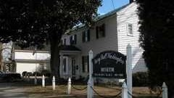

Mary Ball Washington Museum
Mary Ball Washington Museum & Library
Hours: Wednesdays, Thursdays, Fridays 10:00-4:00
Address: 8346 Mary Ball Road Lancaster, VA 22503 ·
Contact Info (804) 462-7280.

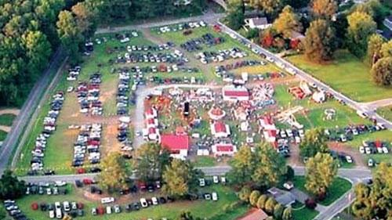
KVFD Summer Carnival
Catch a ride on the vintage ferris wheel or merry-go-round and play tons of carnival games starting last week of July. Run by Kilmarnock Volunteer Fire Department.
839-945 Waverly Avenue Kilmarnock, Virginia 22482
(804) 436-2002

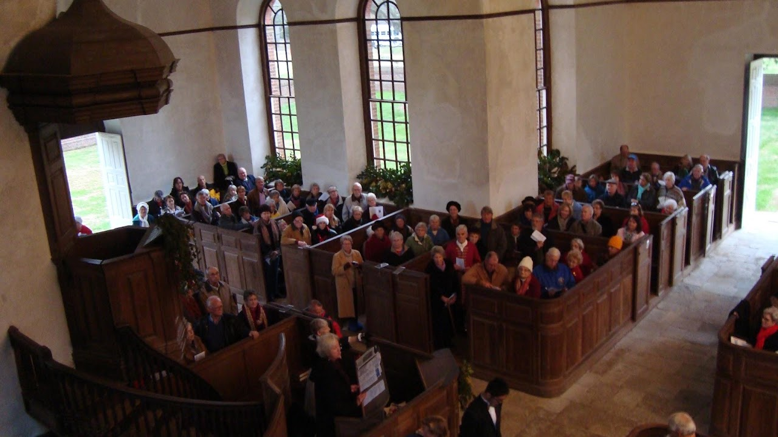
Historic Christ Church
Historic Christ Church
Holy Eucharist Rite I Sunday 8 AM (only during summer months - check website)
Address: 420 Christ Church Road, Weems, VA 22576
Contact Info (804) 438-6855 or info@christchurch1735.org
Virginia Historical Marker J-86
National Register of Historic Places: 66000841

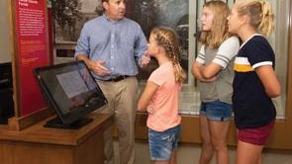

Carter Museum
Carter Museum
Monday, Thursday, Friday & Saturday 10:00 a.m. – 4:00 p.m.
Sunday 1:00 p.m. – 4:00 p.m
Contact Info (804) 438-2441
Virginia Historical Marker O-73
Address: 420 Christ Church Road, Weems, VA 22576
Contact Info (804) 438-6855 or info@christchurch1735.org
Virginia Historical Marker O-73

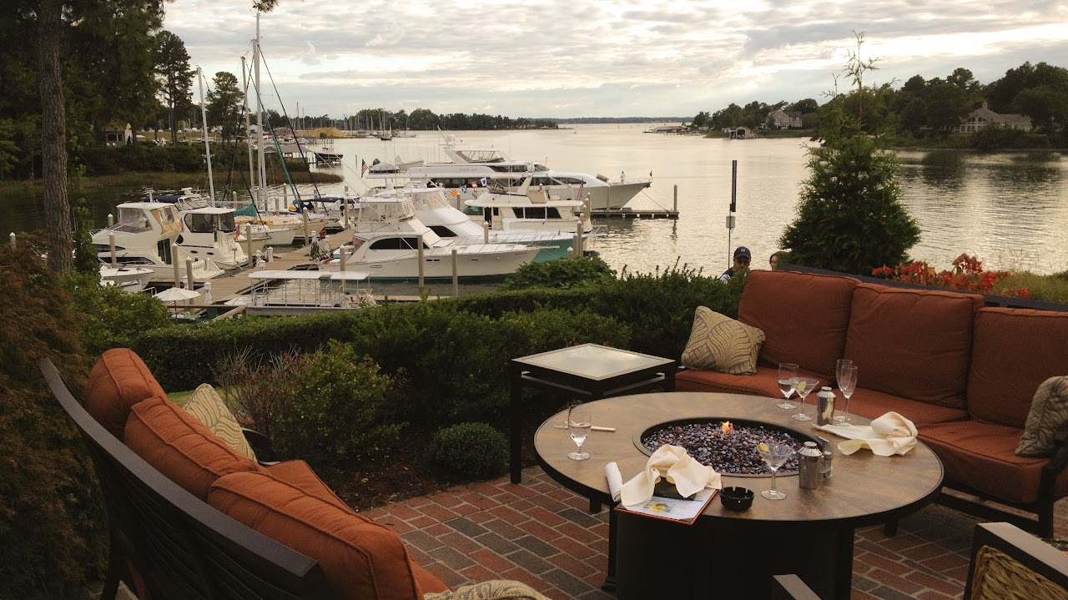

Tides Inn Brunch
Dinner at Chesapeake Restaurant and Terrace Tides Inn Resort Hotel
Breakfast: Everyday 7am – 11am
Brunch: Saturday and Sunday 11am – 2pm
Lunch: Monday – Friday 11am – 2pm
Dinner: Everyday 5pm – 10pm
Address: 480 King Carter Drive Irvington, VA. 22480
Contact Info (804) 438–4457 Opentable Reservations

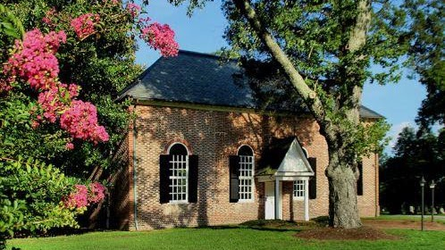

St. Mary's White Chapel
St. Mary's White Chapel info:
Holy Eucharist: Sunday 11:15 AM
Address: 5940 White Chapel Road, Lancaster, Virginia 22503
Contact Info (804) 462-5908 or stmarys.whitechapel@gmail.com
National Register of Historic Places: 69000254

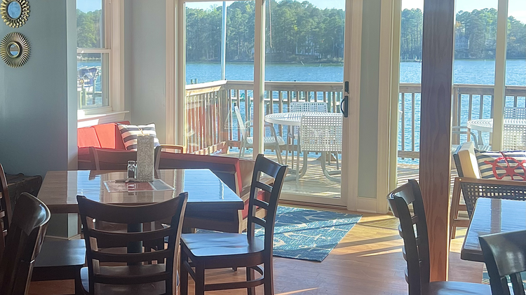
Captain Lounge
Dinner at the Captains Lounge Yankee Point Marina.
Hours: Thursday & Friday 5PM-9PM; Saturday 11 AM-9PM; Sunday 10AM-8PM
Address: 1303 Oak Hill Rd, Lancaster, VA 22503
Contact Info (804) 462-7635 info@yankeepointmarina.com

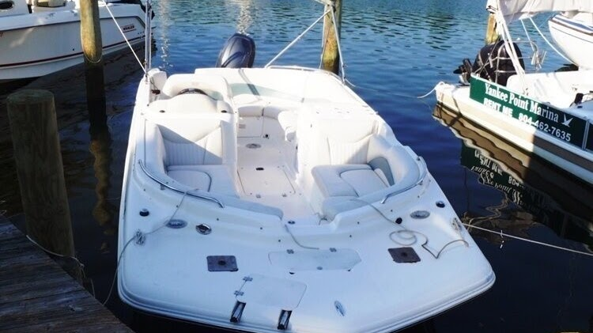
Boat Rentals
Yankee Point Marina Boat Rentals
Address: 1303 Oak Hill Rd, Lancaster, VA 22503
Contact Info (804) 462-7635 info@yankeepointmarina.com

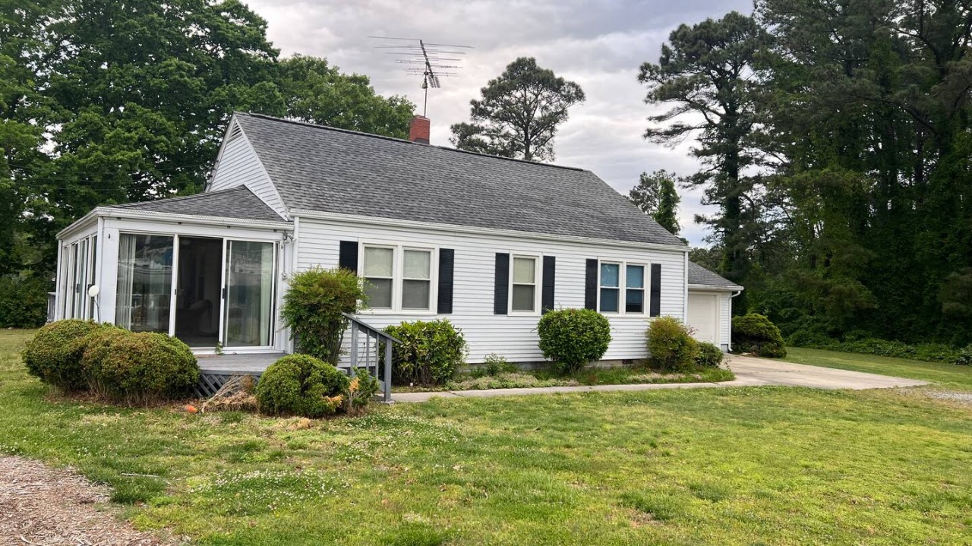
Yankee Point Marina
Yankee Point Marina Airbnb House.
Virginia Historical Marker J-106
Currently 2 day minimum stay required

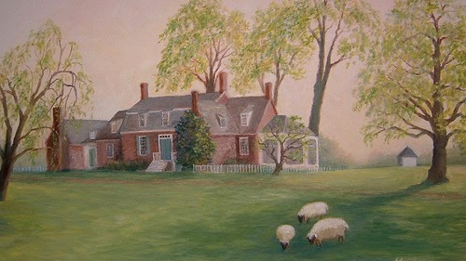
Barford Plantation
Verville Plantation (Barford)
Address: 3709 Merry Point Rd, Lancaster VA 22503
Virginia Historical Marker J-90
National Register of Historic Places: 87000609

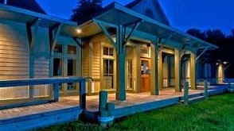
Steamboat Era Museum
156 King Carter Dr, Irvington, VA 22480
(804) 438-6888
steamboateramuseum.org

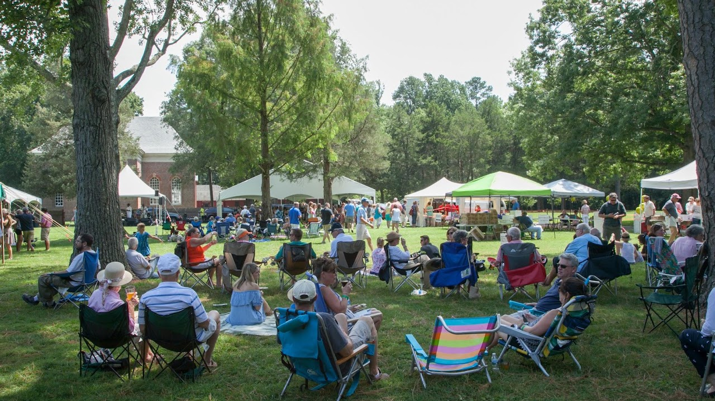
Raise the Roof
"Raise the Roof" at Historic Christ Church & Museum in Weems, Virginia. Enjoy an array of craft beers, delicious BBQ or vegetarian fare, homemade ice cream, and live music, all at one of Virginia’s most historic sites. Funds benefit preservation of Historic Christ Church (1735), a National Historic Landmark. Tickets

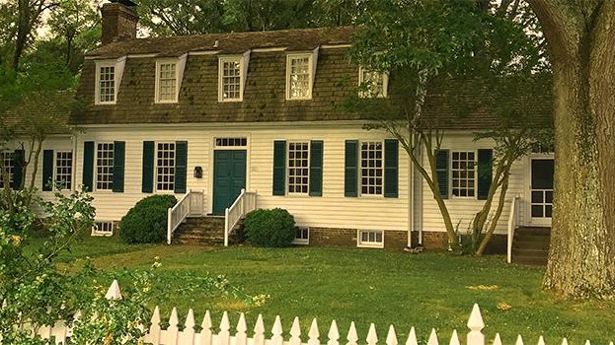

Belle Isle State Park

Belle Isle has seven miles of shoreline on the Northern Neck's Rappahannock River and provides access to Mulberry and Deep creeks. The park lets visitors explore a wide variety of tidal wetlands interspersed with farmland and upland forests. It has a campground, three picnic shelters, hiking, biking and bridle trails, and motor boat and car-top launches. Belle Isle also offers overnight lodging at Bel Air and the Bel Air Guest House. Bicycle, canoe and kayak rentals are available. Guests also enjoy the park's universal access playground, boardwalk and fishing pier, and educational programs. The Bel Air historic area is ideal for weddings.
Its address is 1632 Belle Isle Rd., Lancaster, VA 22503; Latitude, 37.774414. Longitude: -76.599364.

Northern Neck Driving Tour

